GoQUO Backend engine

Administration Manual

# Document Version

|  |  |  |  |
| --- | --- | --- | --- |
| Version | Author | Date | Remarks |
| 1.0 | Michelle Ng | 24/06/2016 |  |
| 2.0 | Alvin Dinesh | 25/07/2016 |  |
| 3.0 | Katie Vu | 09/09/2016 |  |
|  |  |  |  |
|  |  |  |  |
|  |  |  |  |
|  |  |  |  |
|  |  |  |  |

# Table of Contents

Document Version 1

Table of Contents 2

Login Page 7

Dashboard 7

Manage Sites 8

Edit Site 9

Site Settings 12

Users 14

Manage Users 16

Manage Roles 16

Create Role 16

Permissions 17

Create Users 17

Create Users 18

Change User’s Password 20

Edit Users 21

Logs 22

Manage Logs 22

Countries 23

Manage Countries (To check behaviour) 24

Add City 25

Cities 25

Manage Cities 26

Add city 26

Import City 26

Airports 28

Manage Airports 29

Create Airport 29

Edit Airport 29

Date Settings 31

Edit Date Settings 31

Languages 33

Manage Languages 33

Manage Localizable Strings 34

Edit Language 35

Pages 35

Create Page 36

Edit Page 36

Widgets 38

Manage Widgets 38

Create Widget 38

Destinations 40

Manage Destinations 40

Create Destination 40

Email Templates 41

Manage Email Templates 41

Create Email Template 42

Edit Email Template 42

PDF Template 43

Rebuild Cache 44

Import/Export Setting 45

Agent Management 45

Manage Agents/Create Agent 45

All Agent’s Booking 46

Currency Settings 47

Currency Roundings 47

Payment Processors 48

Manage Payment Processors/Create Payment Processor/Edit Payment Processor 48

Payment Methods 50

Manage Payment Methods/Create Payment Method 50

Card Types 51

Manage Card Types/Create Card Type 51

Payment Gateways 52

Manage Payment Gateways/Create Payment Gateway/Edit 52

Promotion Codes 54

Manage Promotion Codes/Create Promotion Code 54

Good Services Taxes 59

Manage Good Services Taxes/Create Good Services Taxes 59

Edit Good Services Taxes/Create Good Services Taxes 60

Booking Fields 61

Manage Booking Fields/Create Booking Fields 61

Booking Settings 63

Blocked BIN Cards 65

Manage Blocked BIN Cards/Create Blocked BIN Card 65

Blocked Emails 65

Manage Blocked Emails/Create Blocked Email 66

Blocked IP Addresses 66

Manage Blocked IP Addresses/Create Blocked IP Address 66

Customer Management 67

Manage Customer Information 67

Customer Subscription 68

Manage Customer Subscription 68

SMTP Settings 69

Message Service Setting 69

Manage Message Service Settings/Create Manage Message Service Setting 69

Booking Management 70

Manage Bookings 70

Reservation 72

Billing Details 74

Passengers 75

Products 76

Render PDF 80

API Access Logs 80

History 81

Booking Notes 82

Flight API Provider 83

Hotel API Providers 84

Manage Hotel API Providers/Create Hotel API Provider 84

Tour API Providers 86

Manage Tour API Providers/Create Tour API Provider 86

Transfer API Providers 87

Manage Transfer API Providers/Create Transfer API Provider 87

Insurance API Providers 88

Manage Insurance API Providers/Create API Provider 88

Hotel OTA API Providers 89

Manage Hotel OTA API Providers/Create Hotel OTA API Provider 89

Operation Times 90

Manage Operation Times/Create Operation Time 90

API Access Logs 91

Manage API Access Logs/Search API Access Log 91

Manage Packages 92

URL Confirms 94

Manage URL Confirms 94

OAuth Settings 95

Sift Science Settings 96

Segment IO Settings 96

Package Queries 97

Manage Package Queries/Create Package Query 97

Hotel Checkin Next Days 97

Manage Hotel Checkin Next Days 97

Trip Advisor Mappings 98

Manage Trip Advisor Mappings/Create Trip Advisor Mapping 98

Route Currency Mappings 99

Manage Route Currency Mappings/Create Route Currency Mapping 99

Destination Mappings 100

Manage Destination Mapping/Create Destination Mapping 100

View Contents 101

Manage View Contents/Import Theme/Sync 101

Double Clicks 103

Edit Double Clicks 103

Flight Markups by Airline 103

Manage Flight Markups by Airline/Create Flight Markups by Airline 103

Flight Markup by Price 104

Manage Flight Markup by Price/Create Flight Markup by Price 104

Flight Cancellation Markup 106

Manage Flight Cancellation Markup/Create Flight Cancellation Markup 107

Hotel Markups 109

Manage Hotel Markups/Create Hotel Markup 109

Hotel Cancellation Markups 111

Manage Hotel Cancellation Markups/Create Hotel Cancellation Markup 111

Tour Markups 112

Manage Tour Markups/Create Tour Markup 112

Transfer Markups 114

Manage Transfer Markups/Create Transfer Markup 114

Other Charge Markups 116

Manage Other Charge Markups/Create Other Charge Markup 116

# Login Page

Login to [URL] (To be provided by PM

Username: To be provided by PM  
Password:

# Dashboard

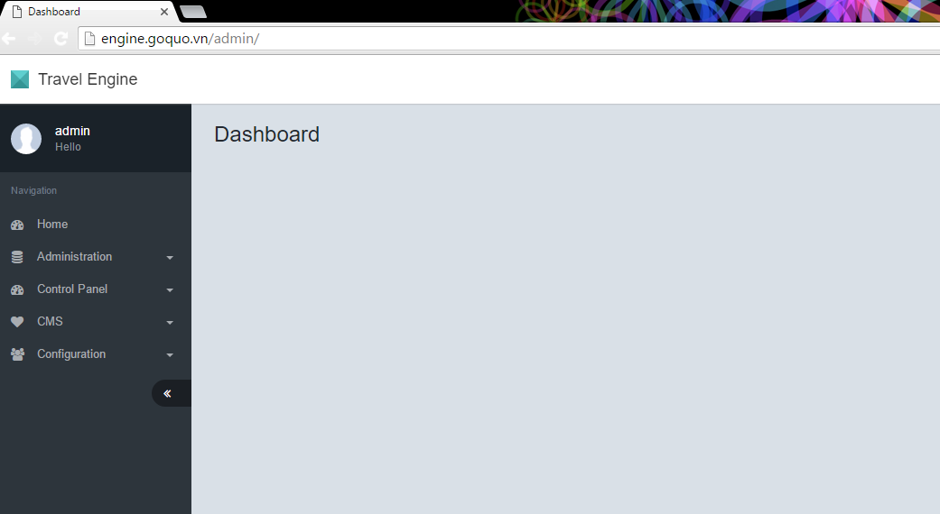

Click on Manage Sites:  
  
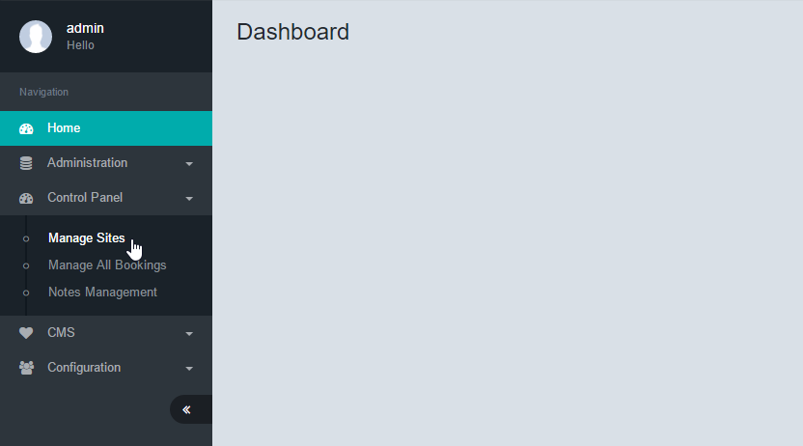

# Manage Sites

Select site to manage and click Go:

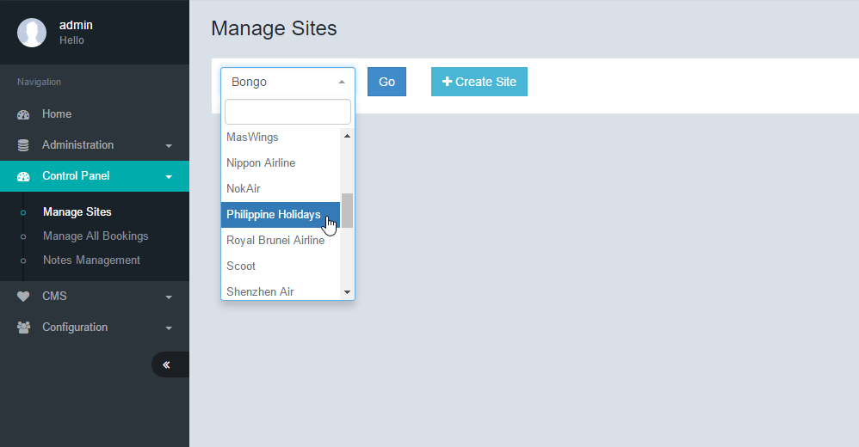

Under General, click on the first setting (the title of the setting will correspond with the name of your Airline).

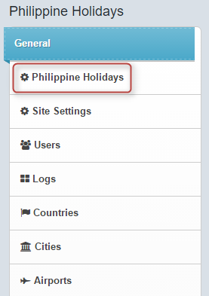

## Edit Site

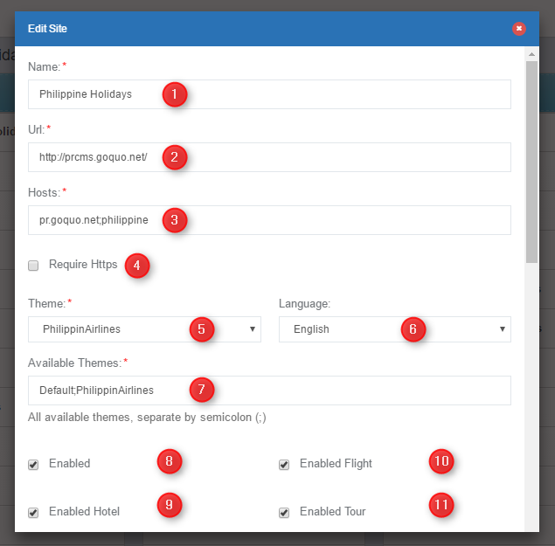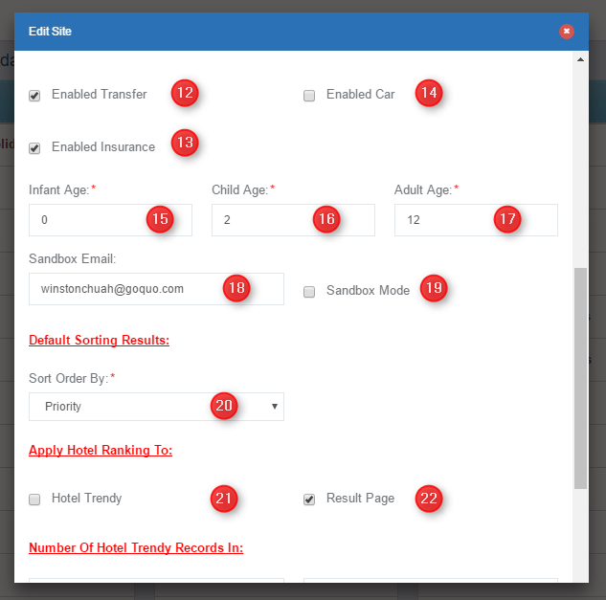

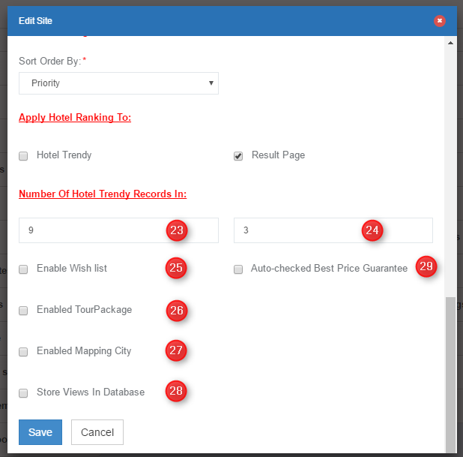

|  |  |  |
| --- | --- | --- |
| **Edit Site** | | |
| No. | Function | Description |
| 1 | Name of Site | Descriptive field for the site. *[Does this affect any area in the site]* |
| 2 | URL | This is the assigned URL/Website of the site. The site will link to this URL as the home page. eg: www.airline.com |
| 3 | Host Address | This is the engine host address. The search engine results page will point to this URL. eg: book.airline.com |
| 4 | Require Https | When this checkbox is selected the site will require an SSL certified URL. All domain and certificate settings are to be applied in the hosted DNS servers. eg: https://www.airline.com |
| 5 | Theme | A specific theme may be applied to the site. There may be multiple themes setup *[where]*. You must setup the Available Themes field to ensure the theme can be applied.  Choose Default if theme is not customized. The default Theme is the most basic setup of the site. Themes affect colors, fonts, sizes, layouts etc *[citation needed]* |
| 6 | Language | This is the default language of the site. Language values are taken from the language section of the backend. |
| 7 | List of Available Themes | Themes may be enabled/disabled by including them in this column. Add or removing themes in this column will affect field #5 (Theme) |
| 8 | Enabled | This is the superset of all items listed in #9-14 |
| 9 | To enable Hotel feature | When this is checked, the engine will allow the hotel component search feature and booking. [How will it affect the front end, search results?] |
| 10 | To enable Flight feature | When this is checked, the engine will allow the flight component and booking. [How will it affect the front end, search results?] |
| 11 | To enable Tour feature | When this is checked, the engine will allow the flight component and booking. [How will it affect the front end, search results?] |
| 12 | To enable Transfer feature | When this is checked, the engine will allow the Transfer component and booking. [How will it affect the front end, search results?] |
| 13 | To enable Insurance feature | When this is checked, the engine will allow the Insurance component and booking. [How will it affect the front end, search results?] |
| 14 | To enable Car feature | When this is checked, the engine will allow the Car component and booking. [How will it affect the front end, search results?] |
| 15 | Infant Age | This defines the lower limit of an Infant age. |
| 16 | Child Age | This defines the lower limit of a Child age and upper limit of an infant age. |
| 17 | Adult Age | This defines the lower limit of an Adult and the upper limit of a Child eg:  Infant Age = 0 Child Age = 2 Adult Age = 12 Then infant age is from 0 to 1 Year, 11 Months, 31 Days. Child age is from 2 to 11 Years, 11 Months, 31 Days (Engine determines the age at the dates of travel) |
| 18 | Sandbox email | When the sandbox mode is enabled, all booking emails will be sent to the sandbox defined email address. Separate multiple email addresses by semi colon (;) *[citation needed]* |
| 19 | Sandbox mode | To enable and disable sandbox mode. Ticked means sandbox is enabled |
| 20 | Default sorting results | This will tell the engine to display search results of hotel based on the following settings Priority – [Citation needed]  Expedia – Expedia ranking from database [Citation needed]  PriceHighToLow – Highest priced hotel will appear on top PriceLowToHigh – Lowest priced hotel will appear on top  Random – Hotels appear randomly  PreviousViewed – Hotels appear based on browser cache |
| 21 | Hotel Trendy | Currently not used |
| 22 | Results Page | This will override Sorting Order and display hotels based on Hotel Ranking algorithms. If checked, the ranking will appear in the search results page. |
| 23 | Hotel Trendy 1 | Currently not used |
| 24 | Hotel Trendy 2 | Currently not used |
| 25 | Enable Wish List | [Citation Needed] |
| 26 | Enabled Tour Package | [Citation Needed] |
| 27 | Enabled Mapping City | [Citation Needed] |
| 28 | Store Views in Database | [Citation Needed] |
| 29 | Auto-Checked Best Price Guarantee | [Citation Needed] |

Once changes have been made, click Save, otherwise click Cancel.

# Site Settings

Under General, select Site Settings.

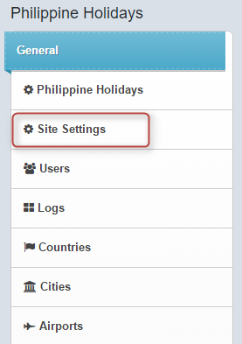

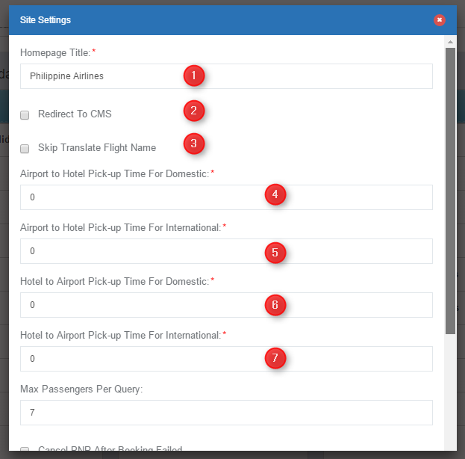

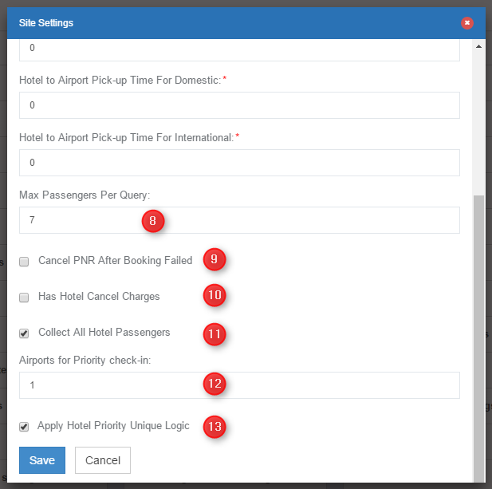

|  |  |  |
| --- | --- | --- |
| **Site Settings** | | |
| No. | Function | Description |
| 1 | Homepage Title | This will affect the <title></title> Tag off the site |
| 2 | Redirect to CMS | When a CMS is in use, the website will automatically redirect to the CMS when a home or dead link is keyed in. |
| 3 | Skip Translate Flight Name | [Citation needed] |
| 4 | Airport To Hotel Pick-Up Time for Domestic | The Pick-up Time for airport to hotel transfers. This value will appear in the transfer voucher and emails for suppliers. This value only affects Domestic routes |
| 5 | Airport To Hotel Pick-Up Time for International | The Pick-up Time for airport to hotel transfers. This value will appear in the transfer voucher and emails for suppliers. This value only affects International routes |
| 6 | Hotel To Airport Pick-Up Time for Domestic | The Pick-up Time for hotel to airport transfers. This value will appear in the transfer voucher and emails for suppliers. This value only affects Domestic routes |
| 7 | Hotel To Airport Pick-Up Time for International | The Pick-up Time for hotel to airport transfers. This value will appear in the transfer voucher and emails for suppliers. This value only affects International routes |
| 8 | Max Passengers Per Query | The Engine only accepts searches for a maximum of x number of passengers. If the form or URL query string sends more than x, the search results will not be returned. |
| 9 | Cancel PNR After Booking Failed | If this field is checked, the engine will send cancellation notification/API call to release the PNR. |
| 10 | Has Hotel Cancel Charges | [Citation needed] |
| 11 | Collect All Hotel Passengers | [Citation needed] |
| 12 | Airports for Priority Check-In | [Citation needed] |
| 13 | Apply Hotel Priority Unique Logic | [Citation needed] |

Once changes have been made, click Save, otherwise click Cancel.

# Users

Under General, select Users.

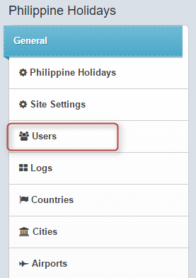

## Manage Users

To create a role, click on Roles:

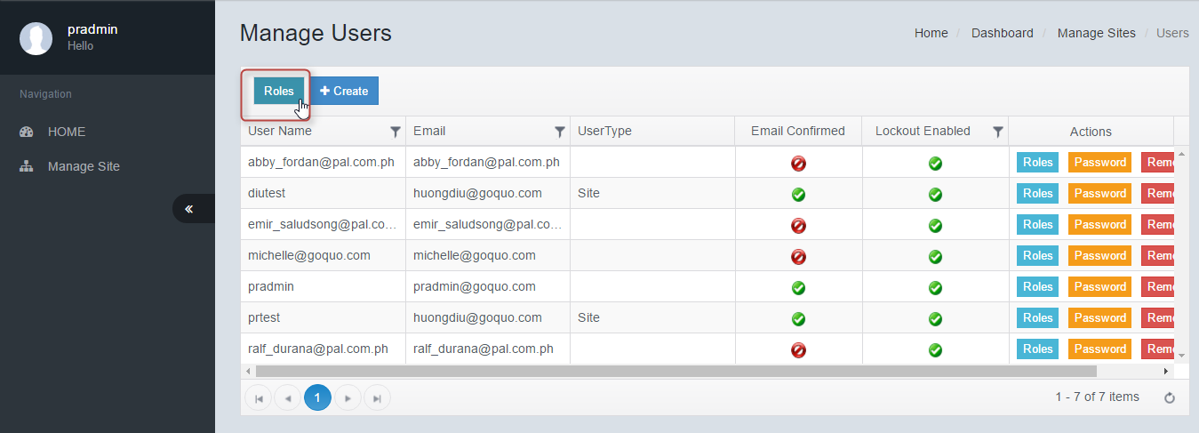

## Manage Roles

To create a role, click on Create:

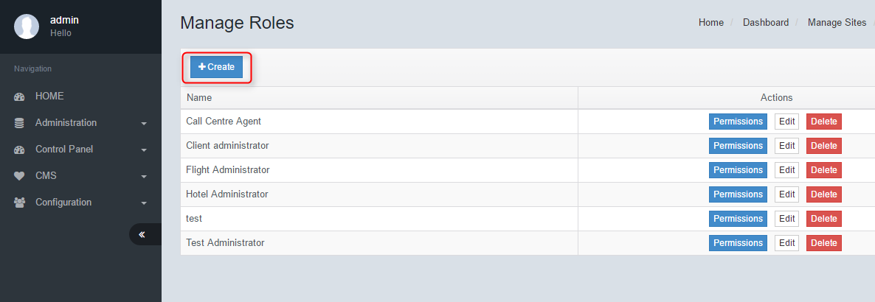

## Create Role

Enter a role name, and click Save. Otherwise click Cancel.

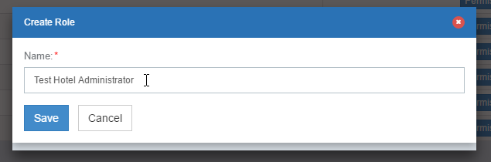

## Permissions

Click on Permissions button to manage the access rights of each role. When creating a user, we can assign the role to them. The corresponding role will allow the user access to only the granted features of the system

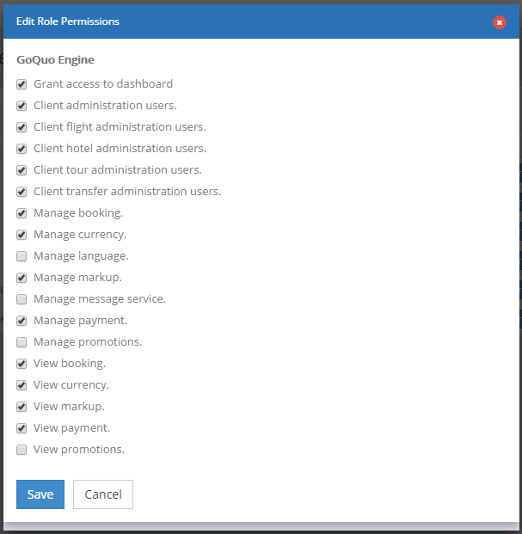

## Create Users

To create a user, click on Create.

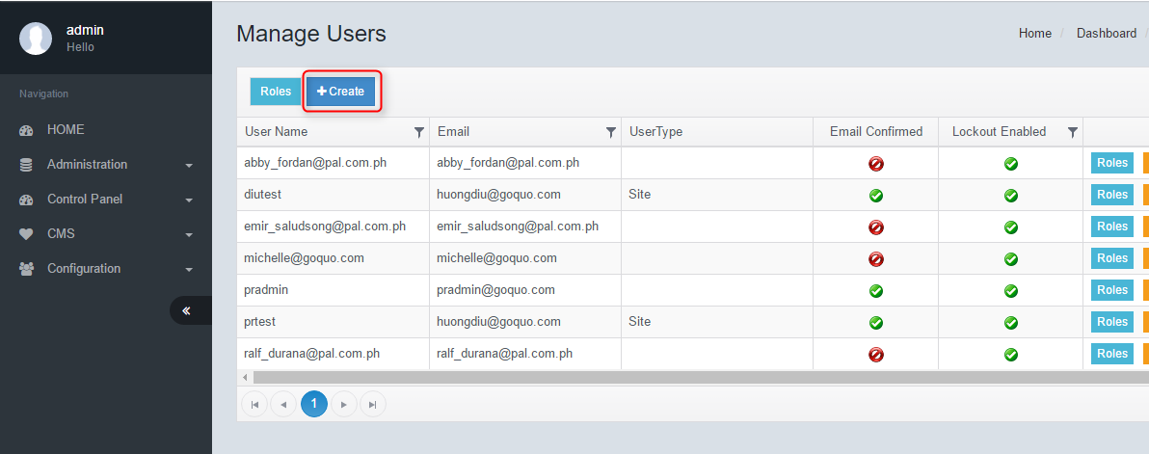

Enter all required fields, and click Save.

|  |  |  |
| --- | --- | --- |
| **Edit Role Permissions** | | |
| No. | Function | Description |
| 1 | Grant access to dashboard | This gives the user full access to view the dashboard |
| 2 | Client administration user | This role gives the user full access rights to perform administrative tasks. [to list the specific features allowed] |
| 3 | Client flight administration users | This role gives the user access to perform only flight administration tasks. [to list the specific features allowed] |
| 4 | Client hotel administration users | This role gives the user access to perform only flight administration tasks. [to list the specific features allowed] |
| 5 | Client tour administration users | This role gives the user access to perform only flight administration tasks. [to list the specific features allowed] |
| 6 | Client transfer administration users | This role gives the user access to perform only flight administration tasks. [to list the specific features allowed] |
| 7 | Manage booking | This role give user the full rights to the manage booking feature. They will be able to view and edit booking details. |
| 8 | Manage currency | A user with this role will be able to upload and edit currency related features, including currency rates. |
| 9 | Manage language | A user with this role will be able to fully use the language feature and edit languages and translations. |
| 10 | Manage markup | A user with this role will be able to adjust and edit markups |
| 11 | Manage message service | [citation needed] |
| 12 | Manage payment | A user with this role will be able to view and edit all payment related features. |
| 13 | Manage promotions | A user with this role will be able to view, edit and create promotions |
| 14 | View booking | A user with this role, will be able to only view the Booking Management feature. They will not be able to edit or make changes |
| 15 | View currency | A user with this role, will be able to only view currency related features. They will not be able to edit or make changes |
| 16 | View markup | A user with this role, will be able to only view all the markup settings. They will not be able to edit or make changes |
| 17 | View payment | A user with this role, will be able to only view payment related features. They will not be able to edit or make changes |
| 18 | View promotions | A user with this role, will be able to only view the Promotions feature. They will not be able to edit or make changes |

## Create Users

To create a user, click on Create.



Enter all required fields, and click Save.

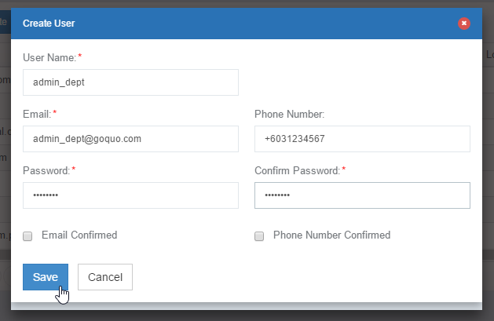

## Change User’s Password

Under the Actions, column, click on Password.

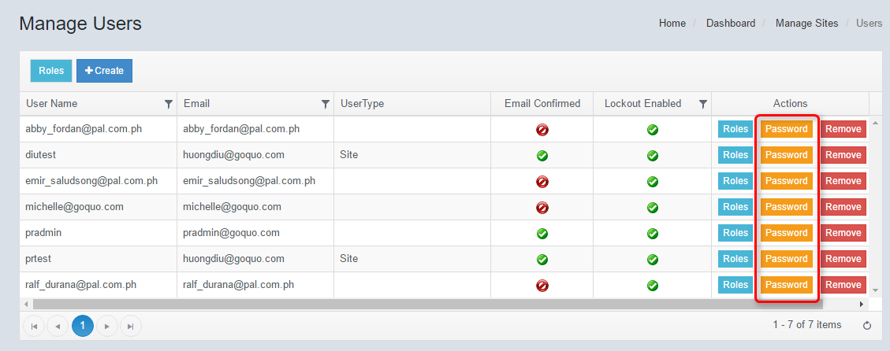  
  
Enter a new password and re-enter the password to confirm.  
  
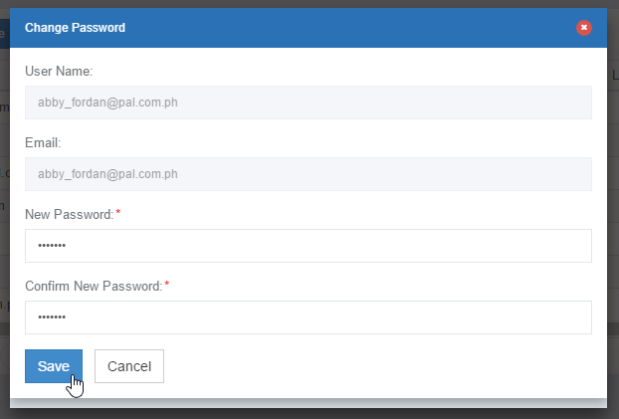

## Edit Users

To edit a user’s details, click on Edit.  
  
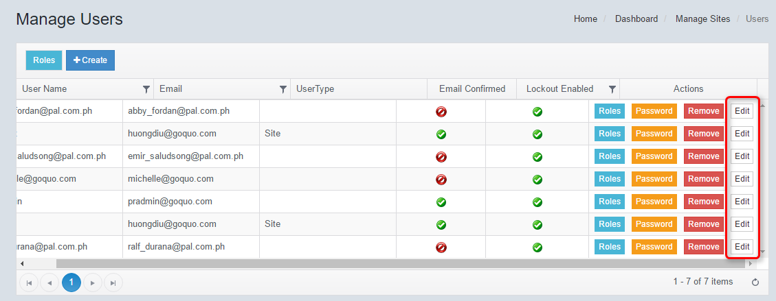

After editing user’s details, click Save.  
  
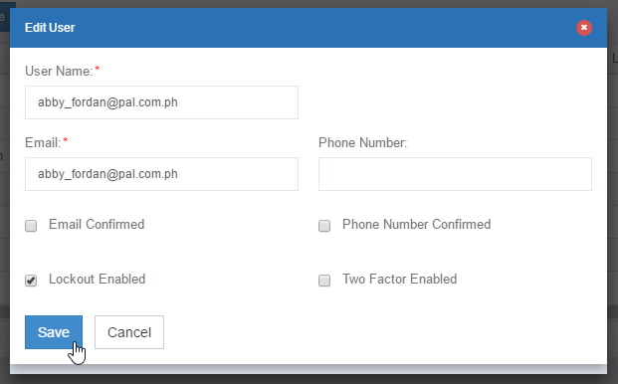



|  |  |  |
| --- | --- | --- |
| **Edit User** | | |
| No. | Function | Description |
| 1 | Email Confirmed | [Citation needed] |
| 2 | Phone number confirmed | [Citation needed] |
| 3 | Lockout Enabled | [Citation needed] |
| 4 | Two factor enabled | [Citation needed] |

# Logs

Under General, select Logs.

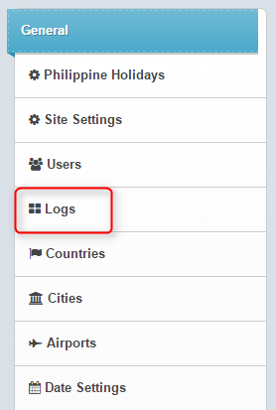

## Manage Logs

To view logs from a specific date range / entity / action / user, select the appropriate values then click Search OR Export to CSV.

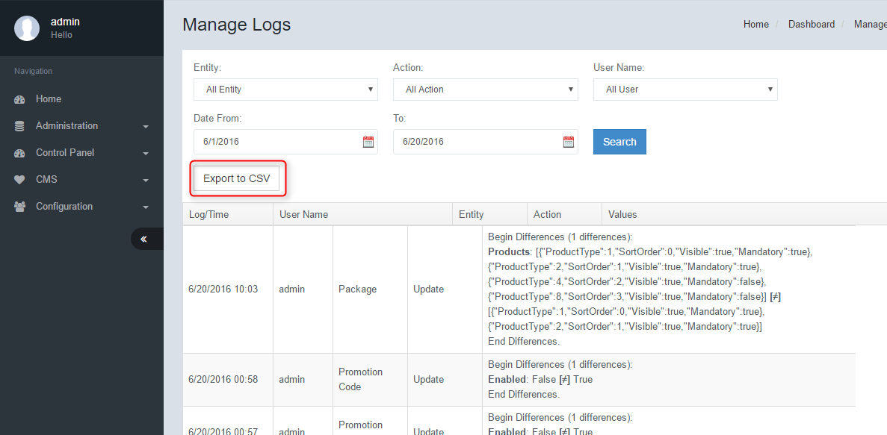

# Countries

Under General, select Countries.

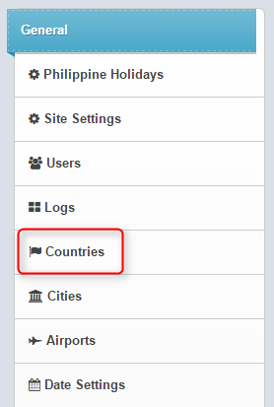

## Manage Countries (To check behaviour)

The system will only allow searches for countries and cities added to the databases. A country must first be added to the database using this feature. Then a city may be added for that country. A client may also decide to remove countries that it wishes not to operate in by deleting the country. In doing so, the system will never return results for those cities or countries.  
  
To add City to a country, click on Add City.  
  
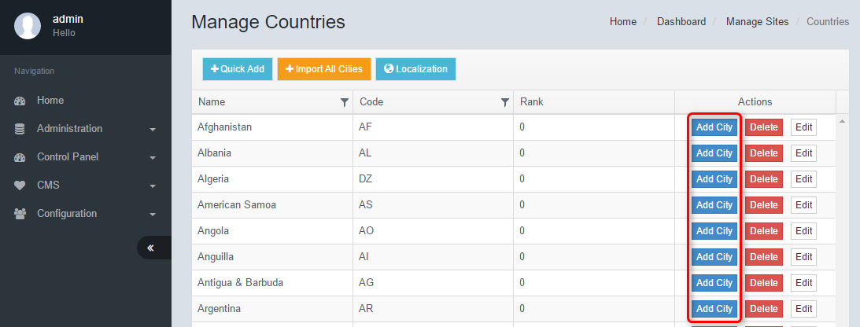

## Add City

Select a city to add, and click Save.

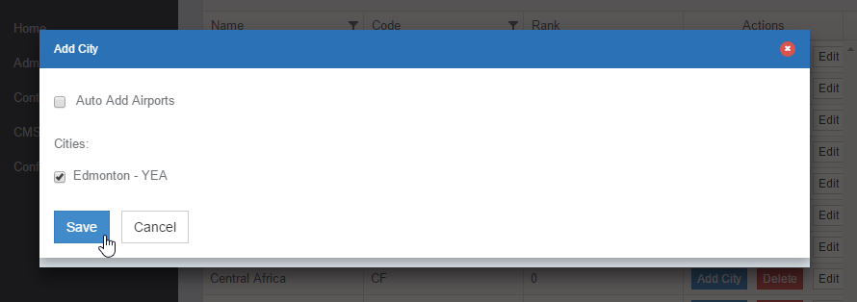

# Cities

Once cities have been added, it is possible to use this feature to manipulate them in detail. You may change the name or city code, depending on your situation.  
  
Under General, select Cities.

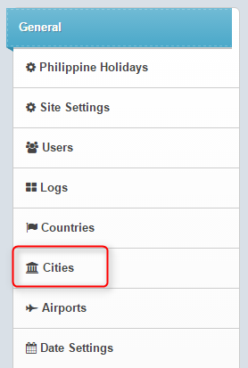

## Manage Cities

To add a city, select Add City.

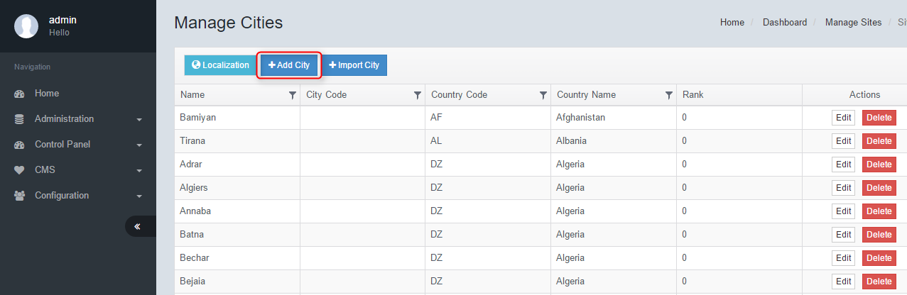

## Add city

Enter all required fields, click Save.  
NOTE: City Code must always be 3 Character.   
  
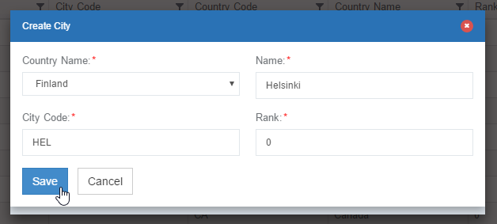

## Import City

This feature gives the user an easy way to add cities by country. The system will only display cities that have not been added yet for the selected country.  
  
To import a city, click on Import City.

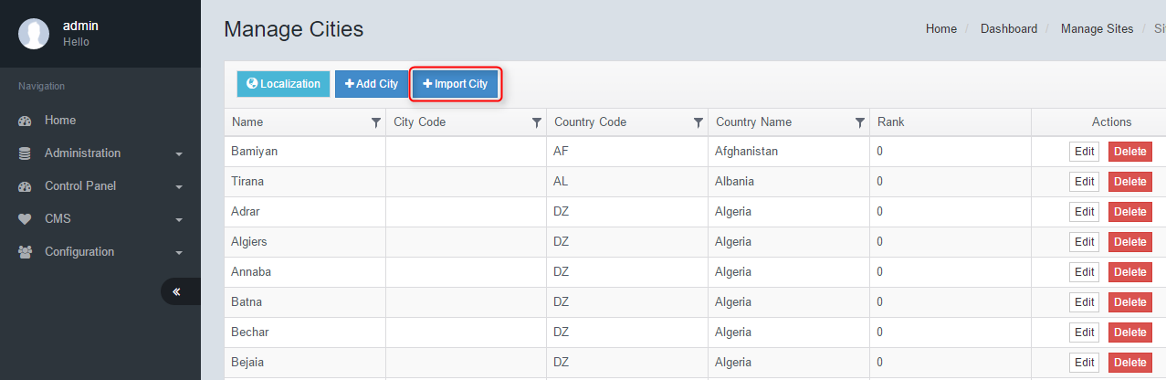

Select the city you wish to import, click Save.

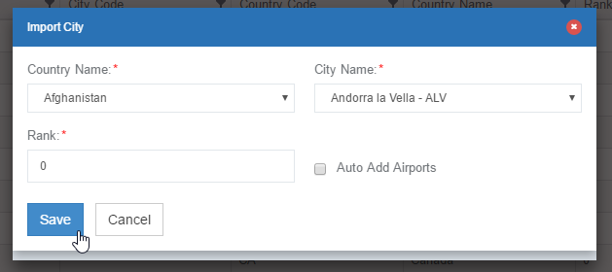

# Airports

The engine will only display flight search results for airports that are added to the database. This feature allows the client to add, remove or modify airports that are within their operated routes.  
  
Under General, select Airports.

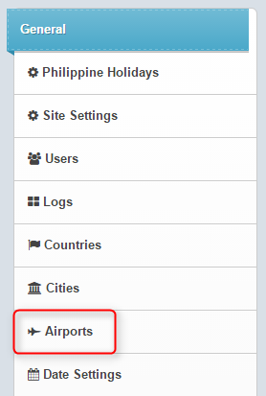

## Manage Airports

To add an airport, click on Create.

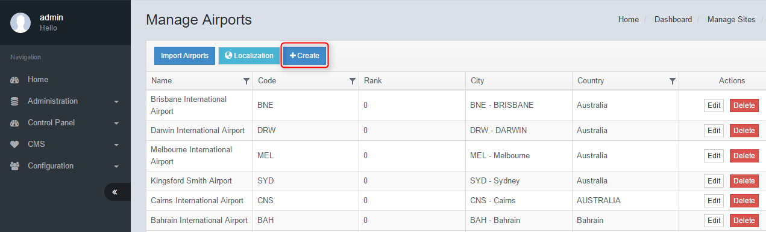

## Create Airport

Enter all required fields, click Save.  
  
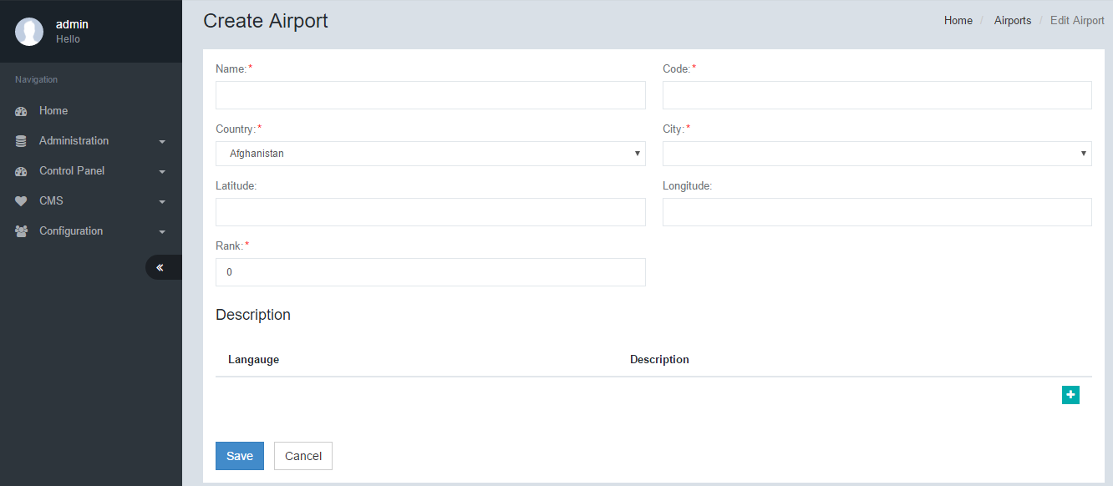

## Edit Airport

To edit an airport’s details, click on Edit.

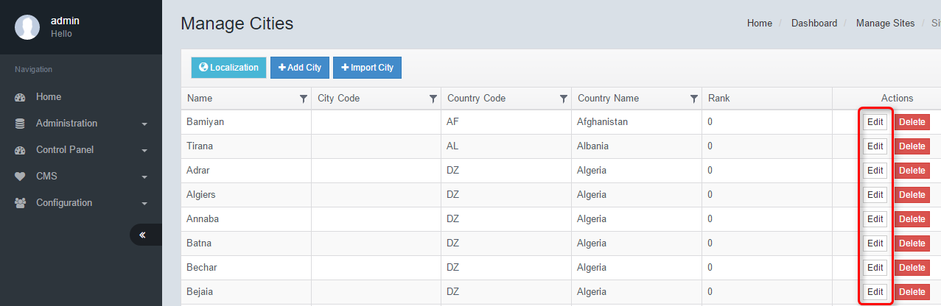

Amend all necessary fields, and click Save.

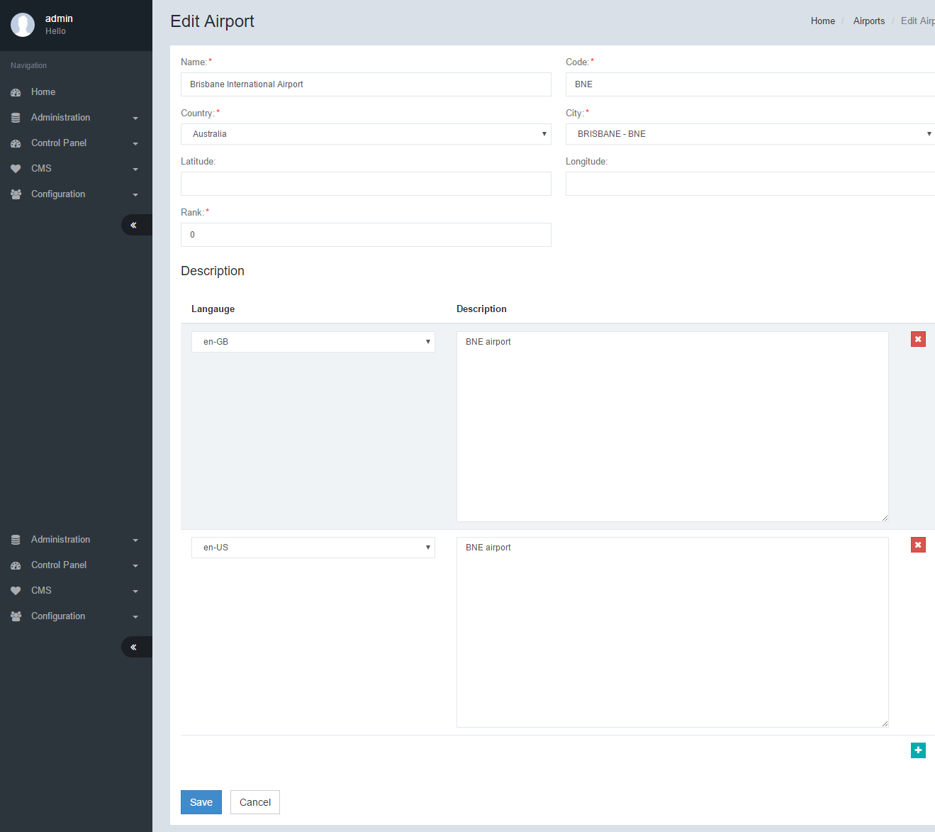

|  |  |  |
| --- | --- | --- |
| **Edit Airport** | | |
| No. | Function | Description |
| 1 | Name | The name of the airport that will appear in Engine |
| 2 | Code | The 3 digit IATA airport code |
| 3 | Country | This is the country of the airport. Values are derived from Country feature |
| 4 | City | The city of the airport. City values are derived from the City feature |
| 5 | Latitude | The geo location latitude code. This value is used for the map feature in engine |
| 6 | Longitude | The geo location longitude code. This value is used for the map feature in engine. |
| 7 | Rank | [Citation needed] |
| 8 | Language | Multiple languages may be used to describe each airport. Select the language and key in the corresponding description in the description field. |
| 9 | Description | A description or message about specific local taxes or emergency notifications may be used for each language selected. |

# Date Settings

Under General, select Date Settings.

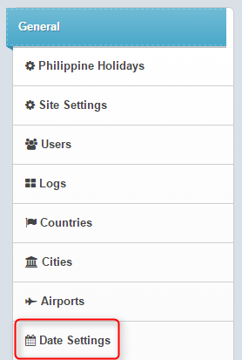

## Edit Date Settings

The system can be setup to display date and time according to the client’s standards. The date and time format will be displayed in the search results as defined.  
  
Enter/select the desired date setting values, then click Save.

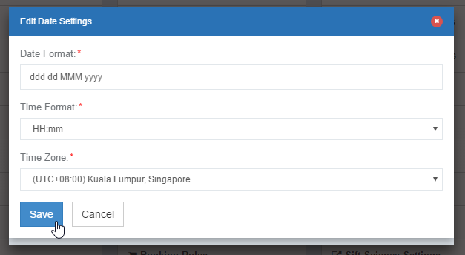

# Languages

The engine is able to support multiple languages. Once a language is added, the client may be able to provide translations for the system to display their relevant fields.  
NOTE: Values that are populated from supplier API/XML may not be translated. Only fixed tags and values may be localized.  
  
Under General, select Languages.

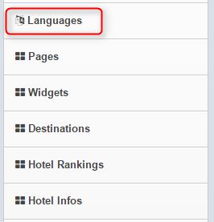

## Manage Languages

The Engine is capable of supporting multiple languages. When a language (culture Code) is selected in the engine, the system automatically populates all localizable strings from the tables in this feature.

To create a Language, click on Create.

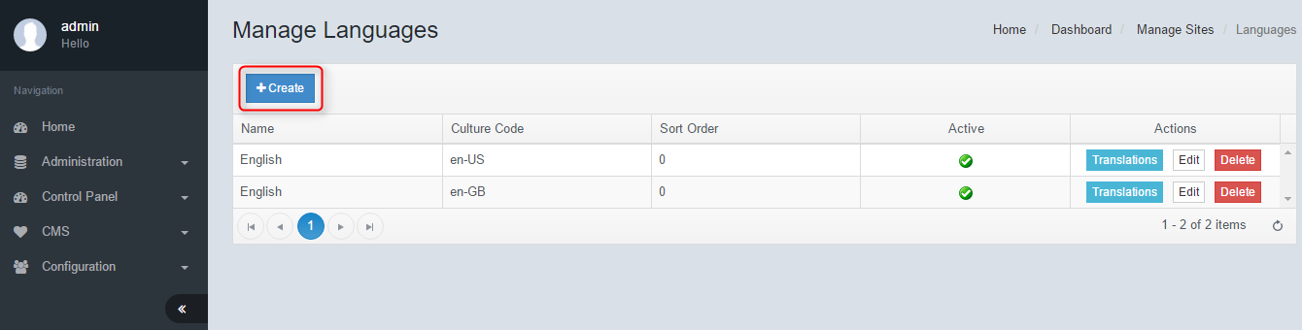  
  
Create Language

Enter all required fields, then click Save.

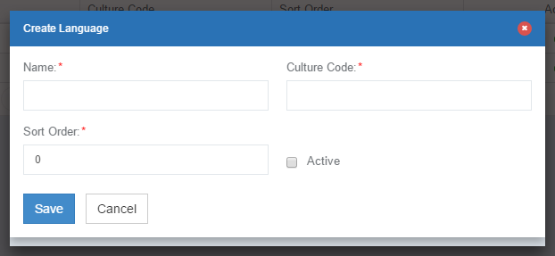

## Manage Localizable Strings

To edit strings in a language, select Translations.

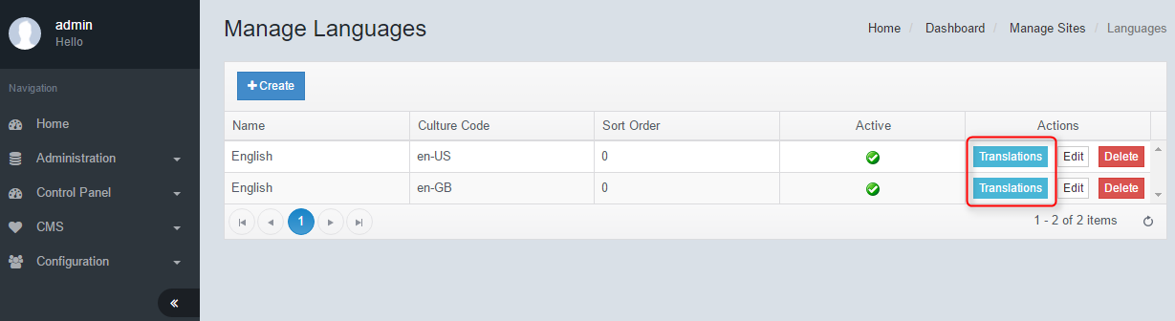

Edit a localized string (#1), and then click Save All (#2).

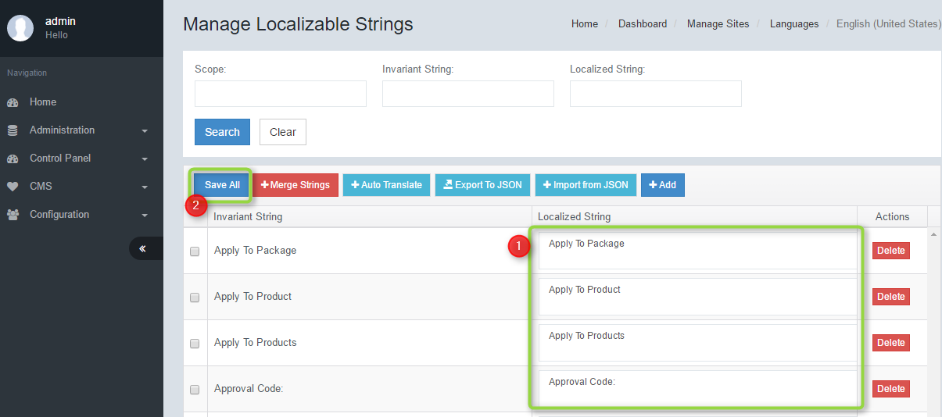

|  |  |  |
| --- | --- | --- |
| **Manage Localizable Strings** | | |
| No. | Function | Description |
| 1 | Search Section | You can drill down to specific translations by filtering based on a combination of the 3 fields below Scope – [Citation needed]  Invariant String – This is the system string value.  Localized String – This is the translated string |
| 2 | Merge Strings | There may be occurrences of duplicated Strings of the same value. When this happens, the system translates based on the first string in the table. To automatically merge duplicate strings, click on this button. The system will automatically match strings and merge them. Strings will not be merged unless they are exactly the same. Even a comma will cause the system to not be merged |
| 3 | Auto Translate | The auto translate function makes use of Google Translate APIs to generate translations for each string. Please note that in many cases the translations may not be relevant to the subject. |
| 4 | Export to JSON | This is a feature to download all the translations into a JSON file that can be manipulated manually using various tools. |
| 5 | Import JSON | The exported JSON file may be uploaded to the engine. Please ensure the format of the JSON file remains intact before importing. |
| 6 | Add | To add a new string not already available in the system. |

## Edit Language

To edit a language, select Edit in Manage Languages. Change the values in the necessary fields and then click Save.

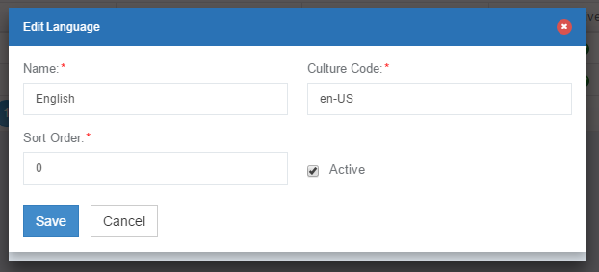

# Pages

The Pages feature is a basic CMS used specific landing pages such as Terms & Conditions. If a more advanced CMS such as composite is used, this feature is redundant and may not function.  
  
Under General, select Pages.

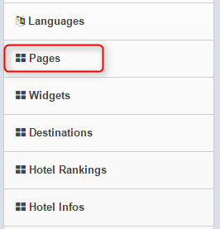  
  
Manage Pages

To create a page, click on Create.

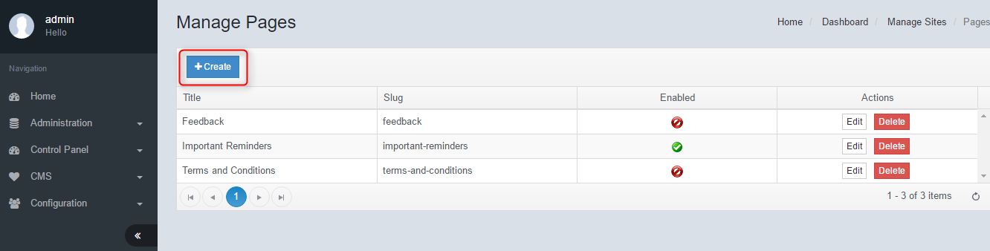

## Create Page

Enter all required fields, then click Save.

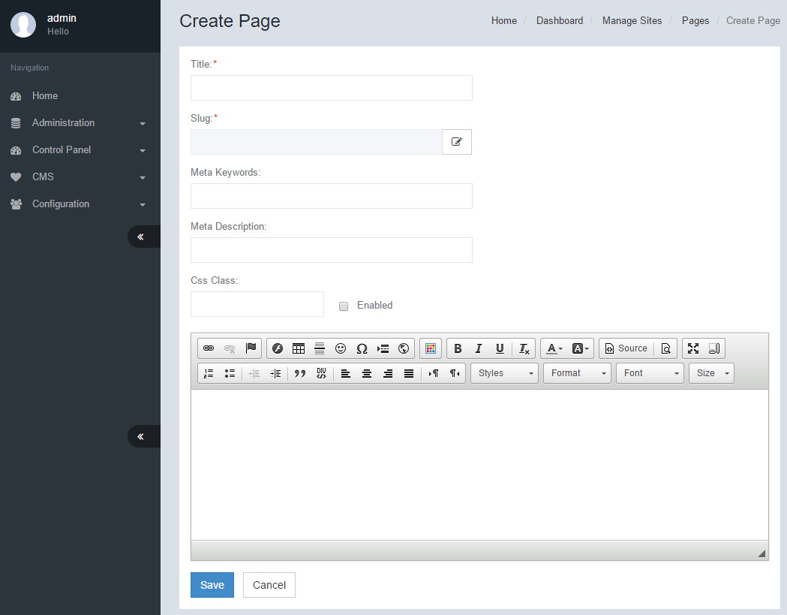

## Edit Page

In Manage Pages, click on Edit.

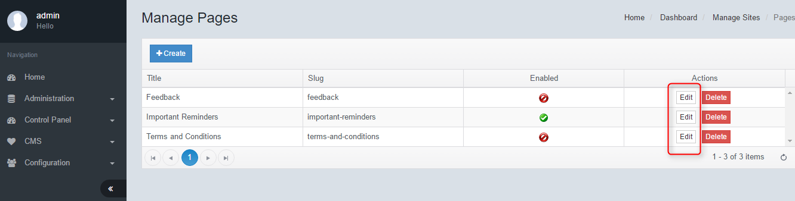  
  
Make changes in necessary fields, then click Save.

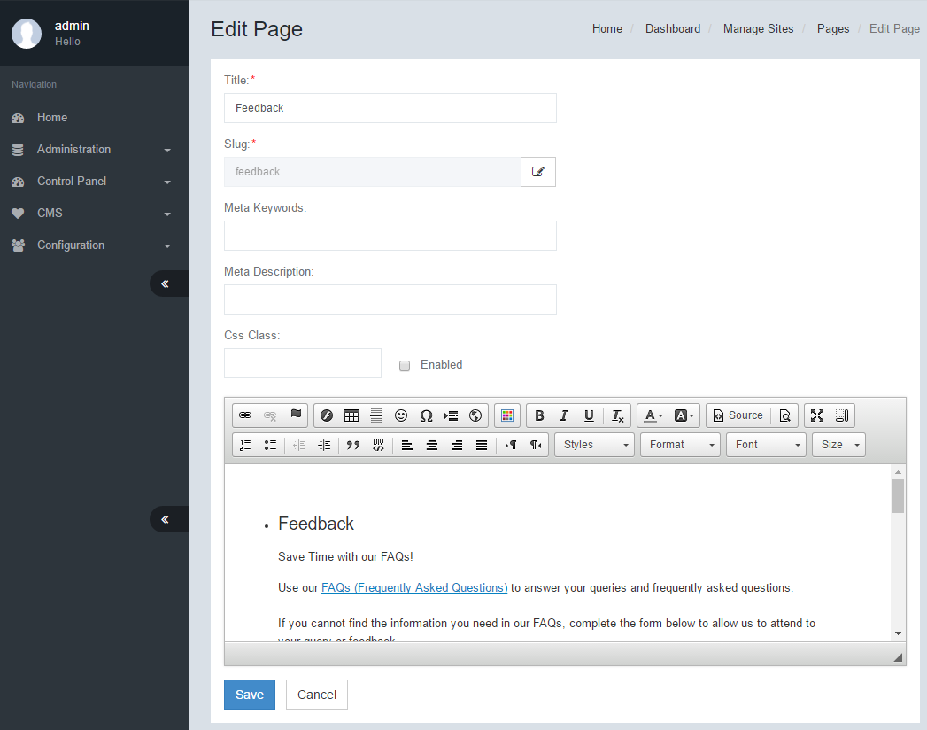

# Widgets

Widgets are used for repeatedly used content such as Headers, Footers and carousels. Google Analytics and other repeated scripts may also be applied using widgets.  
  
Under General, select Widgets.

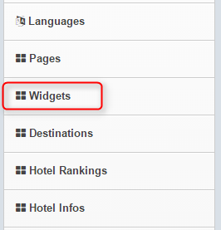

## Manage Widgets

To create a widget, select Create.

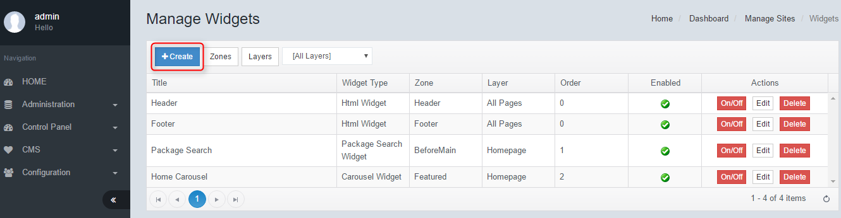

Create Widget  
Enter all required fields, then click Save.

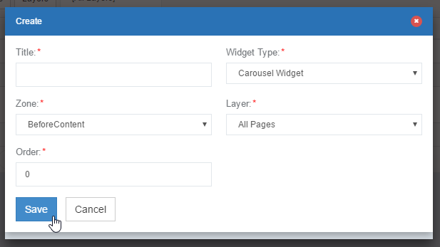

|  |  |  |
| --- | --- | --- |
| **Create Widgets** | | |
| No. | Function | Description |
| 1 | Title | This is the name given for the widget |
| 2 | Widget Type | There are multiple choices of widget templates that may be used to create the widget. Each widget type serves a specific purpose. |
| 3 | Zone | Zones determine which section that the widget will appear in. Zones shall be predefined in the Zone featurette. |
| 4 | Layer | Layers define the landing pages that each widget shall appear. Layers shall be predefined in the Layer featurette. For example, if All pages is selected, the widget will appear in each and every page of the engine. |
| 5 | Order | For each zone, the widget may be set to appear based on the order. 0 being first and 100 being last. |

# Destinations

[This feature has been discontinued]  
Under General, select Destinations.

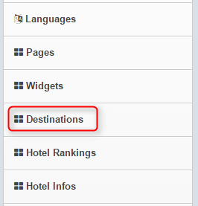

## Manage Destinations

To create a destination, click Create.

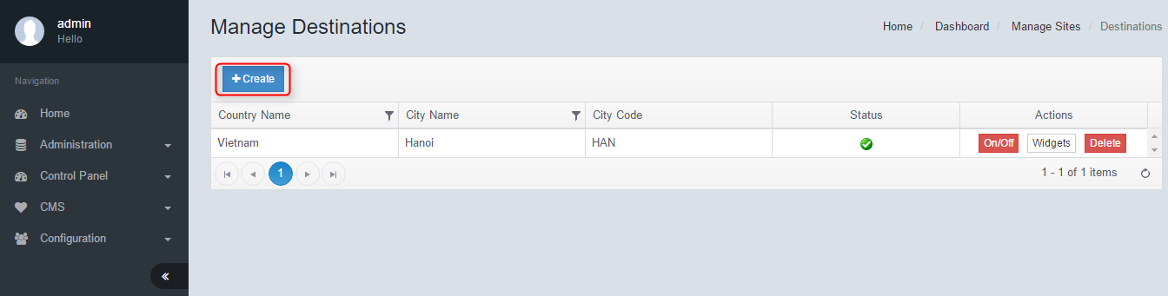

## Create Destination

Select the desired Country Name and City Name, select the Enabled checkbox, then click Save.

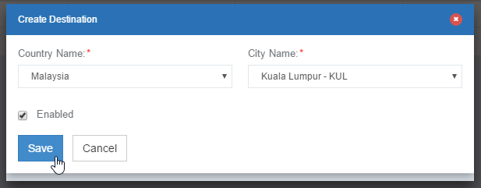

# Email Templates

Under General, select Email Templates.

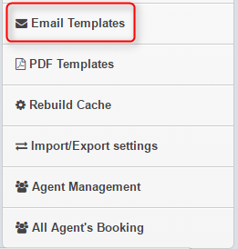

## Manage Email Templates

When a booking is made, a series of emails may be sent out by the engine to various parties. The passenger will receive a confirmation email; or the airline will receive a copy; or a hotel supplier may receive a booking email.  
Each of these emails may be modified according to requirements of the airline; with the ability to setup multiple language templates.  
  
To create an email template, click Create.

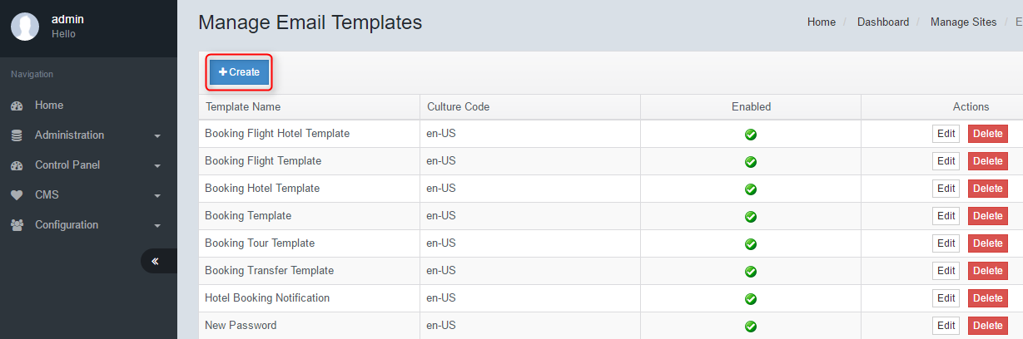

## Create Email Template

Select the desired Template Name and Culture Code, then click Save.

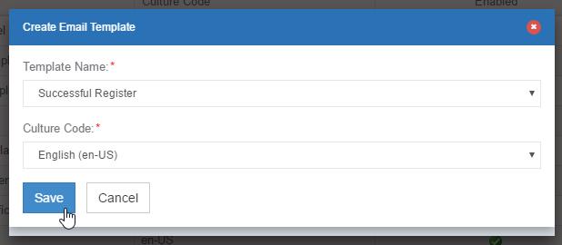

|  |  |  |
| --- | --- | --- |
| **Create Email Template** | | |
| No. | Function | Description |
| 1 | Template Name | A dropdown list of various triggers for the email. An email may be triggered when a particular system state/booking state is reached. For example selecting Booking Template will trigger an email whenever a Flight+Hotel booking is confirmed. It is possible to have multiple emails triggered for the same system state. This will trigger multiple emails per state. For example you may want to trigger a promotional email for every confirmed booking. |
| 2 | Cultre Code | This is the language for the email that will be triggered. |

## Edit Email Template

In Manage Email Template, click on Edit.

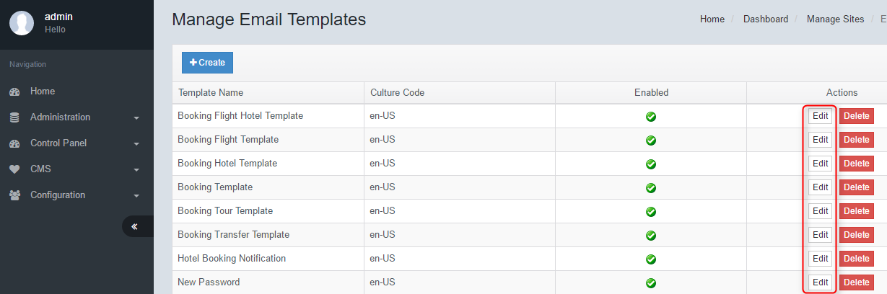

Amend all necessary fields, and click Save.

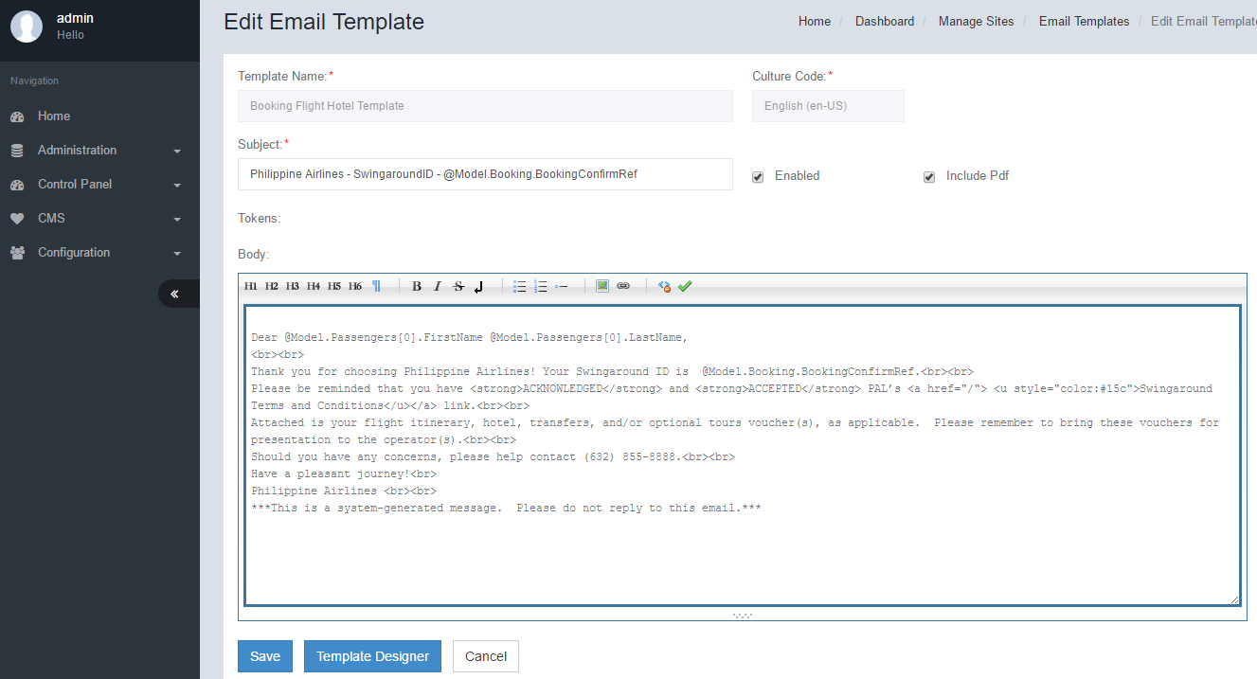

# PDF Template

The PDF template function is used specifically for attaching the booking vouchers, e-tickets and other booking related details that will be emailed to the lead passenger. A bcc copy may be sent to the airline or other 3rd parties as required. The PDF file may be printed for the purpose of Boarding and Check-In.  
  
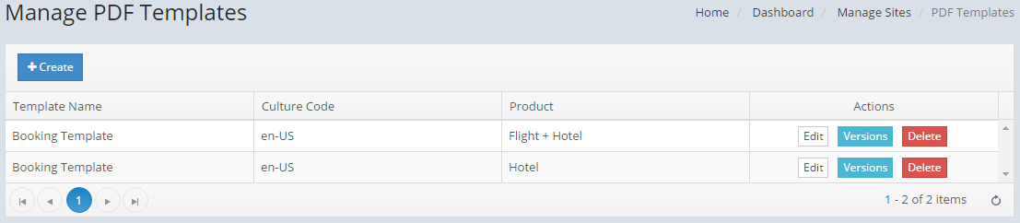  
  
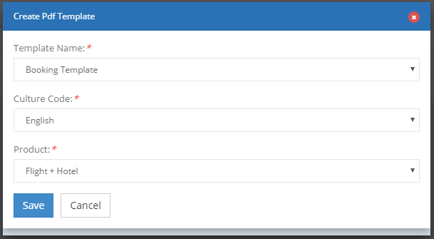

|  |  |  |
| --- | --- | --- |
| **Create PDF Template** | | |
| No. | Function | Description |
| 1 | Template Name | There are currently 2 triggers available for sending out PDFs.  Booking Template and Cancel Booking Template. A predefined template design shall be setup for each trigger and available for multiple language |
| 2 | Cultre Code | This is the language for the pdf that will be triggered. |
| 3 | Product | Each product (Fligt+Hotel, Hotel Only, Tour and Transfer) may have a specific pdf format with predefined details and layout. |

# Rebuild Cache

Clears and rebuilds the engine cache. It is advisable to use this function whenever system changes are done in the Backend.

# Import/Export Setting

This feature is useful whenever the engine needs to be backed up, restored or replicated in its entirety. Once a site has been configured, the system configurations may be exported into a file for backup. The backed up file may be imported into any site.  
Select all desired settings and click Export Configs. A Json file will be available for download in the browser.  
  
To Import, select the Import Settings Tab, select the Json file from your File Explorer and click Import Configs. Clicking “Generate New Identity” will create a new Site. This is useful for setting up staging/testing sites with the same configurations as the production environment.

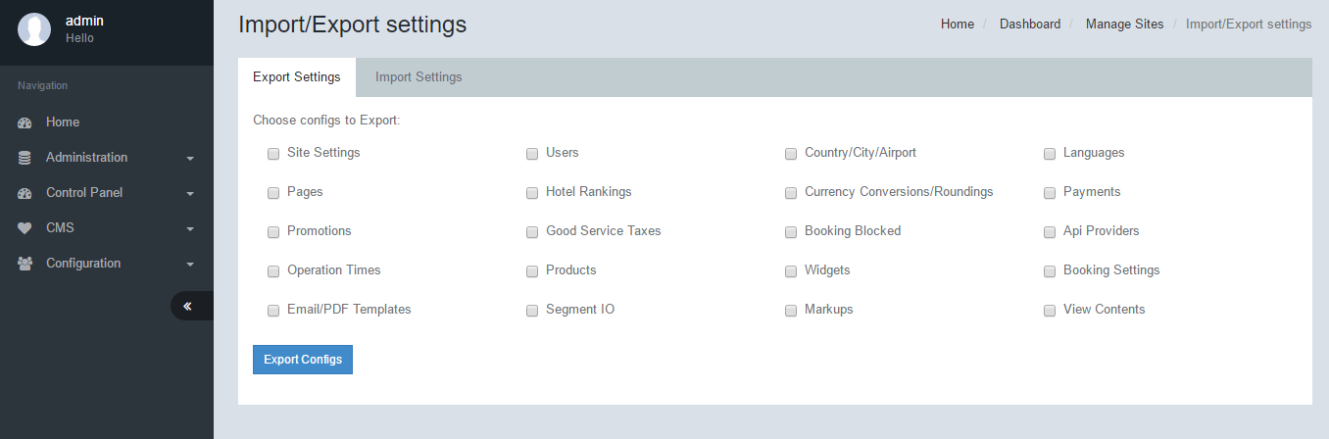

# Agent Management

[This feature is not available at the moment]

## Manage Agents/Create Agent

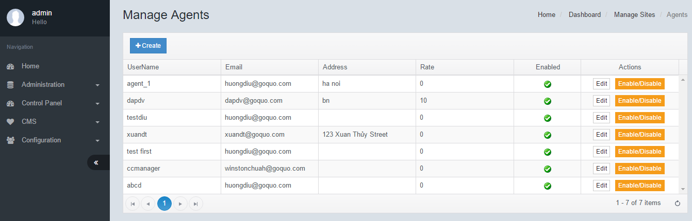

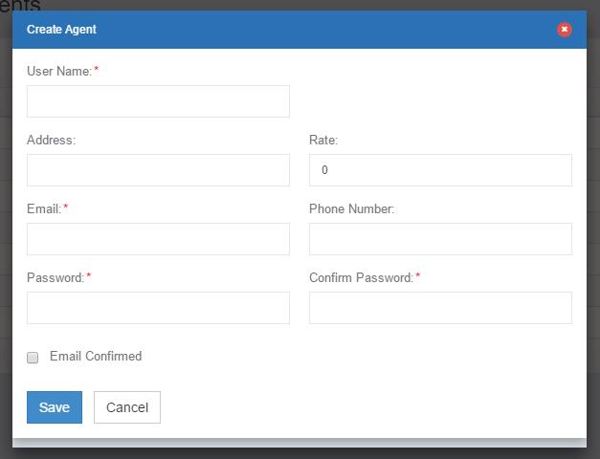

# All Agent’s Booking

Filter out by selecting appropriate fields then click Search.

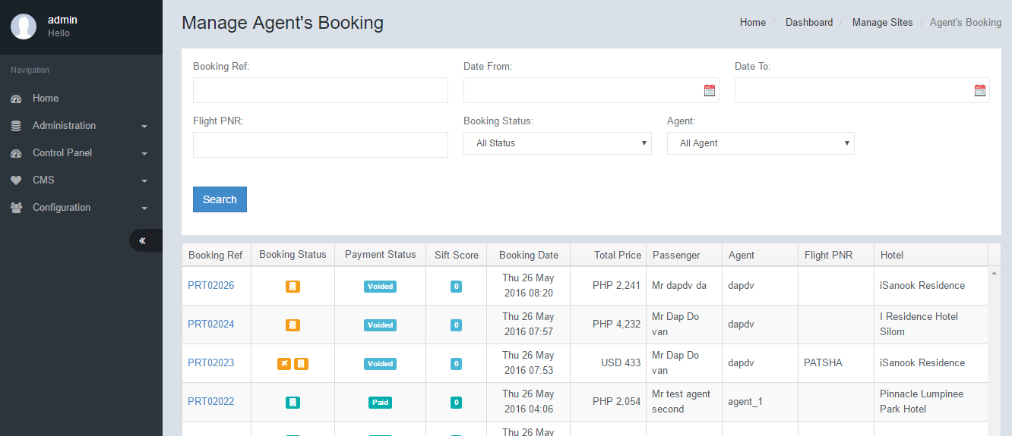

# Currency Settings

The engine supports multiple currencies. You may select multiple currencies that will be supported by the engine. Unchecked currencies will not be handled in the engine query string.  
Select the Default Currency that will be displayed by the engine.  
  
Select all desired currencies to show then click Save.

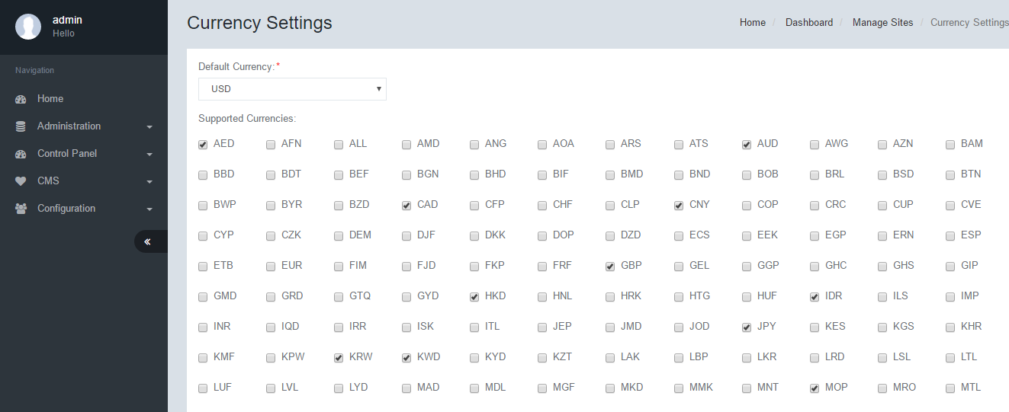  
  
Currency Conversion

The engine will automatically calculate all supported currencies based on the exchange rate that is defined in the table below. You may manually edit each individual currency conversion value by clicking the Edit button. You may also upload the Entire Currency conversion table using an excel template. (To be provided by PM)  
  
To create currency conversion, click Create. To upload currencies, click Upload Currencies.

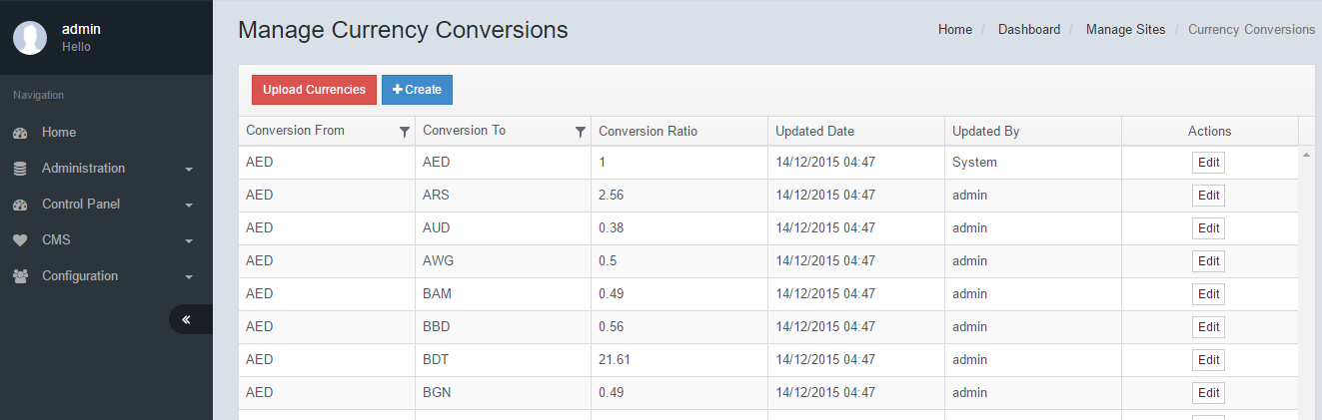

# Currency Roundings

It is possible to round up or down each supported currency. This is useful for currencies where the lowest currency denomination is not supported. Also in some instances due to governmental legislature, currencies have to be rounded up or down.  
  
Adjust currency roundings accordingly then click Save.

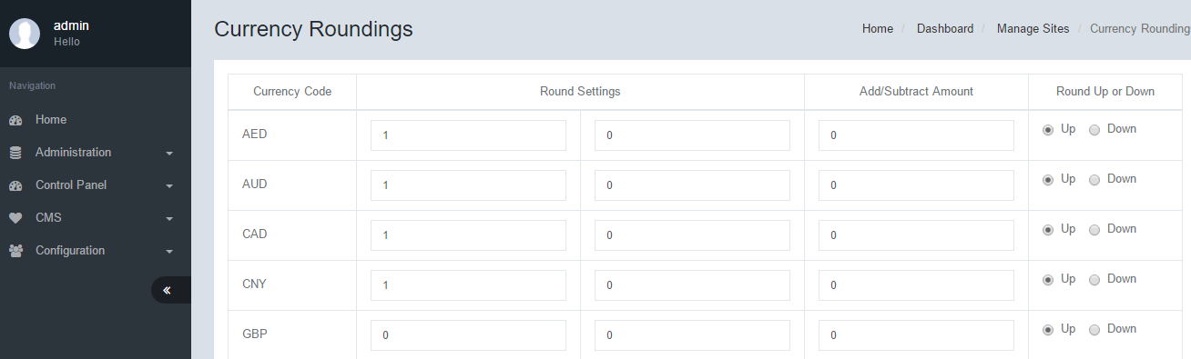

|  |  |  |
| --- | --- | --- |
| **Currency Roundings** | | |
| No. | Function | Description |
| 1 | Rounding Settings | There are 2 columns to be setup. The first column denotes the lowest denominator. The second column denotes the decimal point Eg:  A setting of 10,2, Round Up If the Currency is 62.54 Then rounding will give 70.60 |
| 2 | Add/Subtract Amount | This will add on or subtract a value to the final converted currency. This is commonly used where a bank may apply a currency conversion surcharge. We may also provide discounts to specific currencies in this manner. |
| 3 | Round Up or Down | The system can perform both methods of rounding. |

# Payment Processors

## Manage Payment Processors/Create Payment Processor/Edit Payment Processor

A payment processor is the gateway for the engine to collect payments from a banking provider. A payment connection is setup between the Banking provider’s API. A payment processor is then created to integrate with the client engine. There may be multiple payment processors setup for each bank and payment method.

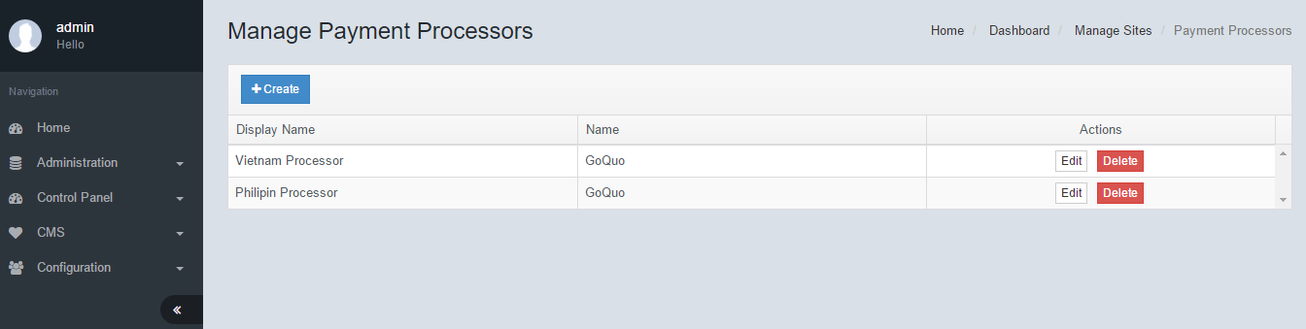

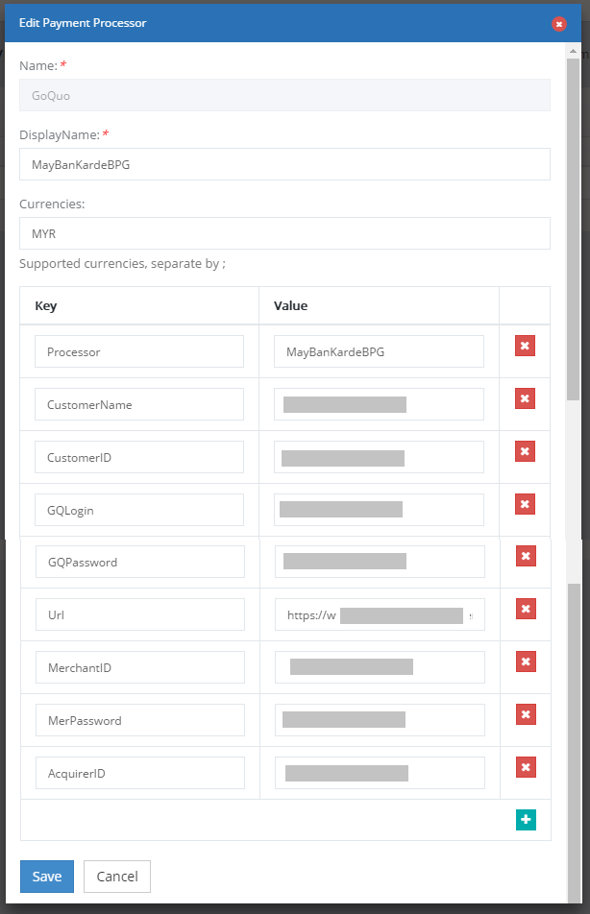

# Payment Methods

## Manage Payment Methods/Create Payment Method

Once a Payment processor has been setup, a corresponding payment method is setup. The payment method is the choice given to the passenger for making their payment. For example VISA, MasterCard, ATM, 3rd Party Provider, Cash.

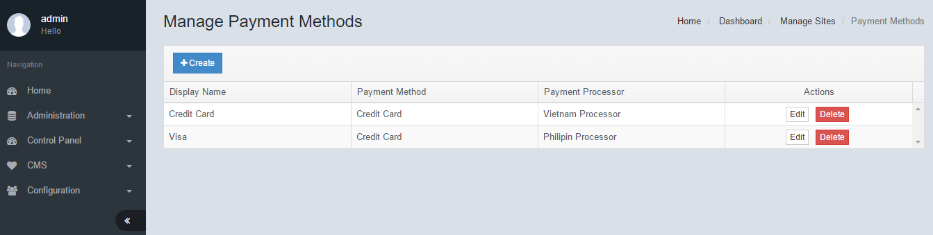

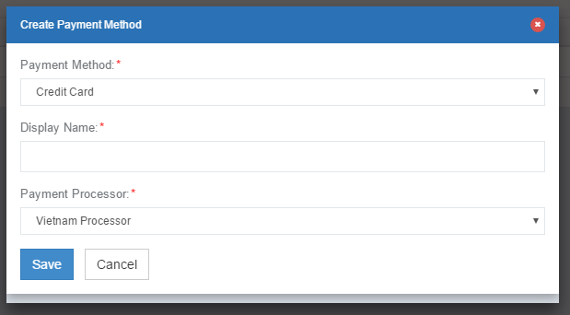

|  |  |  |
| --- | --- | --- |
| **Create Payment Method** | | |
| No. | Function | Description |
| 1 | Payment Method | There are 2 options for setting up a payment processor.  - Credit card is a direct collection method - Redirect is a method that will redirect the payment collection process to a provider. |
| 2 | Display name | The Name that will appear to the passenger |
| 3 | Payment Processor | The payment processor that will be used to handle this payment method. (see Payment Processor) |

# Card Types

## Manage Card Types/Create Card Type

The engine can be setup to only handle certain Card Types. You must first create a card type before assigning to a payment processor.

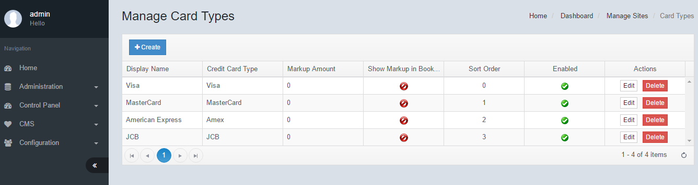

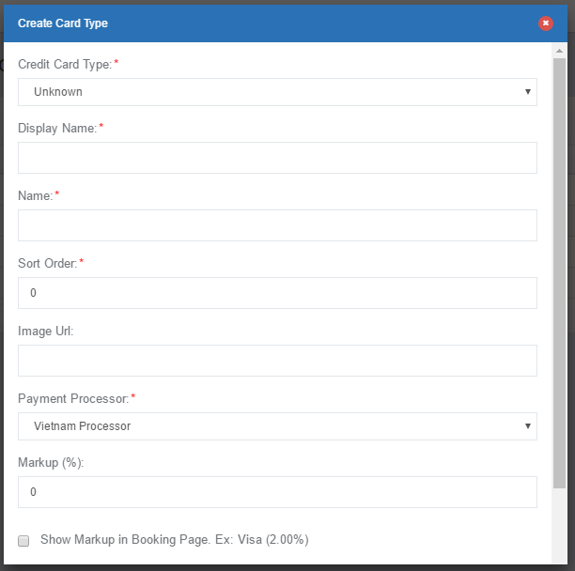

|  |  |  |
| --- | --- | --- |
| **Credit Card Type** | | |
| No. | Function | Description |
| 1 | Credit Card Type | This is the Card type that is being created. The dropdown list presents the most common credit cards available. The “Other Type” may be used for local banks |
| 2 | Display Name | The name of the card that will be displayed to passenger. |
| 3 | Name | System name of the card |
| 4 | Sort Order | This is the order in which the cards will appear to passenger |
| 5 | BIN Cards | This is the list of BIN numbers that are allowed for this card type. |
| 6 | Image URL | The icon that will be displayed during the payment process |
| 7 | Payment Processor | The payment processor that will be linked to the card type. |
| 8 | Markup (%) | A markup may be added to the final package total for the card selected. This is commonly used for merchant bank card charges. |
| 9 | Show Markup in Booking Page | The markup applied to credit card may be displayed or hidden from the passenger. By checking the box the markup value will be displayed. |
| 10 | Is Capture Card Details | The engine is able to capture card details and store it for future reference. Due to legal/banking requirements it may be necessary to hide these values. Check the box to capture card details. |
| 11 | Enabled | Check this box to enable the Credit card option. |

# Payment Gateways

## Manage Payment Gateways/Create Payment Gateway/Edit

The payment gateway needs to setup in order to use the payment option in the booking process. The payment gateway feature allows the client to setup various behaviours of the Credit card.

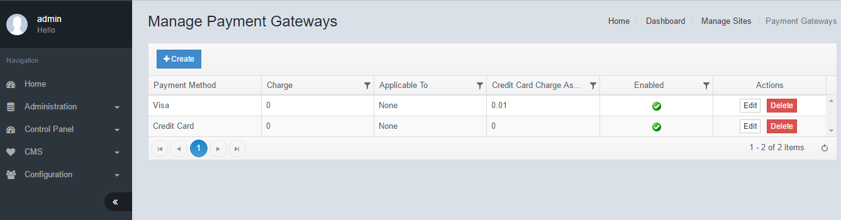

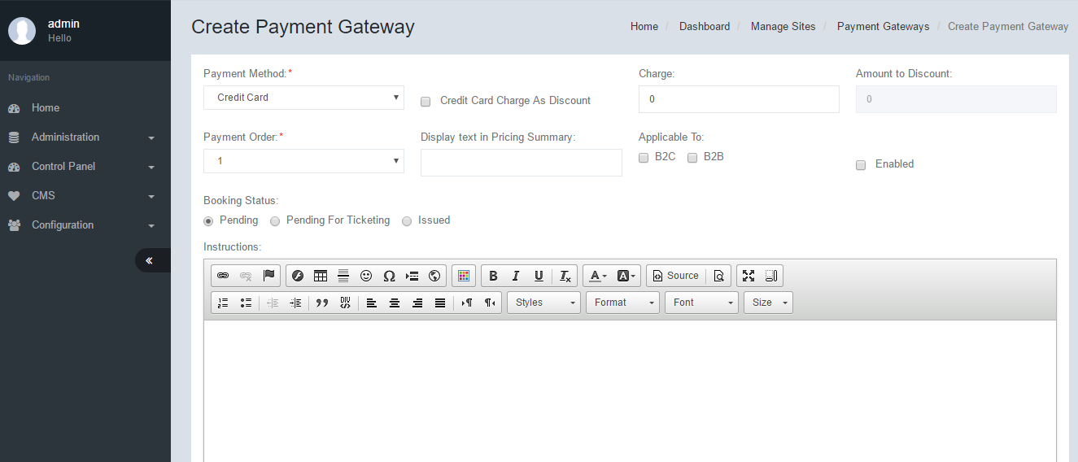

|  |  |  |
| --- | --- | --- |
| **Create Payment Gateway** | | |
| No. | Function | Description |
| 1 | Payment method | The payment method that is tied to this payment gateway. See Payment Method |
| 2 | Credit Card Charge As Discount | An additional credit card charge or discount may be applied to the credit card. This is a fixed value that can be configured. Check the box to setup discount value. Uncheck to setup charge value. |
| 3 | Charge | The charge value that will be applied to the credit card |
| 4 | Amount to Discount | The discount value that will be applied to the credit card |
| 5 | Payment Order | The order in which the payment gateway will appear in the booking page |
| 6 | Display text in Pricing Summary | A corresponding text may be displayed or each payment gateway in the Pricing summary section of the booking page. |
| 7 | Applicable to | The credit card will appear as an option for either B2C or B2B or both. |
| 8 | Enabled | Check this box to enable the Payment Method |
| 9 | Booking Status | Upon successful payment, the booking status will be set as either Pending, Pending for Ticketing or Issued. |
| 10 | Instructions | Some text or content can be displayed as instructions for the payment method. |
| 11 | Instruction Text in Thanks Page | Some text or content can be displayed as instructions for the payment method. This text will appear in the Thank you page. |
| 12 | Products | The payment gateway may be setup to only appear when specific products are selected. The options available, can be set in any combination or all. |
| 13 | URL Image | The URL of an image to be displayed for this payment gateway. |

# Promotion Codes

## Manage Promotion Codes/Create Promotion Code

For marketing purposes, it is possible to setup promotion codes that can be used by passengers to gain further discounts to any combination of the products. Promotions may be setup by Booking Period and Travel Period.

To create a promotion code, click Create. Enter all necessary fields, then click Save.

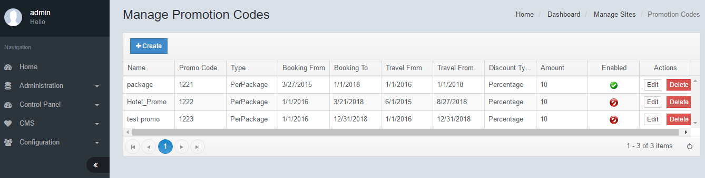

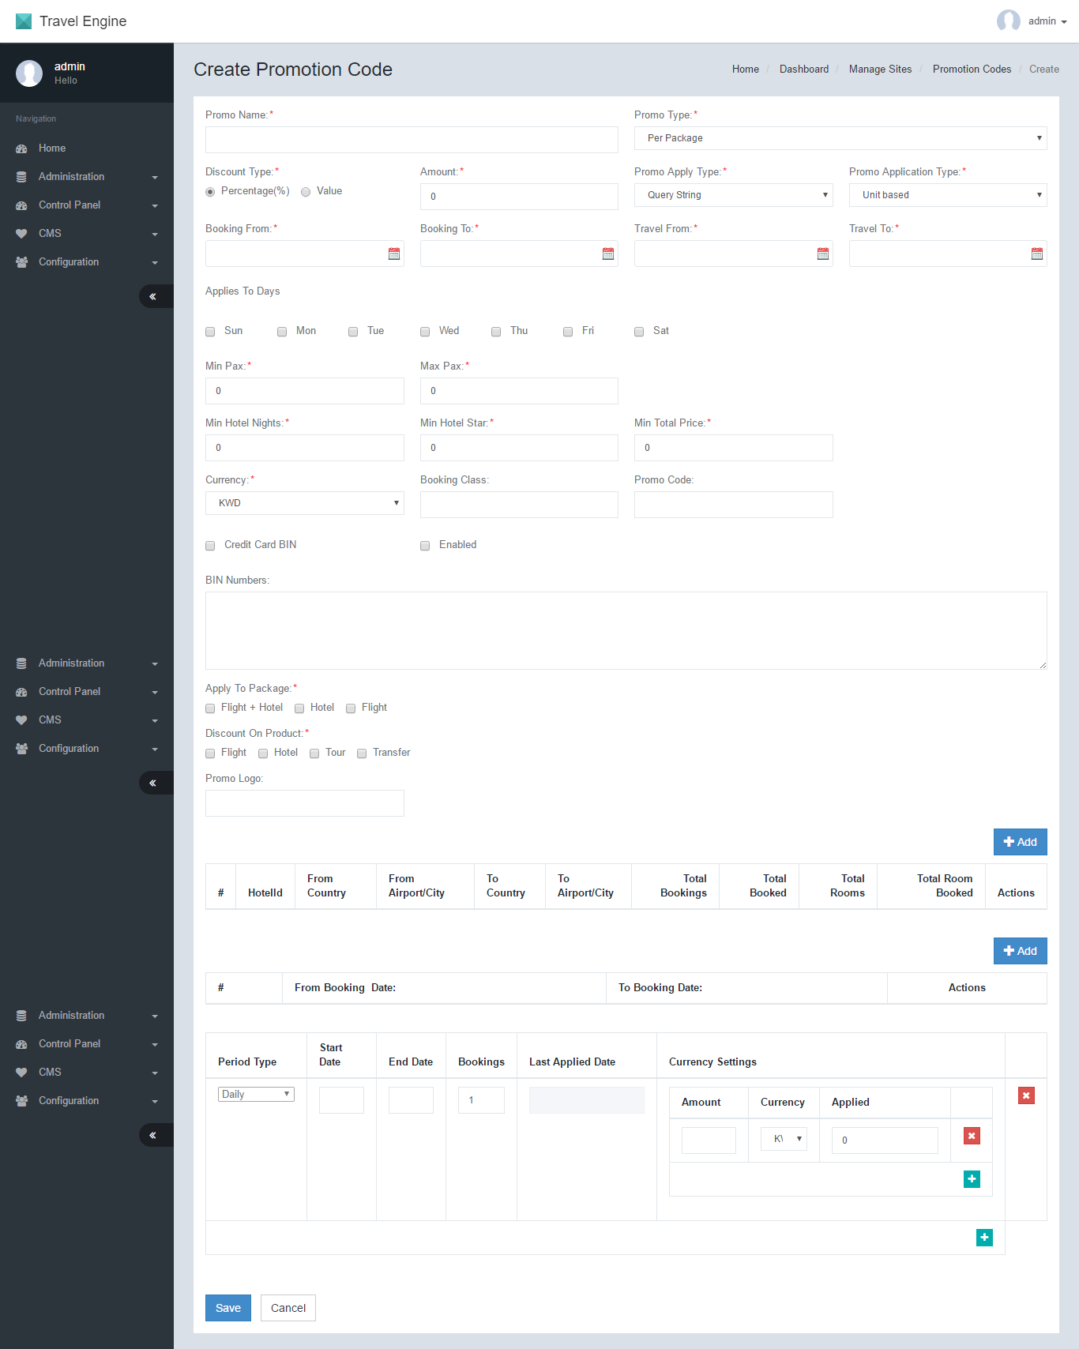

|  |  |  |
| --- | --- | --- |
| **Create Promotion Code** | | |
| No. | Function | Description |
| 1 | Promo Name | The name assigned to the promo code. NOT the actual promo code |
| 2 | Promo Type | This promo code calculation will be applied based on 2 options **Per package** – The promo code will be applied based on the total package price  **Per person** – The promo code will be applied based on the per person price.  [Citation needed for calculation] |
| 3 | Discount Type | You may setup the promo discount calculation based on percentage or value of the package price. |
| 4 | Amount | The discount Percentage or Value that will be applied. |
| 5 | Promo Apply Type | **All** – The promo code may be input at the booking stage or from query string **Query string** – the promo code will only work if applied from query string  When promo code is applied in the query string the discounted value of the package is automatically displayed at the Availability page. This is useful for marketing campaigns where the URL is provided. |
| 6 | Promo Application Type | **Unit Based -**  **Booking Based -**  [Citation needed] |
| 7 | Booking From | The promo code will only work if the booking is made on this date onwards. |
| 8 | Booking To | The promo code will only work if the booking is made on this date and before. |
| 9 | Travel From | The promo code will only work if the travelling date falls on this date onwards |
| 10 | Travel To | The promo code will only work if the travelling date falls on this date and before. |
| 11 | Applies to Days | You may setup the promo code to only work for specific travel dates. This is important whenever there are special weekend prices, for example. |
| 12 | Min Pax | The promo code will work only if the travelling party has a minimum of this number of passengers. |
| 13 | Max Pax | The promo code will NOT work if the travelling party exceeds the maximum number of passengers. |
| 14 | Min hotel Nights | The promo code will NOT work if the stay is less than this number of nights |
| 15 | Min Hotel Star | The promo Code will NOT work if the Star rating of the hotel is less that this value |
| 16 | Min Total Price | The promo code will NOT work if the Package price is less than this value |
| 17 | Currency | You can set the promo code to ONLY work for specific currencies. This is useful for setting up country/currency based campaigns |
| 18 | Booking Class | You can setup the package to only work for specific Airline booking classes. You may setup multiple classes by separating them with “;” [Citation needed] |
| 19 | Promo Code | The actual promo code that will be keyed in to booking page or the query string |
| 20 | Credit Card BIN | To enable Credit card BIN feature, tick this box. When you enable this, the promo code will only work if the passenger uses a credit card that matches the BIN Numbers in the field #22 |
| 21 | Enabled | To enable the promo code tick this box. |
| 22 | BIN Numbers | You can limit the promo code to only work with specific credit card BIN ranges. Separate multiple BIN ranges by “,” |
| 23 | Apply To Package | The promo code can be applied to a combination of products. Select the products that the promo code is applicable to. When selected, the promo code will ONLY work if the product is selected |
| 24 | Discount on Product | The percentage or value discounted will be applied to only the products that are selected. Please select the product that you want the calculations |
| 25 | Promo Logo | The promo logo will appear in the front end [Where?]. Enter the URL location of the promo code. |
|  |  |  |
| Promo Filter The engine is able to make the promo code work for specific hotels, countries or cities. Only items on this list will be allowed access. Multiple lines may be added as required for the promo code. | | |
|  | Hotel ID | Internal GoQuo ID that identifies the hotel |
|  | From Country | This is the origin country for the promo code. When a country code is input, the promo code will only work if the package Origin country falls in this category. |
|  | From Airport/City | This is the origin airport or city for the promo code. When an airport or city code is input, the promo will only work for that selection |
|  | To Country | This is the destination country for the promo code. When a country code is input, the promo code will only work if the package destination country falls in this category. |
|  | To Airport/City | This is the destination airport or city for the promo code. When an airport or city code is input, the promo will only work for that selection |
|  | Total Bookings | This is the Total number of bookings allowed for this promo code. Once the number of bookings is reached, no further bookings will be allowed for this filter. |
|  | Total Booked | This is the number of bookings that have been made under this filter condition to date. |
|  | Total Rooms | This is the Total number of Room nights allowed for this promo code. Once the number of room nights is reached, no further bookings will be allowed for this filter. |
|  | Total Room Booked | This is the number of bookings that have been made under this filter condition to date. |
|  |  |  |
| Blackout Filter  The blackout filter suppresses the promo code from working within the Travel period. For example, there is a special holiday or period in between, where the promotion is no valid. You may add multiple lines for multiple blackout periods. | | |
|  | From Date | The starting date of the travel blackout |
|  | To Booking Date | The ending date of the travel blackout. |
|  |  |  |
| Period Filter [Citation needed] | | |
|  |  |  |

# Good Services Taxes

Many countries have applied special taxes such as Goods and Services Tax. The engine is able to handle the tax calculations based on the values that have been defined. Multiple taxes may be defined for each product and country code.  
[@ajanth, we are unable to setup/modify the value]

## Manage Good Services Taxes/Create Good Services Taxes

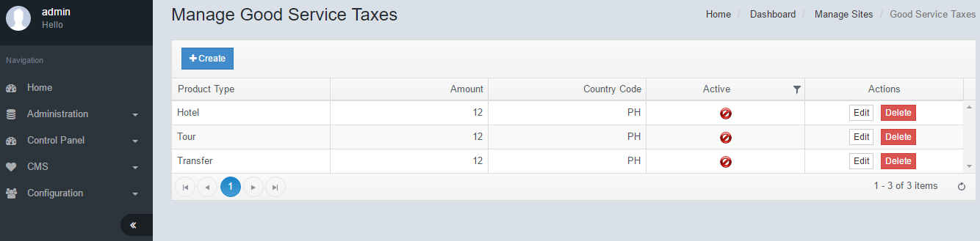

Select appropriate Product and Country Code then click Save.

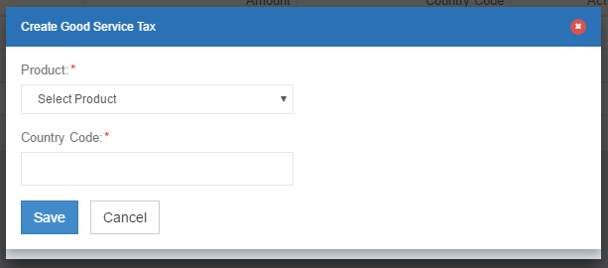

## Edit Good Services Taxes/Create Good Services Taxes

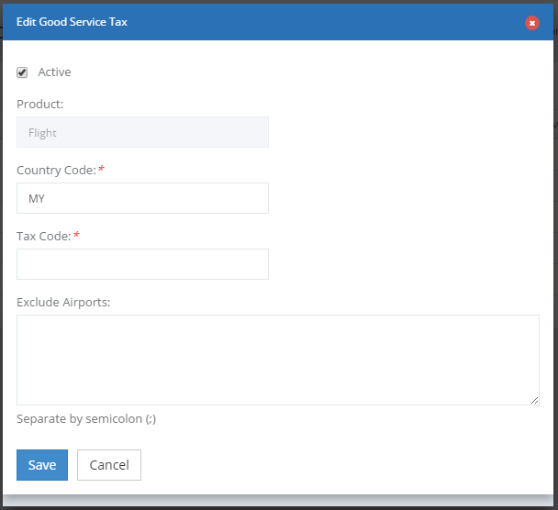

|  |  |  |
| --- | --- | --- |
| **Edit Good Service Tax** | | |
| No. | Function | Description |
| 1 | Active | Check this box to activate the Service Tax |
| 2 | Product | Select the product which the service tax is applicable for. |
| 3 | Country Code | Select the country code which this tax is applicable to. The tax calculation will only be applied to the Country code selected |
| 4 | Tax Code | The tax code that is used for this service tax |
| 5 | Exclude Airports | It is possible to add a list of airports where the tax code is not applicable to. For example there is a duty free airport where there are no taxes applied.  [Is this origin or destination?] |

# Booking Fields

It is possible to define a variety of fields for the passenger to input at the booking stage. The settings may be applied to various categories, by product or even by route. This facilitates a specific requirement be setup for each scenario as determined by the airline, banks or legislature.

## Manage Booking Fields/Create Booking Fields

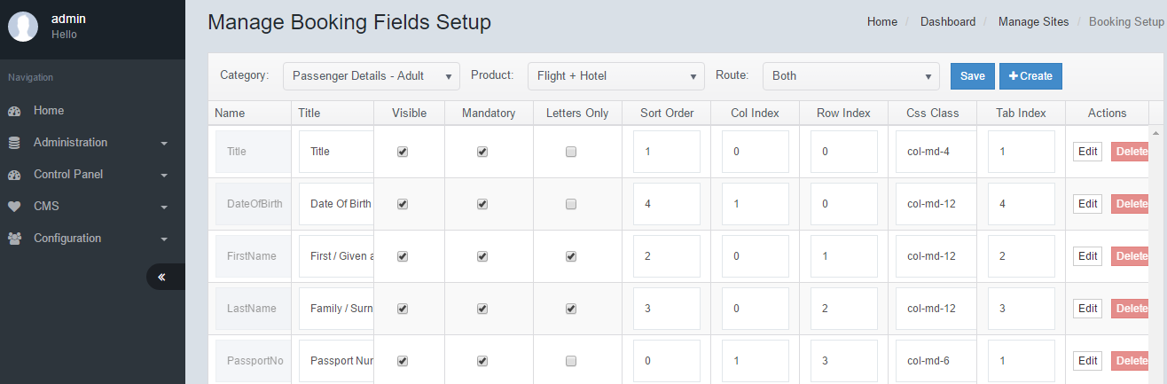

Enter all necessary fields, then click Save.

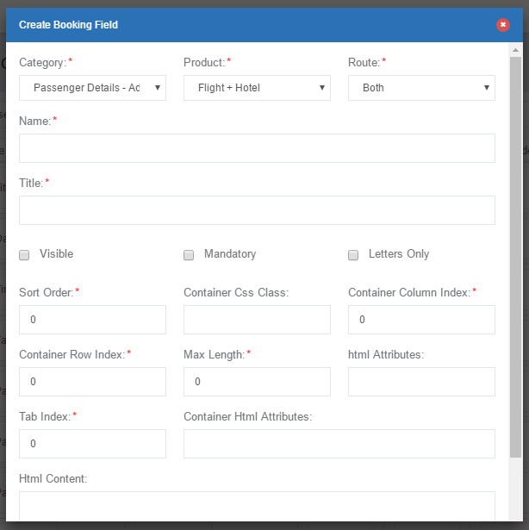

|  |  |  |
| --- | --- | --- |
| **Create/Edit Booking Field** | | |
| No. | Function | Description |
| 1 | Category | For each of the categories below, you may setup individual fields **Passenger Details – Adult :**  For each adults details **Passenger Details – Child:** For each child details  **Passenger Details – Infant:** for each infant details  **Personal Details:** The lead passenger details  **Billing Details:** Billing details  **Contact Information:** Lead passenger contact details |
| 2 | Product | For each of the products you may setup respective booking fields for each Category in #1  Flight+Hotel, Hotel, Tour Package. |
| 3 | Route | For each category and product you may setup different fields for Domestic, International or Both. |
| 4 | Name | The name of the booking field. You may add customized fields as needed for each Category, Product and Route. |
| 5 | Title | The title that will appear to the passenger in the booking page |
| 6 | Visible | To enable or disable particular fields from the booking page |
| 7 | Mandatory | If this box is ticked, the passenger MUST fill up the field to proceed with the booking |
| 8 | Letters Only | If the field will only accept Alphabets, then tick this box. |
| 9 | Sort Order | This is the order of appearance for each field; where 0 is first and 99 is last. |
| 10 | Container Css Class | This is the CSS container that defines how the field will appear in the booking page. |
| 11 | Container Column Index | This is the column order for each field in their respective row |
| 12 | Container Row Index | This is the row order for each field. |
| 13 | Max Length | This is the maximum character length for the field |
| 14 | Html attributes | You may assign customized html attributes to each field. For example to bold or italicize a particular field |
| 15 | Tab Index | This is the order in which the cursor will advance once the keyboard tab is depressed. |
| 16 | Container Html Attributes | You may assign customized html attributes for the entire container where the fields are held. |
| 17 | Html Content | Further customized html content may be added for tagging or other purposes. |

# Booking Settings

This feature sets up the engine behaviour in handling bookings. It will determined the way payments are handled; and post booking activities such as email handling.

To edit Booking Settings, amend all necessary fields then click Save.

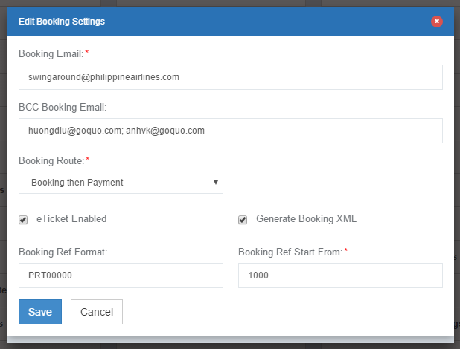

|  |  |  |
| --- | --- | --- |
| **Edit Booking Settings** | | |
| No. | Function | Description |
| 1 | Booking Email | The email address which will send and receive all emails related to bookings such as the Confirmation Email, Email Vouchers, Failure notifications and so on. The recipient will see the Booking email as the From Address. |
| 2 | BCC Booking Email | The list of addresses which will receive a copy of the above. These addresses are hidden from the main recipient. Separate each email with “,” |
| 3 | Booking Route | **Payment then booking –** The API calls for product bookings will only be generated after the payment gateway receives a success confirmation **Booking then payment –** The API calls for product bookings will be generated regardless of the success or failure of the payment. |
| 4 | eTicket Enabled | Select this option to generate an eTicket once the booking has been made. |
| 5 | Generate Booking XML | Select this option to generate the booking XML which will be sent to the hotel supplier. [Citation needed] |
| 6 | Booking Ref Format | Each booking will have a corresponding booking ID. This booking reference number may be defined according to requirements.  eg: ABC0000 will generate a sequence of ABC0000 to ABC9999. [Is it possible to setup AB000C00??] |
| 7 | Booking Ref Start From | The first booking reference number in the sequence. eg: IF ABC0000 was set in #6 and Start from 0999 THEN the first booking booking will be ABC0999 |

# Blocked BIN Cards

This is a fraud security protection mechanism for the engine. It is possible to block a series of BIN numbers to ensure bookings will not be made if the card is used as a payment option. If Apply for All Sites is checked, it will block the series in all Airlines using the same booking engine.  
[Can we block specific cards?]

## Manage Blocked BIN Cards/Create Blocked BIN Card

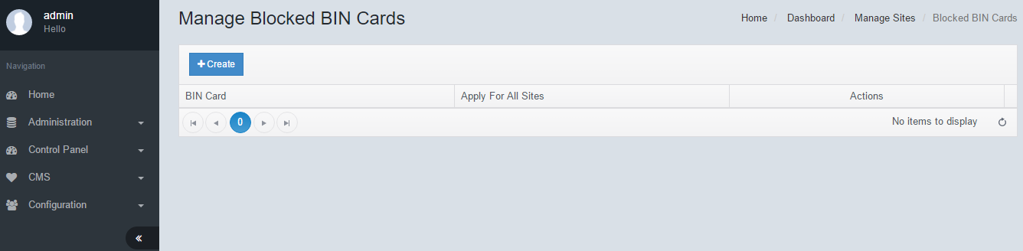

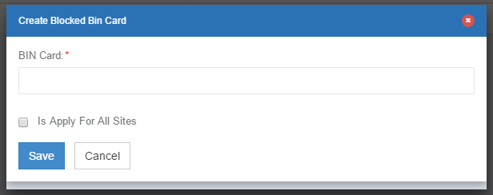

# Blocked Emails

This is a fraud security protection mechanism for the engine. It is possible to block email addresses in the system. If this email address is used for the purpose of making a booking, the engine will reject it. If Apply for All Sites is checked, it will block the series in all Airlines using the same booking engine.

## Manage Blocked Emails/Create Blocked Email

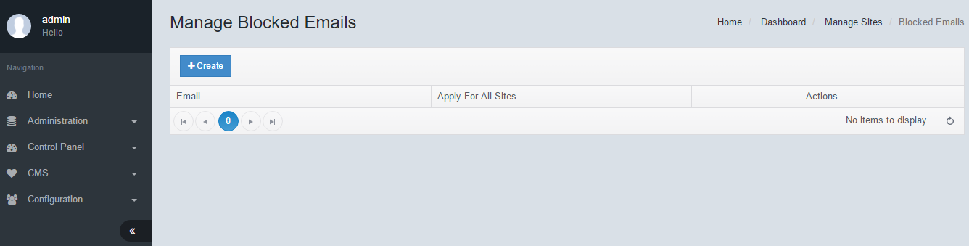

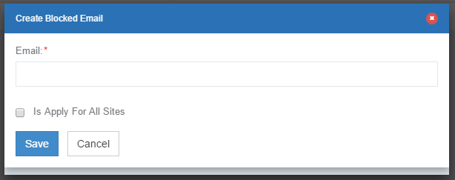

# Blocked IP Addresses

This is a fraud security protection mechanism for the engine. It is possible to block IP addresses in the system. If a passenger tries to make a booking from the blocked IP address, the engine will reject it. [No apply to all sites]

## Manage Blocked IP Addresses/Create Blocked IP Address

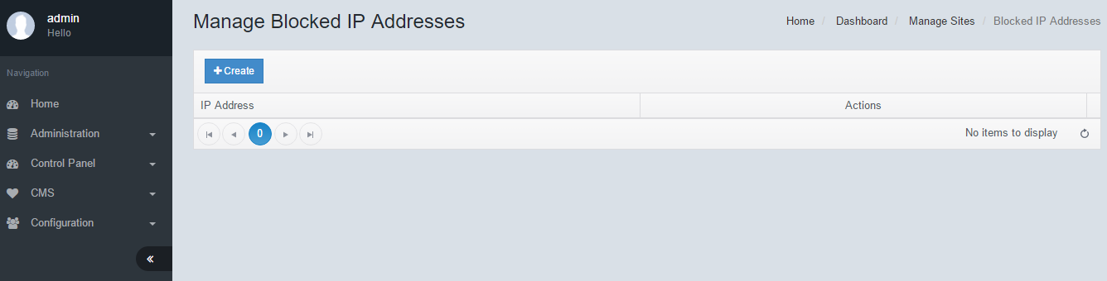

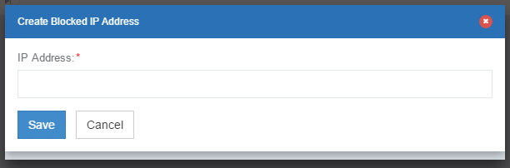

# Customer Management

This is the database of customers who have made bookings in the booking engine. All details about the passenger including their personal details, address, friends & family and any historical payment details.

## Manage Customer Information

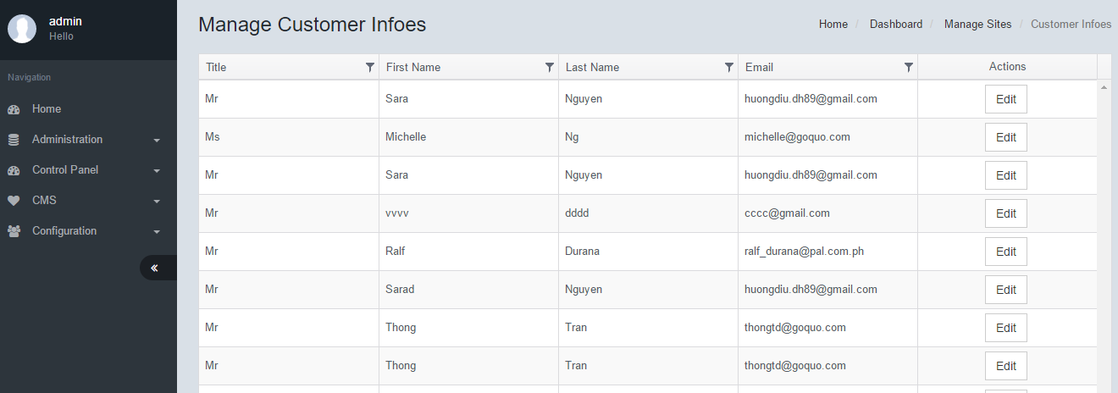

To edit Customer Information, click on Edit, enter all necessary fields, then click Save.

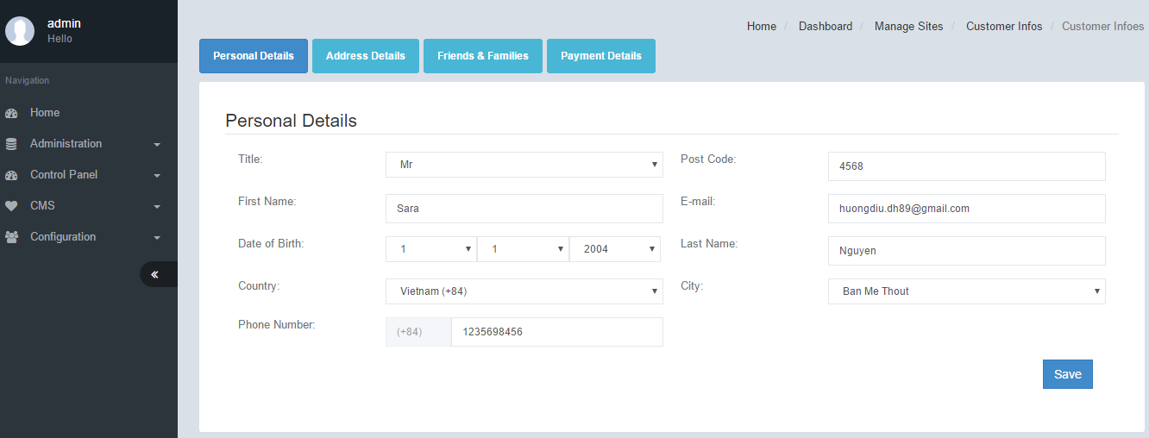

# Customer Subscription

The engine has a built in database for storing Customer Subscription Details. This data can then be exported to a 3rd party CRM system such as Mailjet, Mailchimp and others.

## Manage Customer Subscription

To Export Data, click on Export Data.

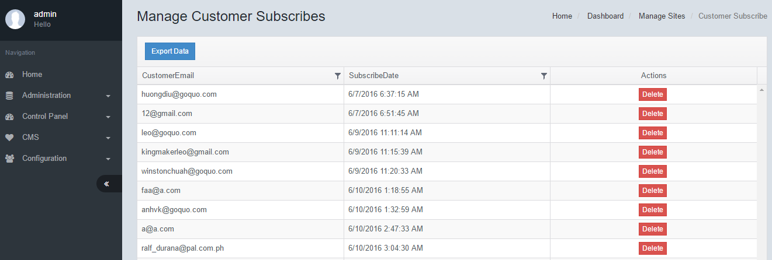

# SMTP Settings

The SMTP settings for email services. The engine will use this SMTP settings to send emails such as confirmation email, vouchers and so on. Enter all necessary fields, click Save.

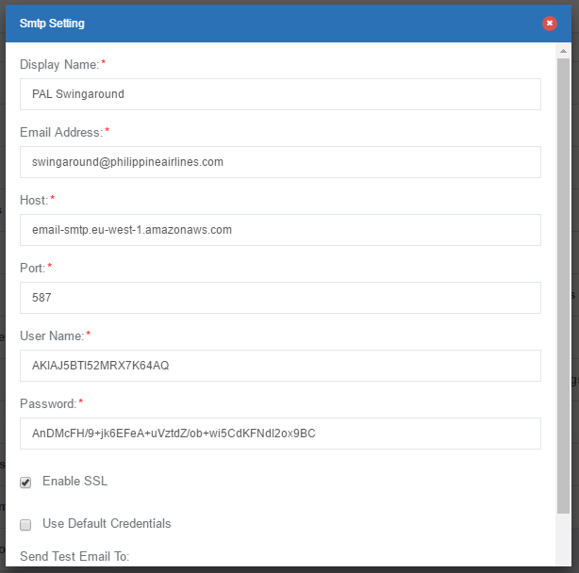

# Message Service Setting

This is the SMS service system settings. Currently not in use.

## Manage Message Service Settings/Create Manage Message Service Setting

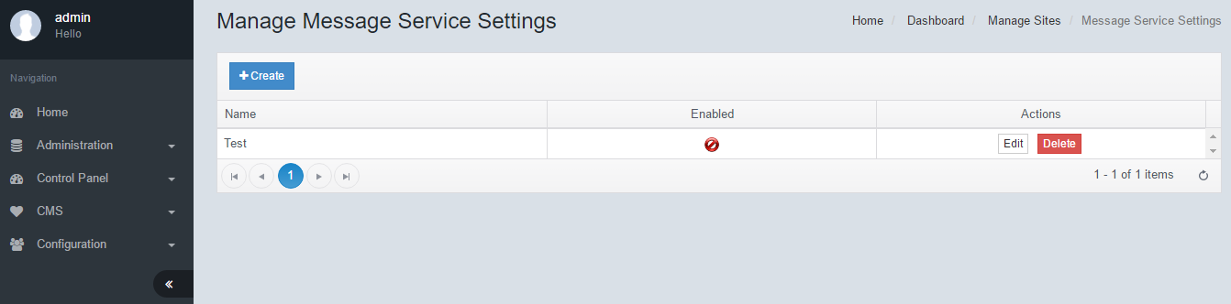

To create a Message Service Setting, click Create. Enter all necessary fields, then click Save.

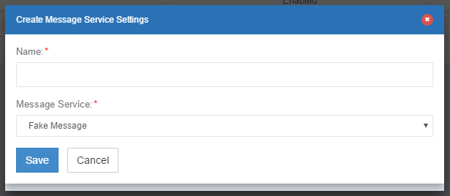

# Booking Management

The booking management feature is a comprehensive feature for viewing, editing and managing various details of each and every booking made in the system. Each booking is stored individually and may be drilled down to view further details about the booking. System operators may verify the status of bookings as well as make changes as required/allowed by policy. The system also keeps track of logs and user changes. Operators may also make notes for each booking.

## Manage Bookings

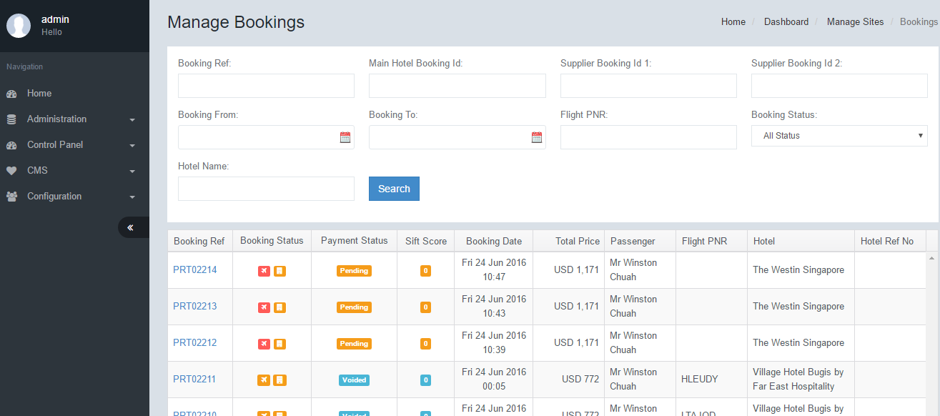

To view more details of a booking, click on the respective Booking Ref. The filter feature at the top allows the user to drill down to a particular booking based on the available fields. A combination of fields may be used to perform the search.  
Additionally the results grid is sortable by clicking the header title. Each time the header is clicked it will sort ascending or descending.

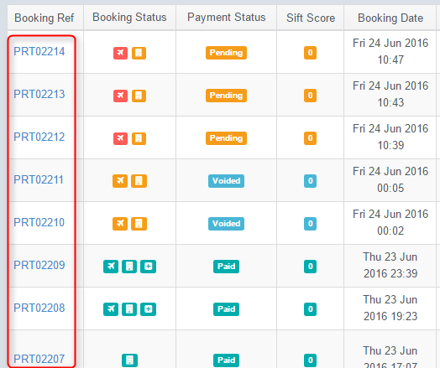

|  |  |  |
| --- | --- | --- |
| **Manage Bookings** | | |
| No. | Function | Description |
| 1 | Search | You can filter bookings by keying in a combination of each of the fields. This helps to further drilldown to specific Bookings or groups of bookings based on predefined criteria. |
| 2 | Booking Ref | Unique identified for each booking made. |
| 3 | Booking Status | The booking status field displays all the products which were purchased for this booking. Each icon represents the status of individual products.  Flight Ticket  Hotel  Insurance  The colour of each icon depicts the status of the product  This color denotes Success status  This color means Pending status  This color denotes Failure status |
| 4 | Payment Status | Paid – The payment status is completed succefully  Pending – The payment status is pending.  Fail – The payment has failed |
| 5 | Sift Score | This is a special payment scoring system for fraud protection. A high score denotes a high risk. There a various algorithms which are used. |
| 6 | Booking Date | This is the date and time which the booking was made. This is based on Date Settings, Time Zone. |
| 7 | Total Price | This is the total package price. |
| 8 | Passenger | The name of the lead passenger |
| 9 | Flight PNR | The PNR of the flight that is generated during booking. |
| 10 | Hotel | The name of the hotel that was booked |
| 11 | Hotel Ref No | The booking reference number of the Hotel Supplier. |
| 12 | Supplier View | When a booking is made, an email is sent to the hotel supplier. A link is provided for the hotel to respond that they have received the email. If they click this link, the status will be Green. |

## Reservation

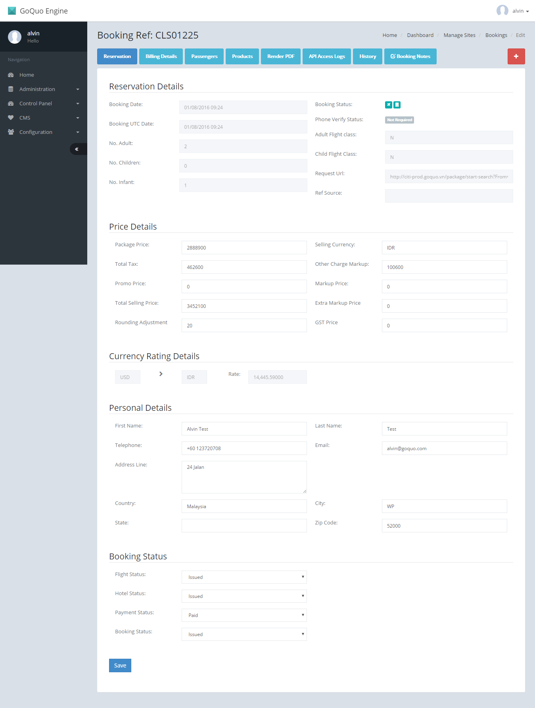

|  |  |  |
| --- | --- | --- |
| **Reservation Details** | | |
| No. | Function | Description |
| 1 | Booking date | This is the date and time which the booking was made. This is based on Date Settings, Time Zone. |
| 2 | Booking Status | The booking status field displays all the products which were purchased for this booking. Each icon represents the status of individual products.  Flight Ticket  Hotel  Insurance  The colour of each icon depicts the status of the product  This color denotes Success status  This color means Pending status  This color denotes Failure status |
| 3 | Booking UTC Date | This is the date and time which the booking was made. This is based on UTC timezone. |
| 4 | Phone Verify Status | Not in use |
| 5 | No Adult | Number of adults in the travelling party |
| 6 | No Children | Number of children in the travelling party |
| 7 | No Infant | Number of Infants in the travelling party |
| 8 | Adult Flight Class | The flight class for the Adult Tickets |
| 9 | Child Flight Class | The flight class for the Child Tickets |
| 10 | Request URL | This is the search string that was used to make the booking |
| 11 | Ref Source | If a query string is pointed from a different source such as a pop-up, then the URL string will appear. [Citation needed] |
| **Price Details** | | |
| No. | Function | Description |
| 12 | Package Price | This is the total cost price of all products |
| 13 | Selling Currency | This is the currency of the final package price |
| 14 | Total Tax | The total taxes for all products |
| 15 | Other Charge Markups | If other charge markups are added, the value is calculated and displayed here. |
| 16 | Promo Price | The total value of the promo discount that was applied. |
| 17 | Markup Price | This is the markup value that was applied to the package price. It is dependent on the settings that was done in the markup feature |
| 18 | Total Selling Price | This is the final selling price that is charged to the passenger. Total Selling Price = Package Price + Total Tax + Markup Price + Other Charge Markup + Extra Markup Price + GST Price – Promo Price - Rounding Adjustment |
| 19 | Extra Markup Price | This value is derived from the extra markup feature |
| 20 | Rounding Adjustment | The rounding value that is applied for each currency |
| 21 | GST Price | The GST price that is applied for this booking |
| **Currency Rating Details** | | |
| No. | Function | Description |
| 22 | From Currency | The cost price for the products. |
| 23 | To Currency | The selling currency for the package. This is the currency that the passenger paid for. |
| 24 | Rate | The conversion rate that was used for this transaction |
| **Personal Details** | | |
| No. | Function | Description |
| 25 | First Name | Lead passenger first name |
| 26 | Last Name | Lead passenger last name |
| 27 | Telephone | Lead passenger Telephone number |
| 28 | Email | Lead passenger email address |
| 29 | Address Line | Lead passenger Address |
| 30 | Country | Lead passenger Country |
| 31 | City | Lead passenger City |
| 32 | State | Lead passenger State |
| 33 | Zip Code | Lead passenger Zip Code |
| **Booking Status** | | |
| No. | Function | Description |
| 34 | Flight Status | Flight product status |
| 35 | Hotel Status | Hotel product status |
| 36 | Payment Status | Payment status |
| 37 | Booking Status | Booking status of the entire package. |
| Note: Any of the fields may be modified and saved manually if the proper authorization is allowed. It is recommended to add notes for easy future reference. See section on Boking Notes | | |

Billing Details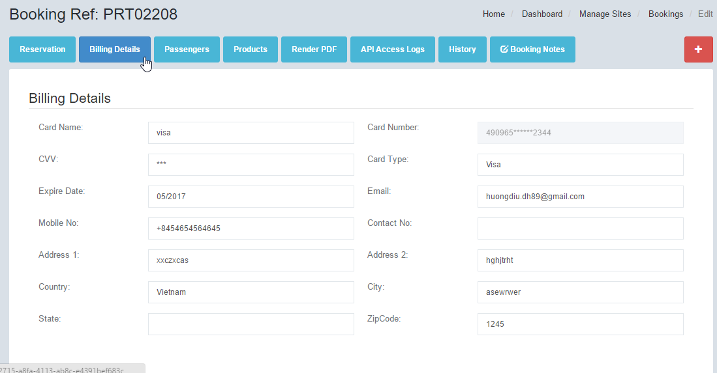

|  |  |  |
| --- | --- | --- |
| **Billing Details** | | |
| No. | Function | Description |
| 1 | Card Name | The assigned card name for this payment method |
| 2 | Card Number | The partial credit card number. For security purpose the whole card number is not captured |
| 3 | CVV | The CVV of the card. This is hidden |
| 4 | Card Type | This is the card Type. Eg VISA, Master, Amex |
| 5 | Expiry date | Expiry date of the card |
| 6 | Email | Email address of the payee |
| 7 | Mobile No | Mobile number of the payee |
| 8 | Contact No | Contact number of the payee |
| 9 | Address 1 | Address line 1 of the payee |
| 10 | Address 2 | Address line 2 of the payee |
| 11 | Country | Country of the payee |
| 12 | City | City of the payee |
| 13 | State | State of the payee |
| 14 | Zip Code | Zip code of the payee |

Passengers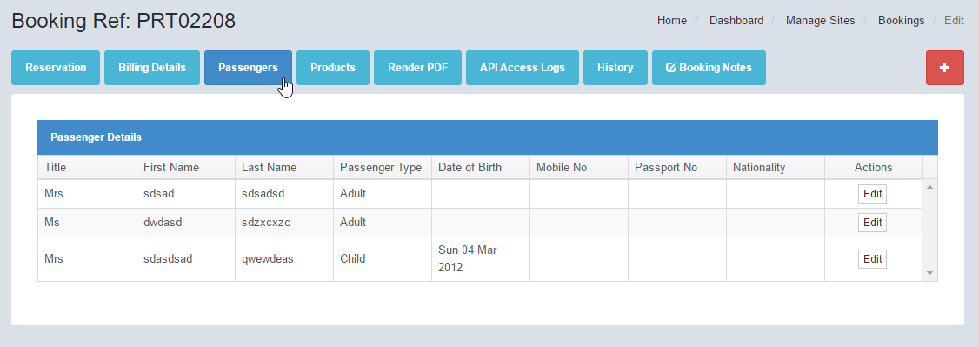

|  |  |  |
| --- | --- | --- |
| **Passengers** | | |
| No. | Function | Description |
|  | Note: | Each passenger in this booking is listed in this function. You may edit their details individually in the booking engine. However, the details will not be synchronized with the PNR details or hotel details. During the booking stage, not all details are mandatory and therefore may not be captured in the booking engine. |
| 1 | Title | The Title of the guest eg Mr, Mrs, Ms, Mstr etc |
| 2 | First Name | First name of the passenger |
| 3 | Passenger Type | Passenger type eg: Adult, Child, Infant |
| 4 | Date of Birth | Date of birth of the passenger |
| 5 | Mobile No | The passenger’s mobile number |
| 6 | Passport No | The passenger’s passport number |
| 7 | Nationality | The nationality of the passenger |
| 8 | Actions | Edit. To view and edit more details of the passenger. |

## Products

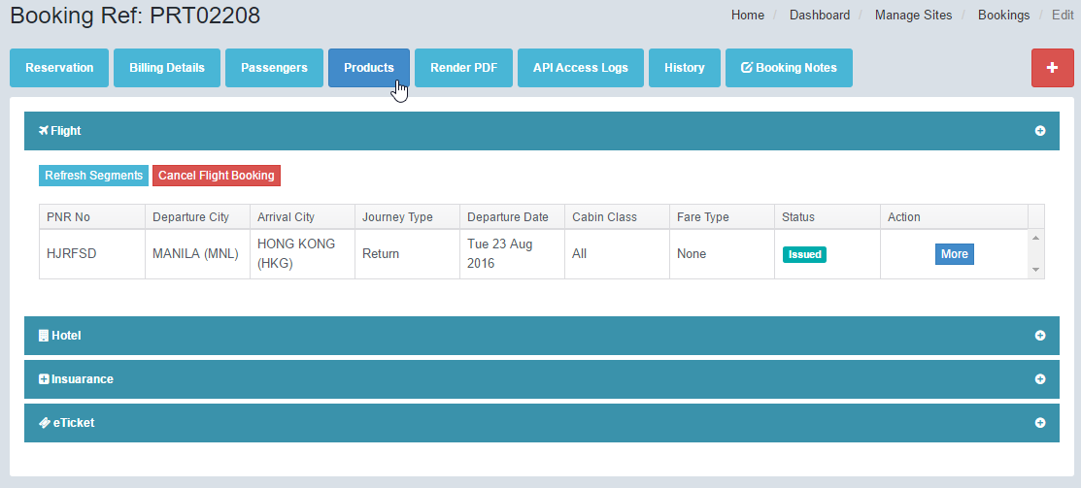

|  |  |  |
| --- | --- | --- |
| **Products - Flight** | | |
| No. | Function | Description |
|  | Note | The general details of the departure and return flights |
|  | Refresh Segments | [Citation Needed] The API is called and the details are refreshed automatically based on the latest flight information in the PNR |
|  | Cancel Flight Booking | This will call the API to cancel the PNR and flight ticket [Citation needed] |
| 1 | PNR No | The PNR for this flight booking |
| 2 | Departure City | The city of departure for this booking. |
| 3 | Arrival City | The arrival city for this booking |
| 4 | Journey Type | One way or Return Flight |
| 5 | Departure Date | The date of departure for this flight |
| 6 | Cabin Class | The cabin class for this booking |
| 7 | Fare Type | Fare type for this booking |
| 8 | Status | Status of the booking - Issued - Pending  - Failed |
| 9 | Action | More. Click this button to view more details about this flight booking |
|  | Note | Each flight segment will display a general section. When you click edit, the Flight Details and the Flight Segment Details are expanded and displayed. Details may be edited as required, but will not synchronize with the actual PNR. Both the Departure Flight and the Return Flight details are the same and are explained below. |
| **General** | | |
| 10 | Flight No | The flight number for this segment |
| 11 | Departure | Departure airport for this segment |
| 12 | Arrival | Arrival Airport for this segment |
| 13 | Departure Date | Departure Date and Time for this segment |
| 14 | Arrival Date | Arrival Date and Time for this segment |
| 15 | Cabin Class | The Cabin Class that was booked for this segment |
| **Flight Details** | | |
| 16 | Passenger Name | The lead passenger name for this flight |
| 17 | PNR No: | The PNR number of this booking |
| 18 | Departure Code | The Departure Airport Code |
| 19 | Arrival Code | The Arrival Airport code |
| 20 | Cabin Class | The cabin class for this segment |
| 21 | Booking Class | The Booking class for this segment |
| 22 | Original Cost | The original cost that was offered by the API for this segment. In some cases, the total original cost for both segments is displayed. |
| 23 | Converted Cost | The converted cost for the flight based on the currency selected by the passenger |
| 24 | Original Tax | The original tax value that was sent by API |
| 25 | Converted Tax | The converted tax value for the flight sent by API |
| 26 | Original Currency | The original cost currency sent by API |
| 27 | Conversion Currency | The currency that was selected by passenger. |
| 28 | GST Price | Calculated GST value for this flight. |
| 29 | Conversion Rate | This is the currency conversion rate at the time the booking was made. Currency conversion rates are derived from the currency conversion table |
| 30 | Markup Price | If a markup was applied, the calculated markup price will be displayed here. |
| 31 | Rounding Adjustment | The rounding value that is made based on the Currency Rounding feature |
| 32 | Promotion | If a promo code is used, the calculated value of the promo is displayed here |
| 33 | Total Amount | The total Flight amount for this route. In some cases, the sum of all routes are displayed. |
| 34 | Tax Price | Total tax price for the flight |
| 35 | Ticketing Deadline | This is the deadline given by the Flight API to generate a ticket for the PNR. If a ticket is not generated by this deadline, the PNR will be released and no tickets can be issued thereafter. |
| **Flight Segment Details** | | |
| 36 | Flight No | The flight number for this segment |
| 37 | Cabin Class | The cabin class for this segment |
| 38 | Departure Airport Code | The departure airport code for this segment |
| 39 | Departure Airport Name | The departure airport name for this segment |
| 40 | Arrival Airport Code | The arrival airport code for this segment |
| 41 | Arrival Airport Name | The arrival airport name for this segment |
| 42 | Departure Date | The departure date and time for this segment |
| 43 | Arrival Date | The arrival date and time for this segment |
| **Products - Hotel** | | |
| No. | Function | Description |
| 44 | Hotel name | The name of the hotel that was booked |
| 45 | Address | The address of the hotel |
| 46 | Supplier ID | The supplier ID of the hotel. This is the booking reference for the booking that was made on the supplier system |
| 47 | Price | The total selling price of the hotel |
| 48 | Check-In | The check-in date of the pax to the hotel |
| 49 | Check-Out | The check-out date of the pax from the hotel |
| 50 | Status | The booking status. -Issued -Pending -Failed |
| 51 | Action | Click the More button to see further hotel details |
| 52 | Cancel Booking | This button will send a cancel notification to the hotel supplier. |
| 53 | No Of Adults | Number of adults for the room |
| 54 | No Of Children | Number of children for the room |
| 55 | No of Infant | Number of infants for the room |
| 56 | Room type | The room type this record |
| 57 | Board Type | The board type for the room. Board type denotes whether breakfast is included. |
| 58 | Price | The price of each room. |
| 59 | Action | Click the Edit button to view further details of the corresponding room |
|  | Note | The grid will display each room that was booked in this transaction. Clicking the Edit button will display further details for each room |
| **Hotel Details** | | |
| 60 | Passenger Name | The lead passenger name for this booking |
| 61 | Provider Hotel Booking ID | The provide hotel booking ID. Some suppliers provide multiple booking IDs for each room. |
| 62 | Hotel Name | The name of the hotel that was booked |
| 63 | Supplier Booking ID 1 | The supplier booking ID 1. The supplier will require different references for each booking |
| 64 | Provider Name | The name of the hotel supplier |
| 65 | Supplier Booking ID 2 | The supplier Booking ID 2. In some cases, there are multiple booking IDs used for different purposes. |
| 66 | Supplier Code | This is the code used by the supplier for the hotel |
| 67 | Hotel Tel No | The hotel’s telephone number. This contact details is provided for reference |
| 68 | Address | The hotel address |
| 69 | Local Contact | The local contact for this hotel |
| 70 | Supplier Local Contact 1 | The supplier local contact number 1. The supplier may have multiple call centre numbers for purpose of customer support |
| 71 | Supplier Local Contact 2 | The supplier local contact number 2. The supplier may have multiple call centre numbers for purpose of customer support |
| 72 | Supplier Local Contact 3 | The supplier local contact number 3. The supplier may have multiple call centre numbers for purpose of customer support |
| 73 | Original Currency | The original cost currency |
| 74 | Converted Currency | The currency that was selected for payment |
| 75 | Original Cost | Original cost of the hotel in the cost currency |
| 76 | Converted Cost | The converted cost of the hotel |
| 77 | Conversion Rate | The rate that was used for converting the currencies |
| 78 | Rounding Adjustment | The currency rounding adjustment based on the setting that was done in the Rounding Adjustment setting |
| 79 | Check-In Date | The check in date for this hotel |
| 80 | Check-Out Date | The check out date for this hotel |
| 81 | Markup Amount | The Markup that was applied to the hotel cost based on the markup settings |
| 82 | GST | The GST value that was applied to the hotel price |
| 83 | Promotion | If a promotion was applied to the hotel, then the promotion value is displayed. |
| 84 | Total Amount | The final selling price for this room. |
| **Room Details** | | |
| 85 | No of Adult | The number of adults staying in this room |
| 86 | No of Child | The number of children stayig in this room |
| 87 | Room Type | The room type for this record |
| 88 | Board Type | The board type for this room |
| **Hotel Cancellation Policy** | | |
| 89 | From | The policy start date |
| 90 | To | The policy end date |
| 91 | Amount | The amount that will be charged if the dates fall between the policy From and To |
| 92 | Markup Amount | Any additional markup that will be added for the cancellation |
|  | Note | There may be multiple cancellation amounts for each date breakdown. |
| **Products - Insurance** | | |
| No. | Function | Description |
| 93 | Policy No | The policy number for the insurance purchased |
| 94 | Price | The total price of the insurance product |
| 95 | Status | The status of the insurance booking - Issued - Pending - Failed |
| 96 | Action | The More button expands the feature to display more details |
| 97 | No | Running number for each person’s individual insurance |
| 98 | First Name | The pax first name |
| 99 | Last Name | The pax last name |
| 100 | Price | Unit price for each insurance purchased |
| **Products - eTicket** | | |
| No. | Function | Description |
| 101 | PNR | The PNR number for this booking |
| 102 | Departure City | The departure city |
| 103 | Arrival City | The arrival city |
| 104 | Journey Type | Return or One Way trip |
| 105 | Departure Date | The departure date for this flight |
| 106 | Cabin Class | The cabin class for this booking |
| 107 | Status | The status of the tickets - Issued  - Pending - Failed |
| 108 | Action | The More button expands the feature to display more details |
| 109 | Passenger Name | The passenger full name which is issued the ticket |
| 110 | Ticket Number | The issued flight ticket number |

## Render PDF

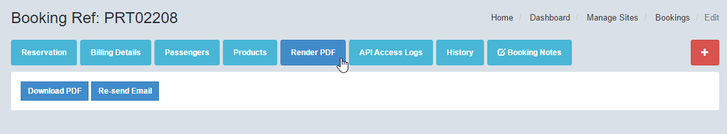

|  |  |  |
| --- | --- | --- |
| **Render PDF** | | |
| No. | Function | Description |
| 1 | Download PDF | By clicking this button the PDF is regenerated and made available for download from browser. |
| 2 | Re-send Email | We can resend the PDF to the customer’s email address by clicking the resend Email button. |
|  | Note | The changes made in the Booking will be rendered to the new PDF. |

## API Access Logs

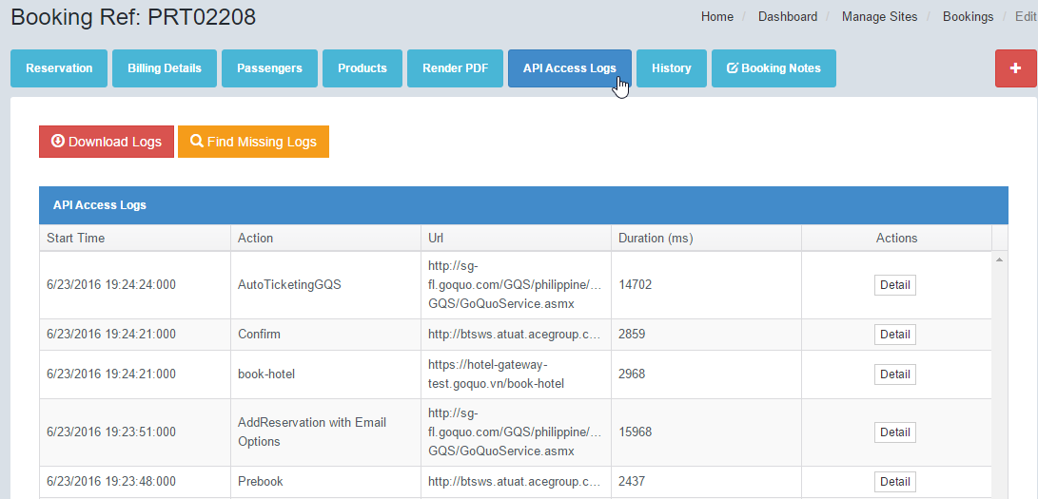

|  |  |  |
| --- | --- | --- |
| **API Access Logs** | | |
| No. | Function | Description |
|  | Note | This tool provides the ability to verify all logs related to this particular booking. The engine keeps track of all API request/response. It also keeps track of the timing and duration of each call. |
| 1 | Download Logs | To download a zip version of all the request and response files for this booking |
| 2 | Find Missing Logs | The system will refresh all the logs from the server database. This action is necessary if there are any logs that did not get stored in the Admin Portal. |
| 3 | Start Time | The system time for when the action started. |
| 4 | Action | The system action that was taken at the start time |
| 5 | URL | The service URL that was used for this action |
| 6 | Duration | The duration it takes from the start time till the full response is received. In some cases there is a cutoff time that the system will stop receiving a response. |
| 7 | Actions | Clicking the Detail button will give an overview of the log. Fro this screen you can download the actual request/response files. The files are commonly in XML format. |

## History

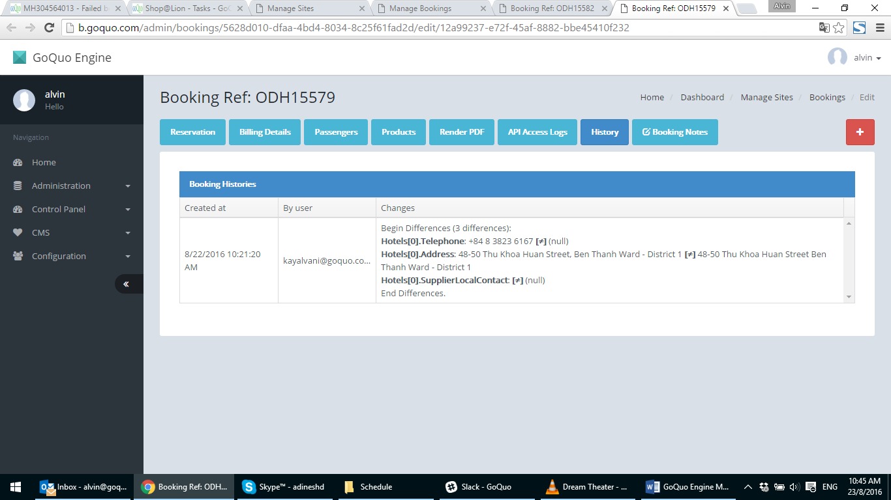

|  |  |  |
| --- | --- | --- |
| **Booking History** | | |
| No. | Function | Description |
|  | Note: | This feature keeps track of all the changes done by each user. For example if a user makes a change to the email address of the lead passenger, the system will track that change for audit purposes. |
| 1 | Created at | The date and time the change was saved based on system clock. |
| 2 | By User | The user that was logged in and made the change. |
| 3 | Changes | The actual changes that were made by the user |

## Booking Notes

The user may make notes about the booking. This feature is useful for call centre and operations teams to keep track of the booking and keep everyone informed about key information.

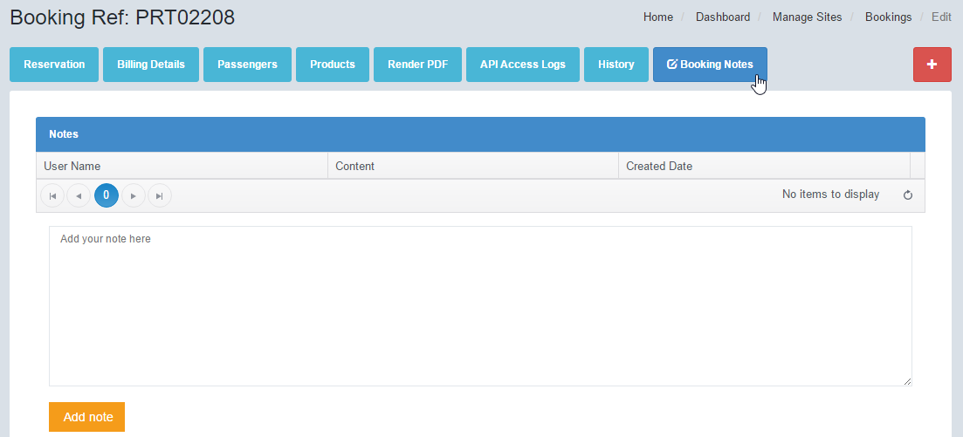

|  |  |  |
| --- | --- | --- |
| **Booking Notes** | | |
| No. | Function | Description |
| 1 | User Name | The user who made the note |
| 2 | Content | The text description of the information that is to be shared. |
| 3 | Created Date | The date the note was created based on system time |
|  | Note | Each note created will have a new line record. There is a + icon at the upper left of the screen. By clicking this button the user may make notes from any area in the Admin Portal. |

# Flight API Provider

This is the flight API settings for the booking engine. Each field sends various xml tags to the flight service. These tags are variables that are specific to each airline.

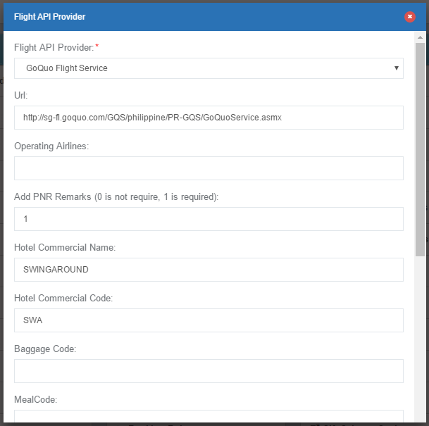

|  |  |  |
| --- | --- | --- |
| **Flight API Provider** | | |
| No. | Function | Description |
| 1 | Flight API Provider | The template for the flight service that is being implemented. [Citation needed] |
| 2 | URL | The service URL for the API. This service URL is an internal service created to point to the actual GDS. |
| 3 | Operating Airlines | The airlines that are operating in this service. [Citation needed] |
| 4 | Add PNR Remarks (0 is not require, 1 is required) | [Citation needed] This adds special remarks tag to the PNR. |
| 5 | Hotel Commercial Name | This is the Hotel commercial name that is assigned to the PNR |
| 6 | Hotel Commercial Code | This is the hotel commercial code that is assigned to the PNR |
| 7 | Tour Commercial Code | This is the tour commercial code that is assigned to the PNR |
| 8 | Transfer Commercial code | This is the transfer commercial code that is assigned to the PNR |
| 9 | Insurance Commercial code | This is the insurance commercial code that is assigned to the PNR |
| 10 | Baggage code | This is the Baggage SSR code that is assigned to the PNR |
| 11 | Meal code | This is the Meal SSR code that is assigned to the PNR |
| 12 | Sport Equipment Code | This is the Sport Equipment SSR code that is assigned to the PNR |
| 13 | Priority Check-in Code | This is the Priority Check-In SSR code that is assigned to the PNR |
| 14 | Meals Mapping | Each meal SSR code mapped to their respective name [Citation Needed] |
| 15 | PnrRemark Category | The category that is assigned in the PNR XML tree |
| 16 | PnrRemark SubCategory | The subcategory that is assigned in the PNR XML tree­­ |

# Hotel API Providers

This is the feature of the booking engine that allows the system to be setup with multiple Hotel Providers. Generally, each hotel supplier such as GTA and Hotelbeds have their own B2B API. The system can be integrated to these APIs to pull pricing from each supplier and to aggregate them in real-time.

## Manage Hotel API Providers/Create Hotel API Provider

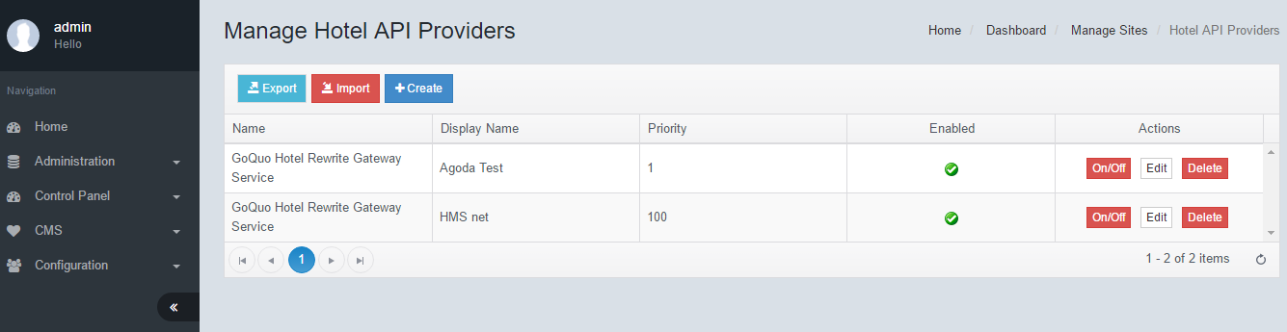

|  |  |  |
| --- | --- | --- |
| **Manage Hotel API Provider** | | |
| No. | Function | Description |
| 1 | Export | The settings of the hotel APIs may be exported for backup purposes. Click the export button and save the file. |
| 2 | Import | You may restore completely a backed-up version of the settings. Simply click import and select the relevant file for import |
| 3 | Create | To create Hotel API Provider, click Create. Enter both fields, then click Save. |
| 4 | On/Off | Each supplier that is created may be switched on or off. If the API is turned off, the system will not take any results from the supplier for aggregation. If enabled a tick mark appears in the grid. |
| 5 | Edit | Click edit to further drill down into the hotel settings See “Edit Hotel API Provider” chart below |
| 6 | Delete | An authorised user may be able to delete any of the hotel API |

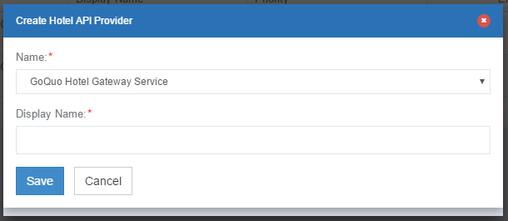

Click edit to further drill down into the detailed setting of each hotel.

|  |  |  |
| --- | --- | --- |
| **Edit Hotel API Provider** | | |
| No. | Function | Description |
| 1 | Name | The descriptive name for the Hotel API |
| 2 | Display Name | The display name for the Hotel API |
| 3 | Enabled | Tick this box to enable the API service |
| 4 | Email to Supplier | Tick this box to send an email to the hotel supplier for confirmation of booking. The email format follows the format that was setup in the email template feature |
| 5 | Supplier BCC emails | The email addresses of all the suppliers and associates that should receive the booking confirmation email. You may also cc a copy to the operations team for their reference. |
| 6 | URL | The URL of the hotel gateway/service |
| 7 | User Name | The username for the hotel gateway/service |
| 8 | Password | The password for the hotel gateway/service |
| 9 | isB2B | [Citation Needed] |
| 10 | isPakage | [Citation Needed] |
| 11 | Priority | The priority order for this hotel API. A higher score will cause the system to aggregate this hotel API results first. Set the score from 1 to 100 |
| 12 | Provider | The name of the provider |
| 13 | Supplier Name | The name of the supplier |
| 14 | Number of Results | The maximum number of hotel results that will be accepted for each search query. |
| 15 | Page No | [Citation Needed] |

# Tour API Providers

This is the feature of the booking engine that allows the system to be setup with multiple Tour Providers. Generally, each supplier such has their own B2B API. The system can be integrated to these APIs to pull pricing from each supplier and to aggregate them in real-time.

## Manage Tour API Providers/Create Tour API Provider

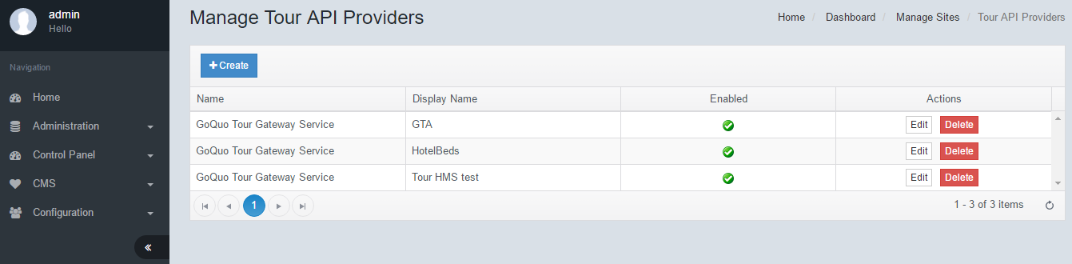

|  |  |  |
| --- | --- | --- |
| **Manage Tour API Provider** | | |
| No. | Function | Description |
| 1 | Create | To create Tour API Provider, click Create. Enter both fields, then click Save. |
| 2 | Edit | Click edit to further drill down into the tour settings See “Edit Tour API Provider” chart below |
| 3 | Delete | An authorised user may be able to delete any of the tour API |

To create Tour API Provider, click Create. Enter both fields then click Save.

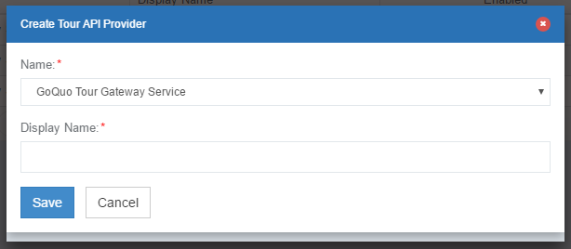

|  |  |  |
| --- | --- | --- |
| **Edit Tour API Provider** | | |
| No. | Function | Description |
| 1 | Name | The descriptive name for the Tour API |
| 2 | Display Name | The display name for the Tour API |
| 3 | Enabled | Tick this box to enable the API service |
| 4 | Email to Supplier | Tick this box to send an email to the tour supplier for confirmation of booking. The email format follows the format that was setup in the email template feature |
| 5 | Service’s Base URL | The URL of the tour gateway/service |
| 6 | Service timeout default (in milliseconds) | The system will cut off the results from the supplier after the time that was set |
| 7 | User Name | The username for the tour gateway/service |
| 8 | Password | The password for the tour gateway/service |

# Transfer API Providers

## Manage Transfer API Providers/Create Transfer API Provider

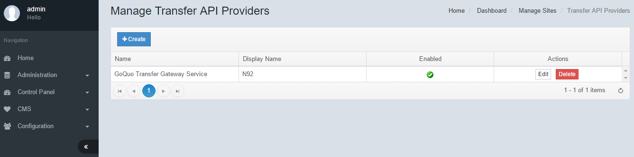

|  |  |  |
| --- | --- | --- |
| **Manage Transfer API Provider** | | |
| No. | Function | Description |
| 1 | Create | To create Transfer API Provider, click Create. Enter both fields, then click Save. |
| 2 | Edit | Click edit to further drill down into the transfer settings See “Edit Transfer API Provider” chart below |
| 3 | Delete | An authorised user may be able to delete any of the Transfer API |

To create a Transfer API Provider, click Create. Enter both fields then click Save.

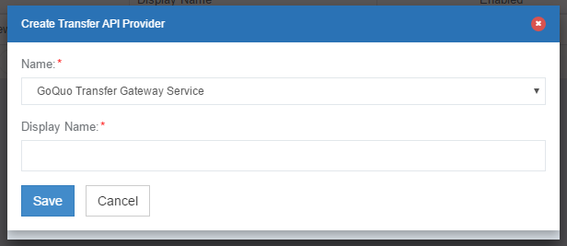

|  |  |  |
| --- | --- | --- |
| **Edit Transfer API Provider** | | |
| No. | Function | Description |
| 1 | Name | The descriptive name for the Transfer API |
| 2 | Display Name | The display name for the Transfer API |
| 3 | Enabled | Tick this box to enable the API service |
| 4 | Email to Supplier | Tick this box to send an email to the Transfer supplier for confirmation of booking. The email format follows the format that was setup in the email template feature |
| 5 | Service’s Base URL | The URL of the Transfer gateway/service |
| 6 | Service timeout default (in milliseconds) | The system will cut off the results from the supplier after the time that was set |
| 7 | User Name | The username for the Transfer gateway/service |
| 8 | Password | The password for the Transfer gateway/service |

# Insurance API Providers

## Manage Insurance API Providers/Create API Provider

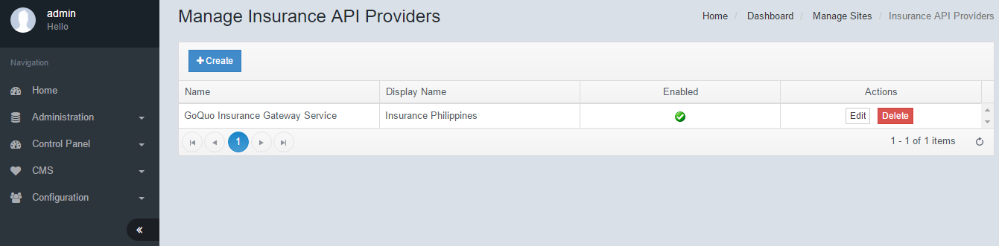

|  |  |  |
| --- | --- | --- |
| **Manage Insurance API Provider** | | |
| No. | Function | Description |
| 1 | Create | To create Insurance API Provider, click Create. Enter both fields, then click Save. |
| 2 | Edit | Click edit to further drill down into the Insurance settings See “Edit Insurance API Provider” chart below |
| 3 | Delete | An authorised user may be able to delete any of the Insurance API |

To create an Insurance API Provider, click Create. Enter both fields then click Save.

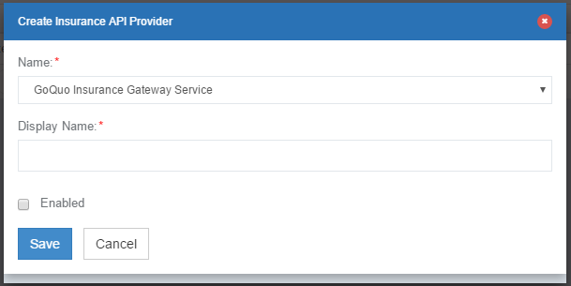

|  |  |  |
| --- | --- | --- |
| **Edit Insurance API Provider** | | |
| No. | Function | Description |
| 1 | Name | The descriptive name for the Transfer API |
| 2 | Display Name | The display name for the Transfer API |
| 3 | Enabled | Tick this box to enable the API service |
| 4 | Url | API URL of the Insurance company |
| 5 | User Id | The user ID for the insurance API |
| 6 | Username | The user display name for the insurance API |
| 7 | Password | Password for the insurance API |
| 8 | Domestic Product Id | Domestic product ID as defined by provider |
| 9 | International Product Id | Internation product ID as defined by provider |
| 10 | Domestic Oneway | Domestic Oneway product ID as defined by provider |
| 11 | Domestic RoundTrip | Domestic RoundTrip product ID as defined by provider |
| 12 | Country Exclusions | Any destination country code that will not be allowed for insurance product. [Citation needed] |
| 13 | Asia exclusions | Any Asian destination country code that will not be allowed for insurance product. [Citation needed] |
| 14 | International Oneway | International Oneway product ID as defined by provider |
| 15 | International Roundtrip | International RoundTrip product ID as defined by provider |
| 16 | Insured Type Id | The type of insurance as defined by provider |
| 17 | Destination Domestic | Domestic destination code defined by provider. |
| 18 | Destination International Asia | International Asian destination code defined by provider. |
| 19 | Destination International | Internationa destination code defined by provider. |
| 20 | Country Codes Apply | Origin country codes that apply for insurance [Citation needed] |

# Hotel OTA API Providers

## Manage Hotel OTA API Providers/Create Hotel OTA API Provider

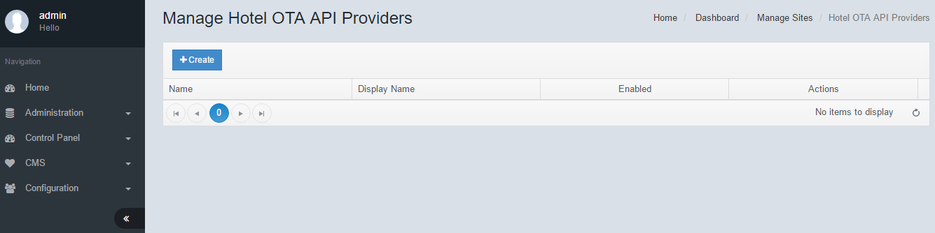

To create a Hotel OTA API Provider, click Create. Enter both fields then click Save. Click Edit on the line to key in the URL of the OTA API Provider.

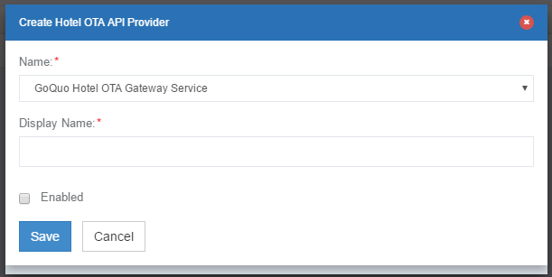

# Operation Times

This feature allows the system to coordinate the routes schedules of each origin and destination. Airlines may fly routes only on specific days of the week. This database keeps track of all the allowed flight operation times and may be used to synchronize with the search form. With this feature, the calendar will be blocked off for specific days of each route.

## Manage Operation Times/Create Operation Time

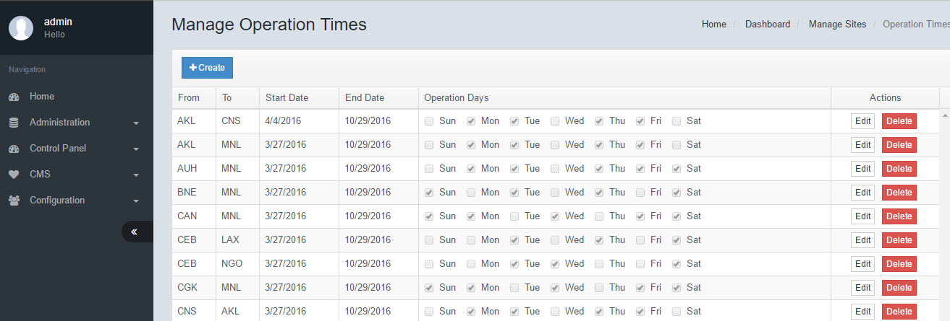

To create an Operation Time, click Create. Enter From and To city codes, date range, days of flight service, then click Save.

|  |  |  |
| --- | --- | --- |
| **Manage Operation Times** | | |
| No. | Function | Description |
| 1 | From | Origin Airport code |
| 2 | To | Destination Airport code |
| 3 | Start Date | The start date where this route restriction will begin |
| 4 | End Date | The end date where this route restriction will end |
| 5 | Operation Days | The days of operation that fall within the date range. Tick each day that the flight will be in operation. |

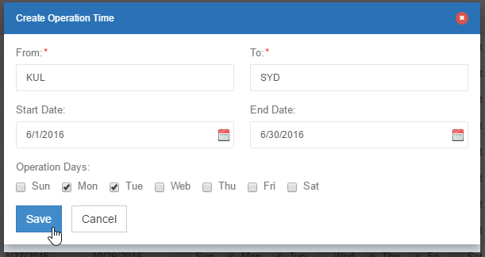

# API Access Logs

The API access logs captures each and every action/task along every step of the booking flow process. It keeps track of the duration of each service call and also captures the request/response xml logs.

|  |  |  |
| --- | --- | --- |
| **API Access Logs** | | |
| No. | Function | Description |
| 1 | Start Time | The start time of the action that was performed |
| 2 | Action | The action that was performed at that specific time in the booking flow |
| 3 | URL | The URL that was called for performing that function. If no URL is shown, this is likely a server/service/browser related process. |
| 4 | Duration | The amount of time in milliseconds that the action was performed |
| 5 | Actions | Click Edit to view further details of the action and to download/view request/response xml logs. |

## Manage API Access Logs/Search API Access Log

To search API access log, enter Package ID and click Search. The Package ID can be found from the html source of each page in the booking flow. A list of action items will appear. Click Edit to view further details and to download XML logs.

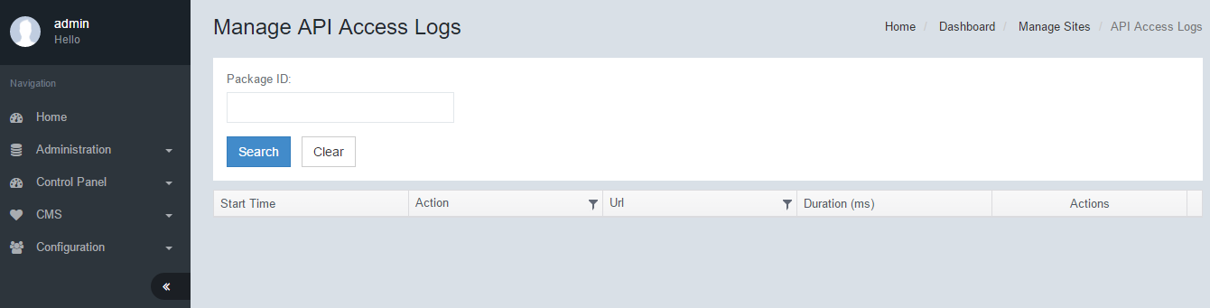

# Manage Packages

From this module, we can easily create, manage, turn on or off package combinations and their various settings.

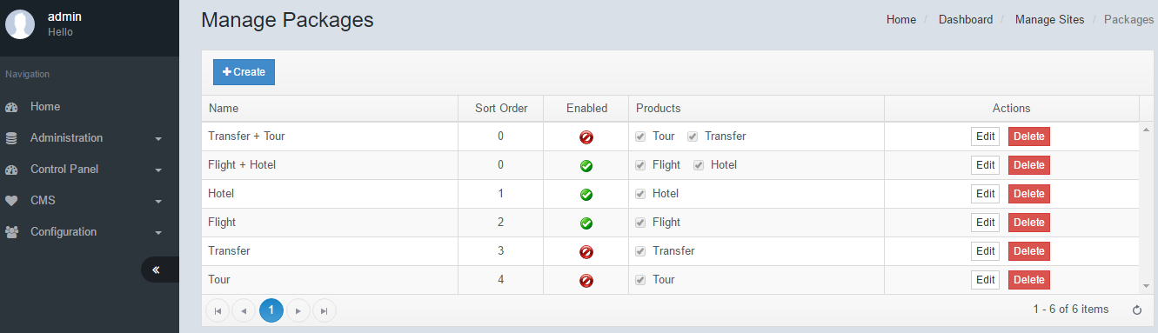

To create a package, click on Create. Enter all necessary fields, then click Save. Click edit to see more details.

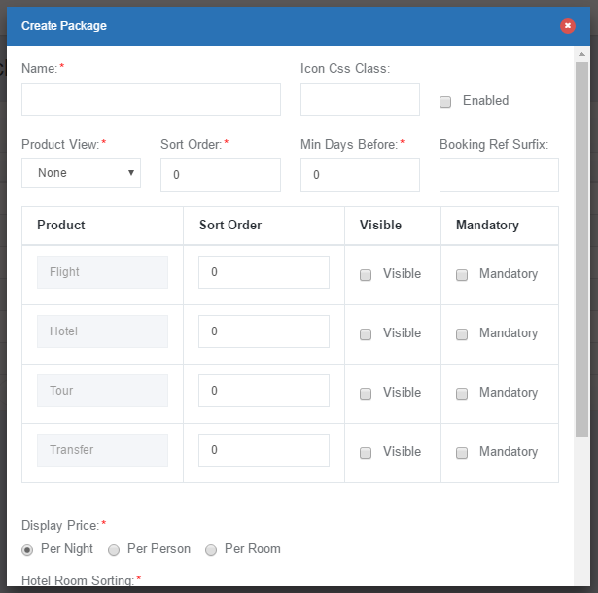

|  |  |  |
| --- | --- | --- |
| **Edit Package** | | |
| No. | Function | Description |
| 1 | Name | The name of the package. Eg: Flight + Hotel |
| 2 | Icon CSS Class | The icon class that will be used for this Package in the front end |
| 3 | Enabled | To enable the product tick the checkbox |
| 4 | Product View | There are 3 possible designs to display the packages. Separate, combined, slim. |
| 5 | Sort Order | This is the sort order for the package. |
| 6 | Min Days Before |  |
| 7 | Booking Ref Surfix |  |
| 8 | Product | The combined products that will be packaged. Each product will be displayed in a new line |
| 9 | Sort Order | The sort order of appearance for each product. It is possible to display hotels before flight. Simply set the order from 0 to 10 (0 being first). |
| 10 | Visible | To make this product visible tick the checkbox |
| 11 | Mandatory | When this is selected, the product must be part of the package and is not optional. |
| 12 | Display Price | The engine is able to display the package price in 3 ways 1) Per night – The total package price is divided by the total nights and displayed.  2) Per person – The total package price is divided by the total passengers and displayed.  3) Per room – The total package price is divided by the number of rooms and displayed. |
| 13 | Hotel Room Sorting | The engine is able to sort the hotels that appears based on 2 criterial. [Citation needed] 1) By Price – The system automatically sorts the hotels by price.  2) By Priority – The system sorts the hotels to appear based on internally sorted logic. |
| 14 | Payment Status When Booking Flight Failed | The engine will automatically set the payment status of the booking if a Flight has failed [Does it automatically cancel the payment?] |
| 15 | Must Verify via sms | An sms verification code will need to be replied to before a booking is confirmed. This is used for security purposes [Citation needed] |
| 16 | Verify countries excluded | These countries will be exempted from requiring an SMS verification |
| 17 | Departures | This package is only available for Departure cities that are specified. Enter the Airport of the departure cities and separate multiple cities with comma [Citation needed] |
| 18 | Arrivals | This package is only available for Arrival cities that are specified. Enter the Airport of the arrival cities and separate multiple cities with comma [Citation needed] |

# URL Confirms

This function displays all the hotel confirmation emails. When a booking is made, an email confirmation is sent to the hotel provider. In the email an URL is provided for the supplier to click to confirm that the email was received. When the URL is clicked, the engine stores the date and time it was clicked.

## Manage URL Confirms

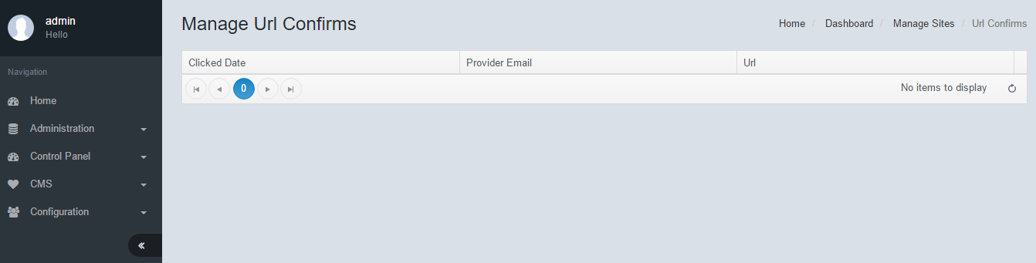

# OAuth Settings

OAuth (Open Authorization) is an open standard for token-based authentication and authorization on the Internet. It allows an end user's account information to be used by third-party services, such as Facebook, without exposing the user's password. The Engine is able to integrate with these 3rd party applications via the use of these OAuth codes. Enter all necessary fields, then click Save.

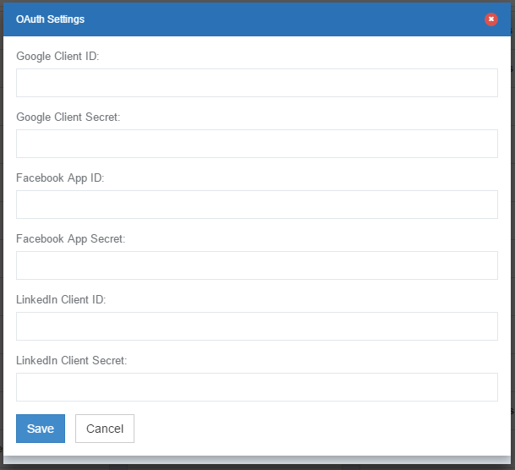

# Sift Science Settings

Sift Science is a 3rd party service which is used for Credit Card fraud prevention. The system uses this API to score credit cards and prevent bookings that are marked as high risk. Enter all necessary fields, then click Save.  
NOTE: A score which is higher than what is set, will be declined for payment. Scores that are lower than what is set is safe.

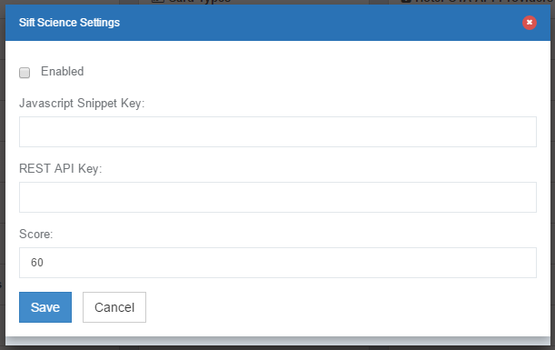

# Segment IO Settings

This function integrates the Analytics feature of the engine.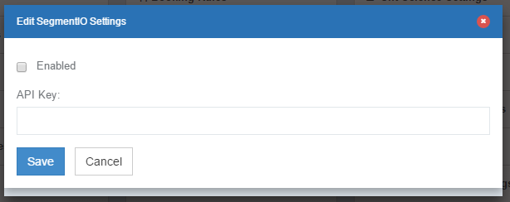

# Package Queries

This module displays all the searches that are performed in the engine via any means including search forms, pop-ups, shortcuts etc. The system logs the date and time that the query was made. It is also able to display the actual criteria that was used. Click on Download to display further details of each individual query.

## Manage Package Queries/Create Package Query

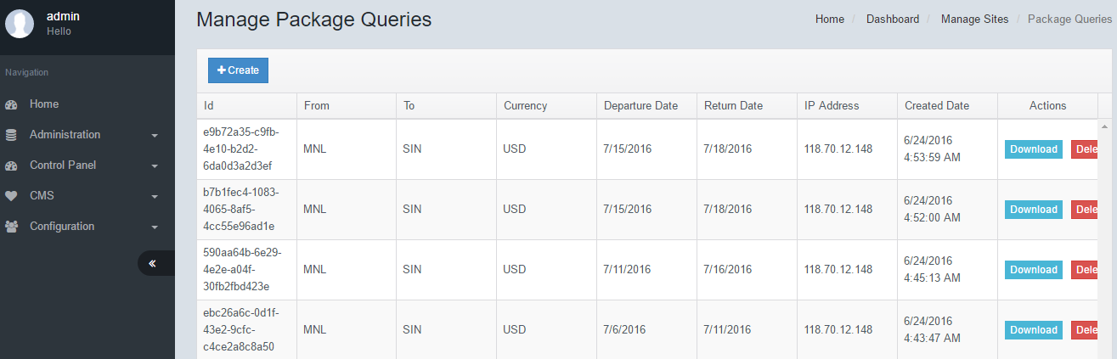

# Hotel Checkin Next Days

[Citation Needed] Generally, the hotel check in is made on the same day as the flight arrival. However, there cases where the flight arrival time is late at night and it is desirable to have the check in date as the next day.  
Question: Can we have Day minus 1? For example, the guest arrives early morning at 2am. But check-in is at 12pm.

## Manage Hotel Checkin Next Days

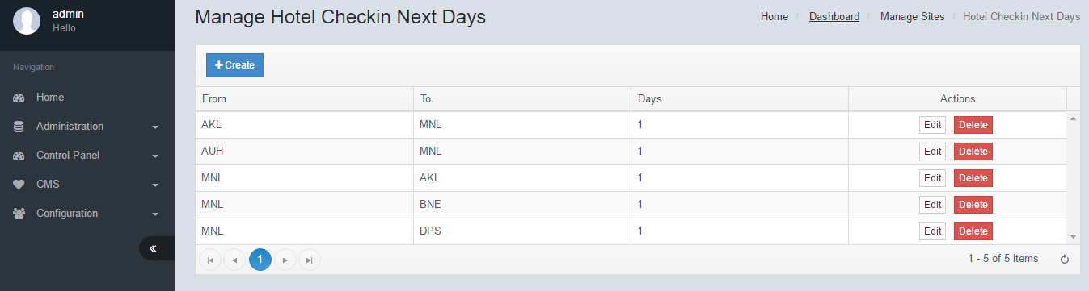

To create a Hotel Checkin Next Day, click Create. Enter all necessary fields, then click Save.

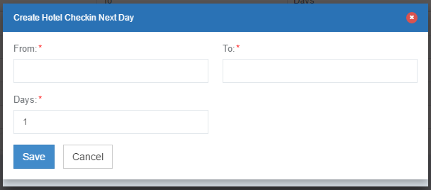

# Trip Advisor Mappings

[Citation needed]

## Manage Trip Advisor Mappings/Create Trip Advisor Mapping

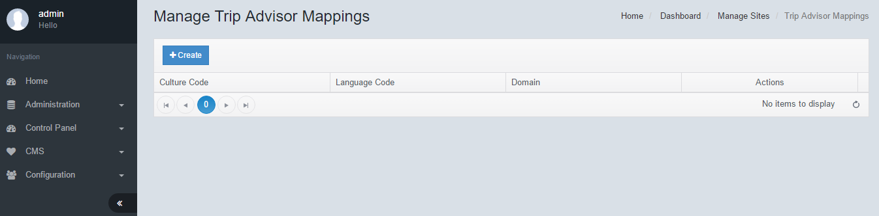

To create a Trip Advisor Mapping, click Create. Enter all necessary fields, then click Save.

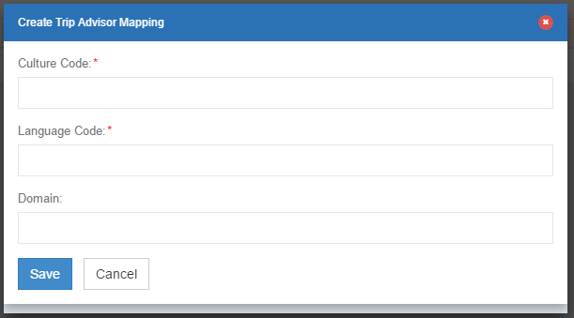

# Route Currency Mappings

It is possible to pre-set the currency of each route. For example; if the currency of operations for Australia is AUD; and the route from SYD to KUL is always charged as AUD, then it is possible to set this up in the engine. The engine will automatically convert the currency and display as AUD.

## Manage Route Currency Mappings/Create Route Currency Mapping

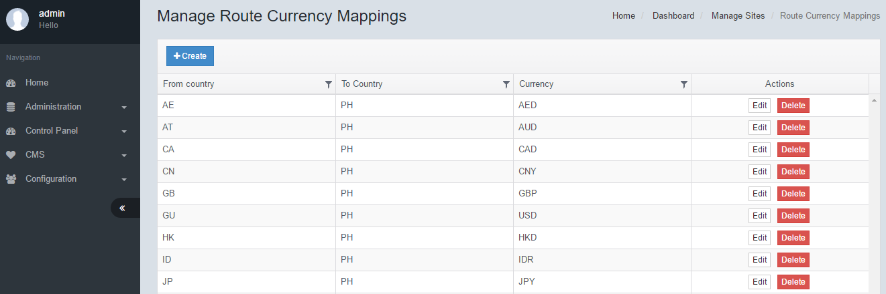

To create a Route Currency Mapping, click on Create. Enter all necessary fields, then click Save.

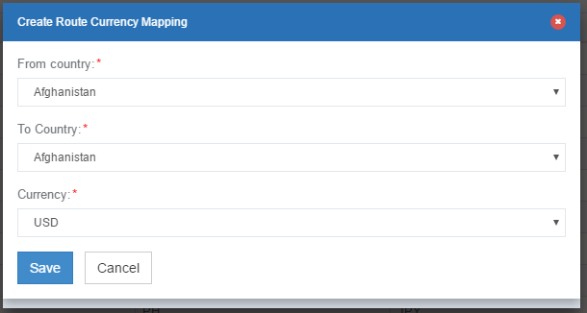

# Destination Mappings

Origin and destination routes may be mapped such that the engine will only return results that are stored in the database. Each origin may have multiple destinations. It is also possible that the destination mappings may be synchronized with the Search Form through an internal API.

## Manage Destination Mapping/Create Destination Mapping

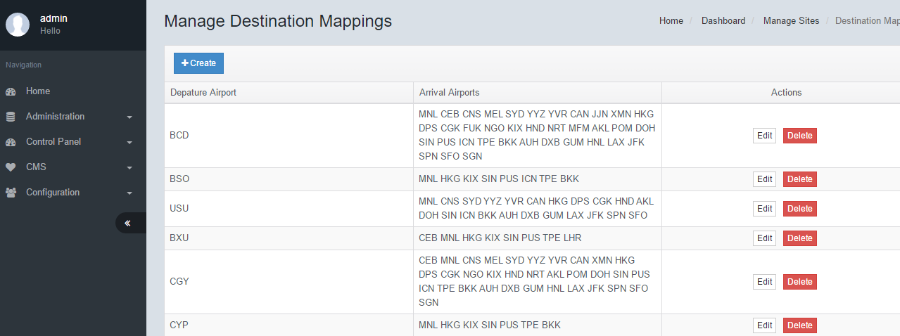

To create a Destination Mapping, click Create. Enter the Departure Airport Code, followed by all the mapped Arrival Airport codes. Ensure that each Airport Code is keyed into a new line.

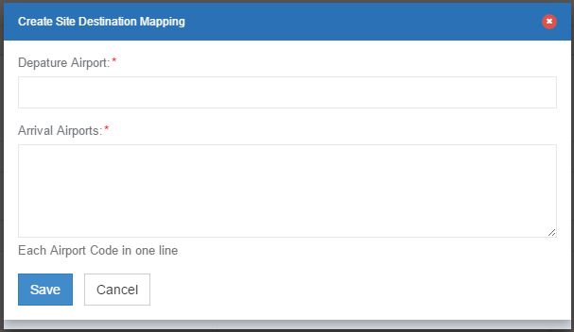

# View Contents

[THIS FEATURE HAS BEEN DISCONTINUED]

Each and every page in the booking flow may be modified from this module. The layout of each page is setup as cshtml files and may be modified accordingly. Each version is stored for easy restoration.  
Click Edit to make changes to the the respective cshtml file. Click Versions to view and restore an older format. You may also download the file to edit in a separate html editor.

## Manage View Contents/Import Theme/Sync

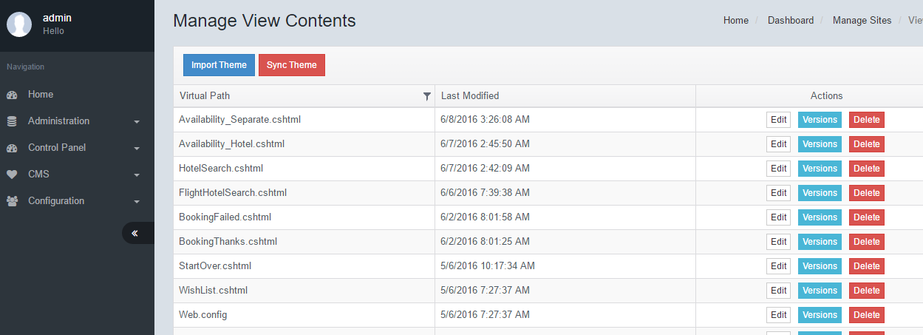

To Import Theme, click Import Theme. If you wish to override current view content, check the Override Current view Content checkbox and click Save.

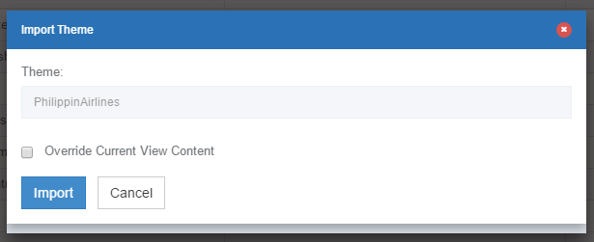

# Double Clicks

[Citation needed]

## Edit Double Clicks

Enter all necessary fields, then click Save.

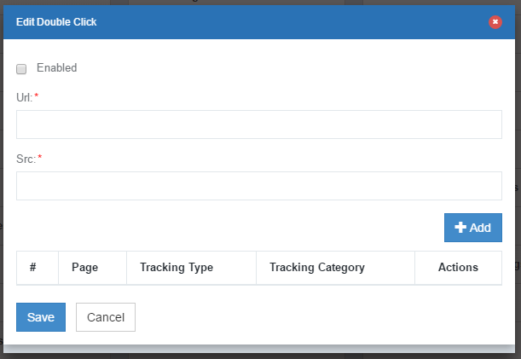

# Flight Markups by Airline

Multiple markups can be added for the Airline product. Whether it is being sold separately or together in a package. It is possible to add markups by date range and other criteria. If multiple markups are coinciding at the same time, it will be added into the total package.

## Manage Flight Markups by Airline/Create Flight Markups by Airline

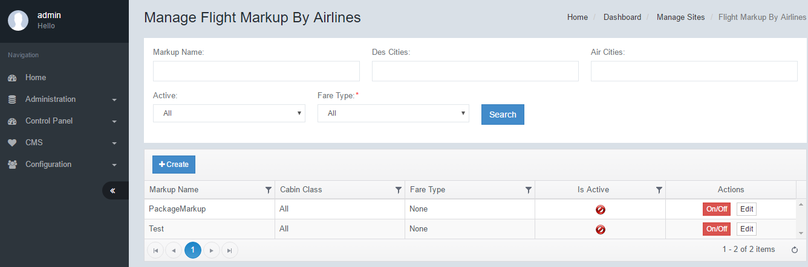

The filter function allows the user to search all the markups by the various filters available.  
Click Create to add a new markup. Click Edit to view further details of the individual markup.

To create a Flight Markup by Airlines, click Create. Enter all necessary fields, then click Save.

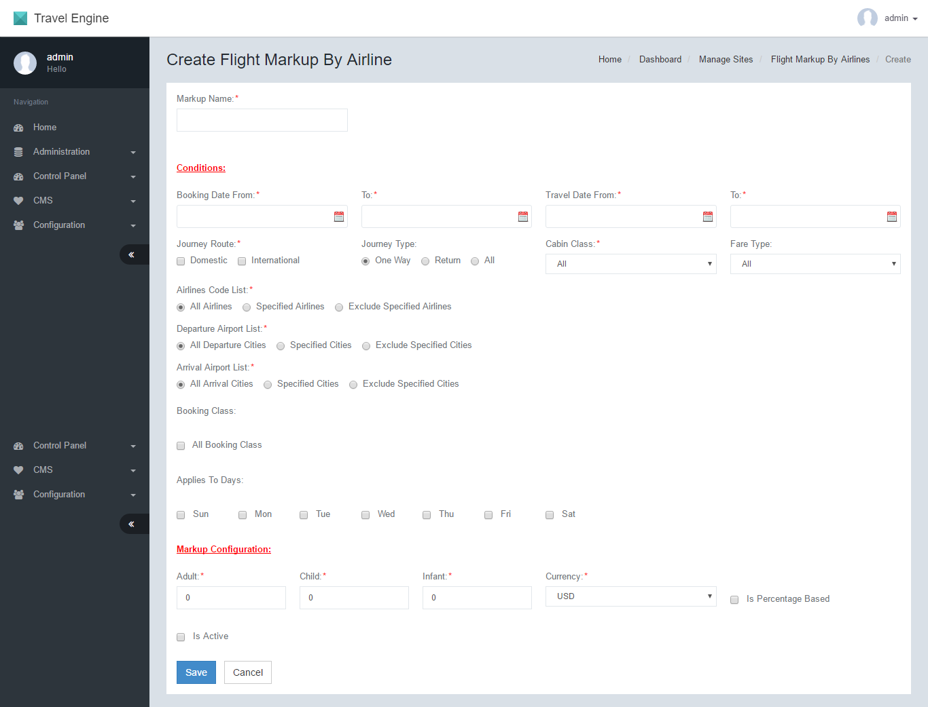

# Flight Markup by Price

## Manage Flight Markup by Price/Create Flight Markup by Price

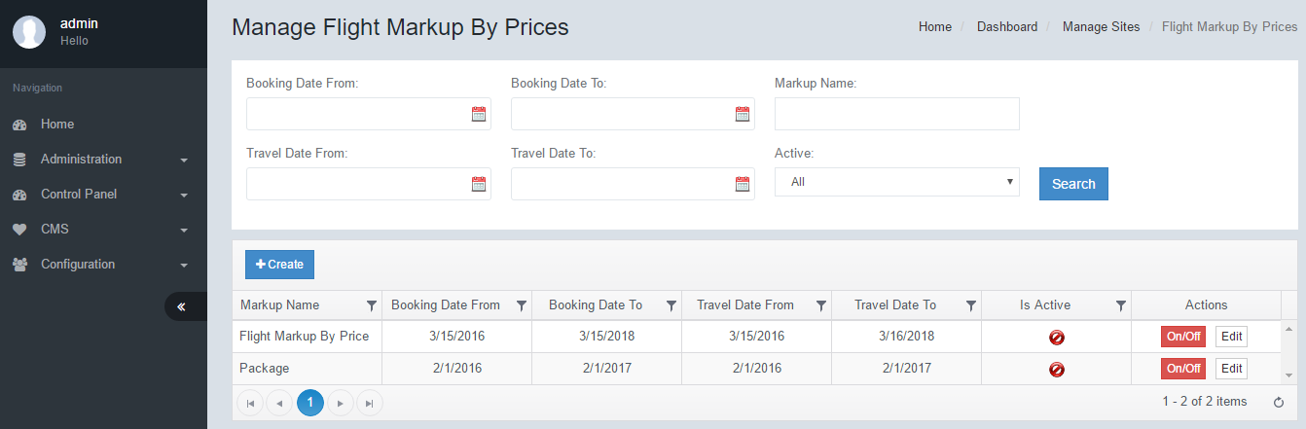

To create a Flight Markup by Prices, click Create. Enter all necessary fields, then click Save.

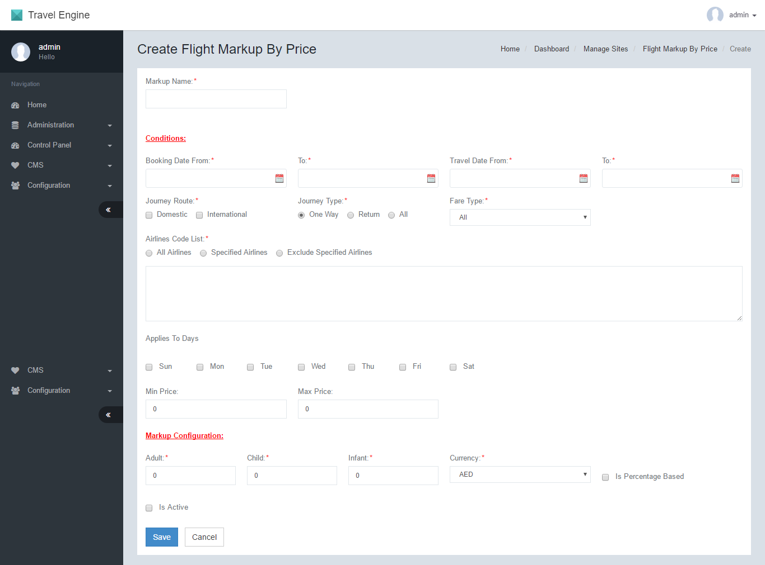

|  |  |  |
| --- | --- | --- |
| **Create Flight Markup By Price** | | |
| No. | Function | Description |
| 1 | ­Markup Name | The name for the markup record |
| 2 | Booking Date From | The booking date range start date. The markup will only be applied if the date the booking is made falls within the predefined date range |
| 3 | Booking Date To | The booking date range end date. |
| 4 | Travel Date From | The travel date range start date. The markup will only be applied if the dates that the passenger is travelling falls within the predefined date range. |
| 5 | Travel Date To | The travel date range end date. |
| 6 | Journey Route | The markup will be applied to the routes that are selected - Domestic – Domestic/local routes will have this markup  - International – International routes will have this markup |
| 7 | Journey Type | The markup will be added to either One-Way, Return or both types of journeys as defined. |
| 8 | Cabin Class | Depending on the cabin class selected, the markup will only be applied when the particular cabin class fare is returned. |
| 9 | Airlines Code List | The engine can apply markups based on the airline code as well. There are 3 options:  1) All Airline Codes – All codes will have the markup  2) Specified Airlines – When selected, the Airline codes may be input. Airline codes that are input will be included for this markup and the calculations will be applied.  3) Exclude Airlines – When selected the Airline codes may be input. Airline codes that are input will be excluded from this markup and the calculations will NOT be applied. |
| 10 | Departure Airport List | The engine can apply markups based on the Departure Airports as well. There are 3 options:  1) All Departure Cities – All codes will have the markup  2) Specified Cities – When selected, the City codes may be input. City codes that are input will be included for this markup and the calculations will be applied.  3) Exclude Cities – When selected the City codes may be input. City codes that are input will be excluded from this markup and the calculations will NOT be applied. |
| 11 | Arrival Airport List | ­­­ The engine can apply markups based on the Arrival Airports as well. There are 3 options:  1) All Arrival Cities – All codes will have the markup  2) Specified Cities – When selected, the City codes may be input. City codes that are input will be included for this markup and the calculations will be applied.  3) Exclude Cities – When selected the City codes may be input. City codes that are input will be excluded from this markup and the calculations will NOT be applied. |
| 12 | Booking Class | Markups may also be constricted to specified Booking Classes. Key in the list of classes that are applicable to the markup. The engine will automatically verify the markup based on the list keyed in. |
| 13 | Applies to Days | This will restrict the markup to only specific flight days. And the markup will only be calculated if the flight falls on these days. [Citation needed]. How about return. What if departure flight falls on Applied day and arrival falls on NON Applied day? |
| 14 | Adult | The value of markup that will be applied to Adult tickets |
| 15 | Child | The value of markup that will be applied to Child tickets |
| 16 | Infant | The value of markup that will be applied to Child tickets |
| 17 | Currency | The currency value of the markup. |
| 18 | Is Percentage Based | If this is selected, the value of the markup configuration will be in percentage form. It will take the percentage of the ticket price. If not selected, it will add on the value in monetary form. |
| 19 | Is Active | To activate this markup check this box. |

# Flight Cancellation Markup

This markup type is used for handling cancellations. It may be necessary to have a surcharge for cancellations such as processing fees etc.

## Manage Flight Cancellation Markup/Create Flight Cancellation Markup

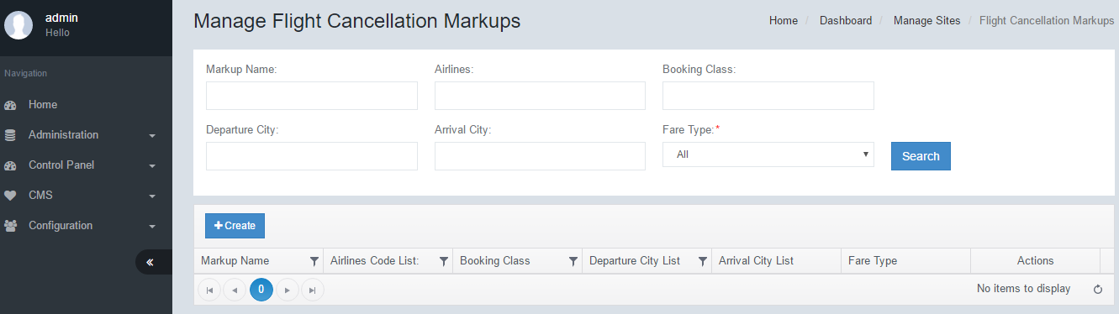

To create a Flight Cancellation Markup, click Create. Enter all necessary fields, then click Save.

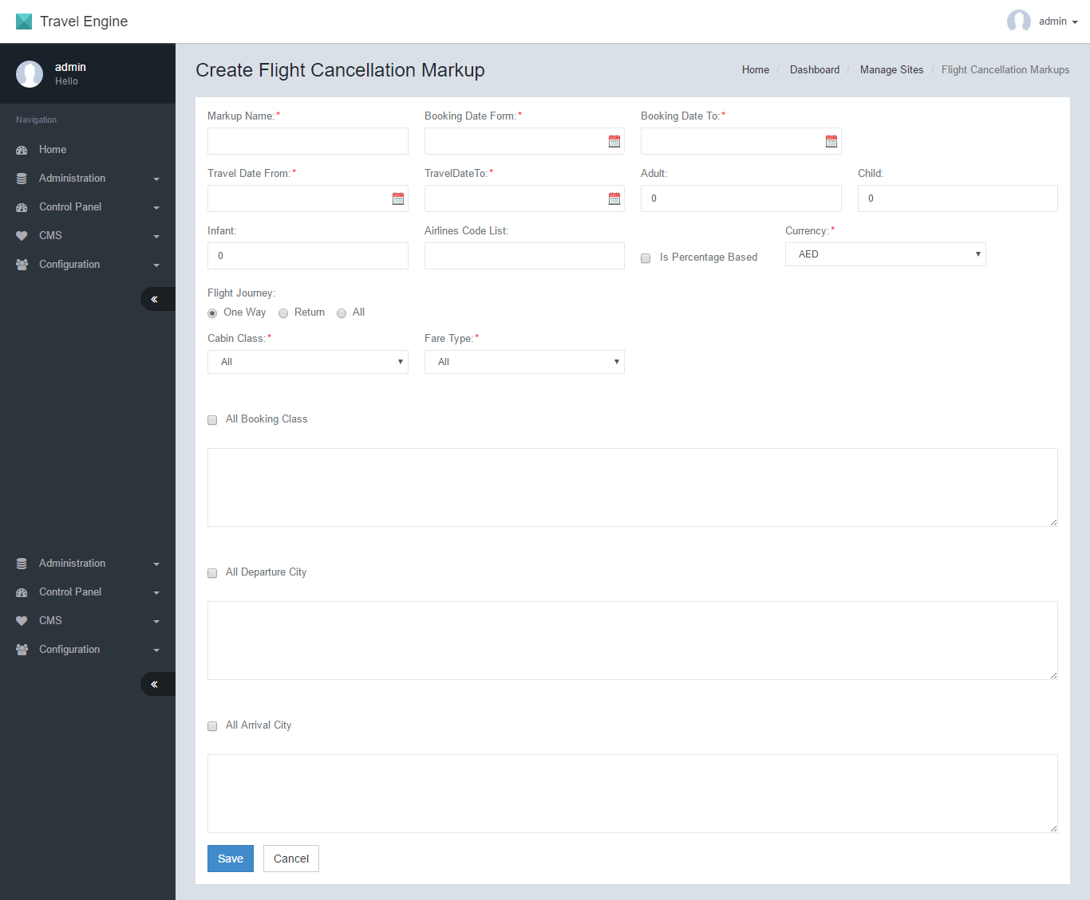

|  |  |  |
| --- | --- | --- |
| **Create Flight Cancellation Markup** | | |
| No. | Function | Description |
| 1 | Markup Name | The name for the markup record |
| 2 | Booking Date From | The booking date range start date. The markup will only be applied if the date the booking is made falls within the predefined date range |
| 3 | Booking Date To | The booking date range end date. |
| 4 | Travel Date From | The travel date range start date. The markup will only be applied if the dates that the passenger is travelling falls within the predefined date range. |
| 5 | Travel Date To | The travel date range end date. |
| 6 | Adult | The value of markup that will be applied to Adult tickets |
| 7 | Child | The value of markup that will be applied to Child tickets |
| 8 | Infant | The value of markup that will be applied to Child tickets |
| 9 | Flight Journey | The currency value of the markup. |
| 10 | Cabin Class | Depending on the cabin class selected, the markup will only be applied when the particular cabin class fare is returned. |
| 11 | Is Percentage Base | If this is selected, the value of the markup configuration will be in percentage form. It will take the percentage of the ticket price. If not selected, it will add on the value in monetary form. |
| 12 | Airlines Code List | Airline codes that are input will be included for this markup and the calculations will be applied. |
| 13 | Currency | The currency value of the markup. |
| 14 | All Booking Class | If checked all booking classes will carry this markup. If unchecked, markups may be constricted to specific Booking Classes. Key in the list of classes that are applicable to the markup. The engine will automatically verify the markup based on the list keyed in. |
| 15 | All Departure City | If checked all Departure cities will carry this markup. If unchecked, markups may be constricted to specific Departure Cities. Key in the list of Airport Codes that are applicable to the markup. The engine will automatically verify the markup based on the list keyed in. |
| 16 | All Arrival City | If checked all Arrival cities will carry this markup. If unchecked, markups may be constricted to specific Arrival Cities. Key in the list of Airport Codes that are applicable to the markup. The engine will automatically verify the markup based on the list keyed in. |

# Hotel Markups

Multiple markups can be added for the Hotel product. Whether it is being sold separately or together in a package. It is possible to add markups by date range and other criteria. If multiple markups are coinciding at the same time, it will be added into the total package.

## Manage Hotel Markups/Create Hotel Markup

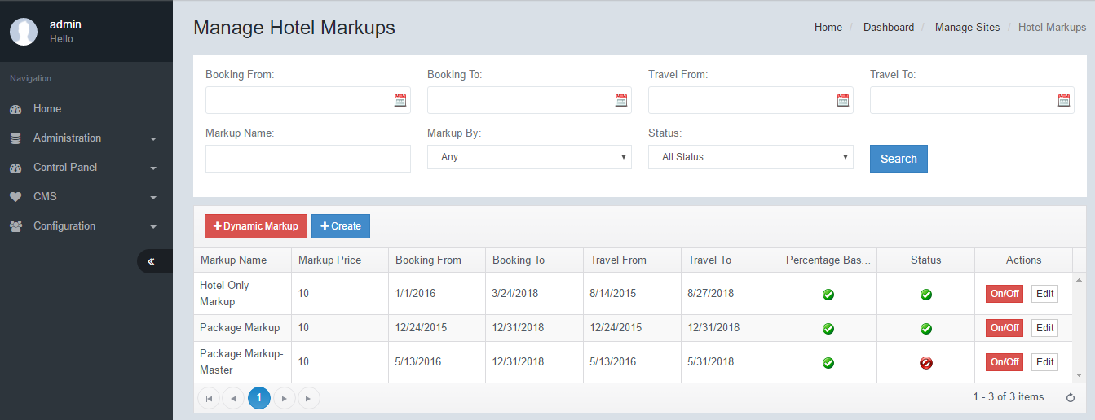

The filter function allows the user to search all the markups by the various filters available.  
Click Create to add a new markup. Click Edit to view further details of the individual markup.

[Citation Needed] Dynamic markup is a built in markup feature that performs markups based on BAR rate of hotels and the comparison rates with various OTAs. The engine will always try to match the cheapest industrial hotel rates while maintaining the highest markup.

To create a Hotel Markup, click on Create. Enter all necessary fields, then click Save.

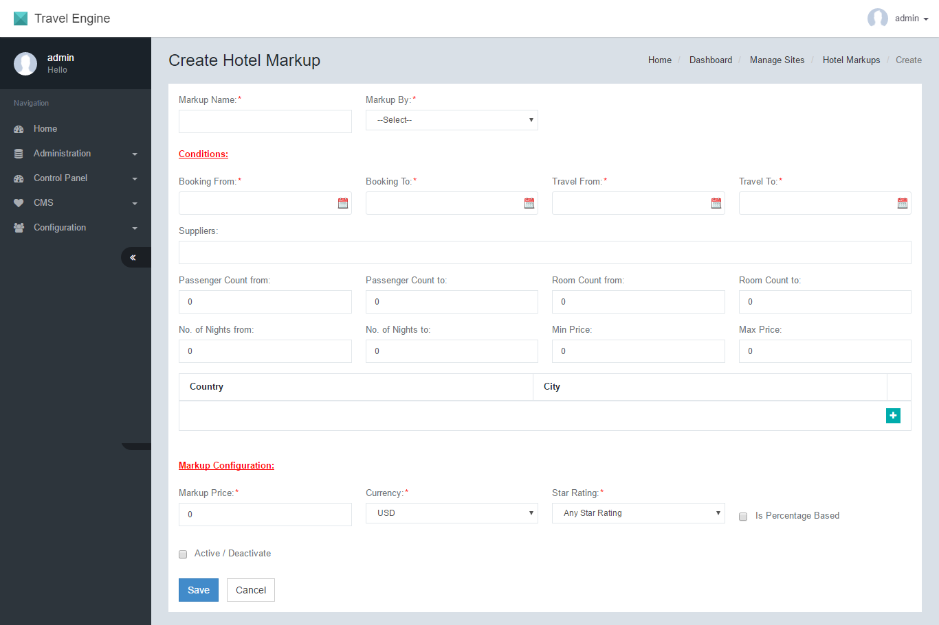

|  |  |  |
| --- | --- | --- |
| **Create Hotel Markup** | | |
| No. | Function | Description |
| 1 | Markup Name | The name of the markup |
| 2 | Markup By | There are 2 methods of calculation for the markup  - Package – The markup will be applied to the hotel component of a package.  - DIY – The markup will be applied to the hotel only product.  [Citation needed] |
| 3 | Booking From | The booking date range start date. The markup will only be applied if the date the booking is made falls within the predefined date range |
| 4 | Booking To | The booking date range end date. |
| 5 | Travel From | The travel date range start date. The markup will only be applied if the dates that the passenger is travelling falls within the predefined date range. |
| 6 | Travel To | The travel date range end date. |
| 7 | Suppliers | The markup will only be applied to the list of suppliers that are entered. Key in the supplier codes. Leave blank to apply to all suppliers. |
| 8 | Passenger Count from | The markup will be applied if the search criteria matches the minimum number of passengers configured |
| 9 | Passenger Count to | The passenger maximum count. |
| 10 | Room Count from | The markup will be applied if the search criteria matches the minimum number of rooms configured |
| 11 | Room Count to | The maximum rooms count. |
| 12 | No of Nights from | The markup will be applied if the search criteria matches the minimum number of room nights configured. |
| 13 | No of Nights to | The maximum no of room nights. |
| 14 | Min Price | The markup will be applied if the minimum total price of the hotel matches the configuration |
| 15 | Max Price | The markup will be applied if the maximum total price of the hotel matches the configuration |
| 16 | Country | Markups can be set for specific Countries. Select the country and click the + icon for more countries. The Markups will be applied only to the countries listed. |
| 17 | City | Markups can be set for specific Cities. Select the country and city. Click the + icon for more Cities. The Markups will be applied only to the Cities listed. |
| 18 | Markup Price | The value of the markup that will be added. |
| 19 | Currency | The currency value of the configured value. |
| 20 | Star Rating | The markups will only be applied to the Star rating configured. If the star rating does not match, no markup will be applied. |
| 21 | Is Percentage Based | The value of the markup price may be setup as a percentage. If the checkbox is selected, then the markup calculations will be based on percentage of the total hotel price. |
| 22 | Active/Deactive | Select this checkbox to enable/activate this markup record. |

# Hotel Cancellation Markups

This markup type is used for handling cancellations. It may be necessary to have a surcharge for cancellations such as processing fees etc

## Manage Hotel Cancellation Markups/Create Hotel Cancellation Markup

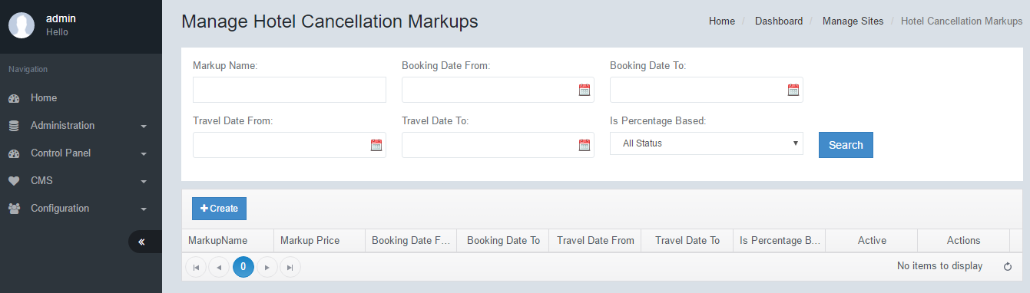

To create a Hotel Cancellation Markup, click Create. Enter all necessary fields, then click Save.

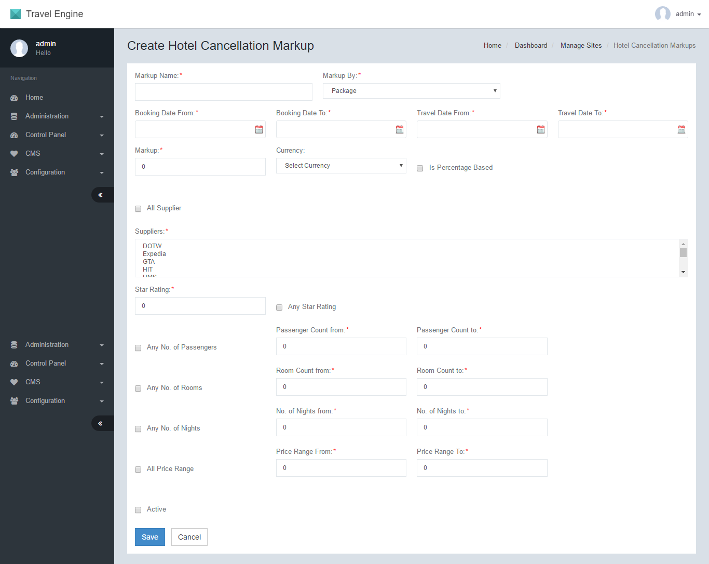

|  |  |  |
| --- | --- | --- |
| **Create Hotel Cancellation Markup** | | |
| No. | Function | Description |
| 1 | Markup Name | The name for the markup record |
| 2 | Booking Date From | The booking date range start date. The markup will only be applied if the date the booking is made falls within the predefined date range |
| 3 | Booking Date To | The booking date range end date. |
| 4 | Travel Date From | The travel date range start date. The markup will only be applied if the dates that the passenger is travelling falls within the predefined date range. |
| 5 | Travel Date To | The travel date range end date. |
| 6 | Markup | The value of the markup to be applied upon cancellation |
| 7 | Currency | The currency value of the markup. |
| 8 | Is Percentage Base | If this is selected, the value of the markup configuration will be in percentage form. It will take the percentage of the ticket price. If not selected, it will add on the value in monetary form. |
| 9 | Suppliers | The list of suppliers that the markup will be applied to. Key in the supplier Code. |
| 10 | Star Rating | The markups will only be applied to the Star rating configured. If the star rating does not match, no markup will be applied. Select the checkbox to apply to all star ratings. |
| 11 | No of Passengers | This is the minimum and maximum total passenger count. If the configuration falls within this range, the markup will be applied |
| 122 | No of Rooms | This is the minimum and maximum total rooms. If the configuration falls within this range, the markup will be applied |
| 13 | No of Nights | This is the minimum and maximum total room nights. If the configuration falls within this range, the markup will be applied |
| 14 | Price Range | This is the minimum and maximum total price of the hotel. If the configuration falls within this range, the markup will be applied |
| 15 | Active | Select this checkbox to activate this markup record. |

# Tour Markups

## Manage Tour Markups/Create Tour Markup

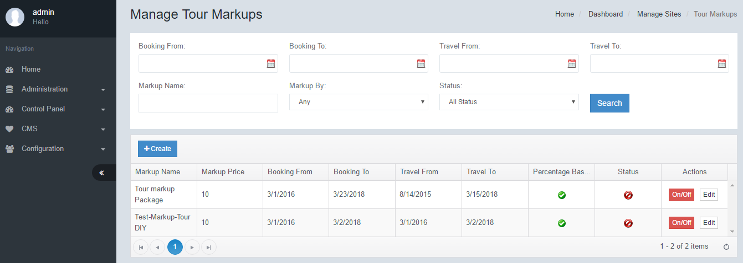

To create a Tour Markup, click Create. Enter all necessary fields, then click Save.

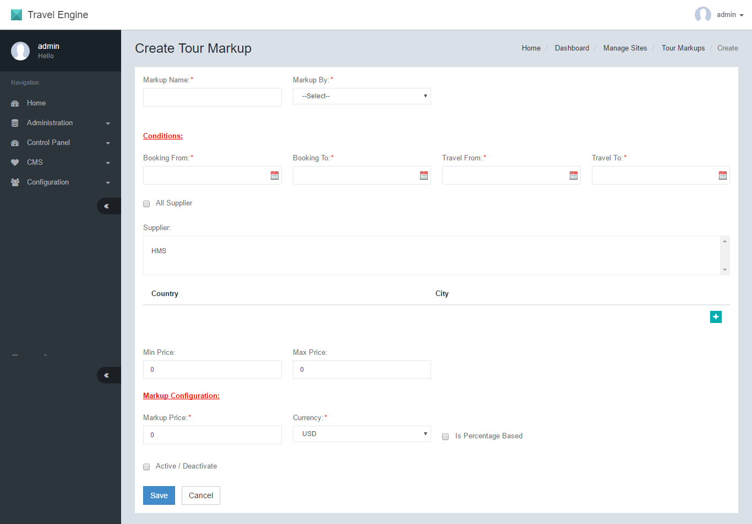

|  |  |  |
| --- | --- | --- |
| **Create Tour Markup** | | |
| No. | Function | Description |
| 1 | Markup Name | The name of the markup |
| 2 | Markup By | There are 2 methods of calculation for the markup  - Package – The markup will be applied to the tour component of a package.  - DIY – The markup will be applied to the tour only product.  [Citation needed] |
| 3 | Booking From | The booking date range start date. The markup will only be applied if the date the booking is made falls within the predefined date range |
| 4 | Booking To | The booking date range end date. |
| 5 | Travel From | The travel date range start date. The markup will only be applied if the dates that the passenger is travelling falls within the predefined date range. |
| 6 | Travel Date To | The travel date range end date. |
| 7 | Suppliers | The markup will only be applied to the list of suppliers that are entered. Key in the supplier codes. Leave blank to apply to all suppliers. |
| 8 | Country | Markups can be set for specific Countries. Select the country and click the + icon for more countries. The Markups will be applied only to the countries listed. |
| 9 | City | Markups can be set for specific Cities. Select the country and city. Click the + icon for more Cities. The Markups will be applied only to the Cities listed. |
| 10 | Min Price | The markup will be applied if the minimum total price of the tour matches the configuration |
| 11 | Max Price | The markup will be applied if the maximum total price of the tour matches the configuration |
| 12 | Markup Price | The value of the markup that will be added. |
| 13 | Currency | The currency value of the configured value. |
| 14 | Is Percentage Based | The value of the markup price may be setup as a percentage. If the checkbox is selected, then the markup calculations will be based on percentage of the total transfer price. |
| 15 | Active/Deactive | Select this checkbox to enable/activate this markup record. |

# Transfer Markups

## Manage Transfer Markups/Create Transfer Markup

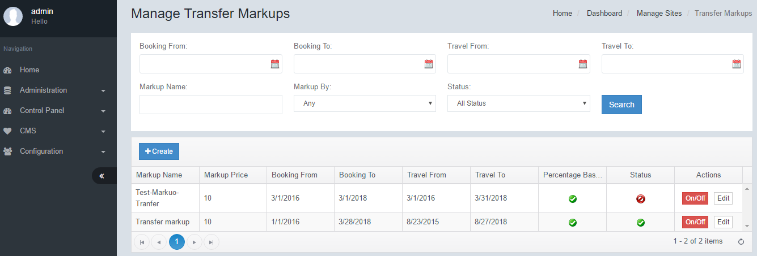

To create a Transfer Markup, click Create. Enter all necessary fields, then click Save.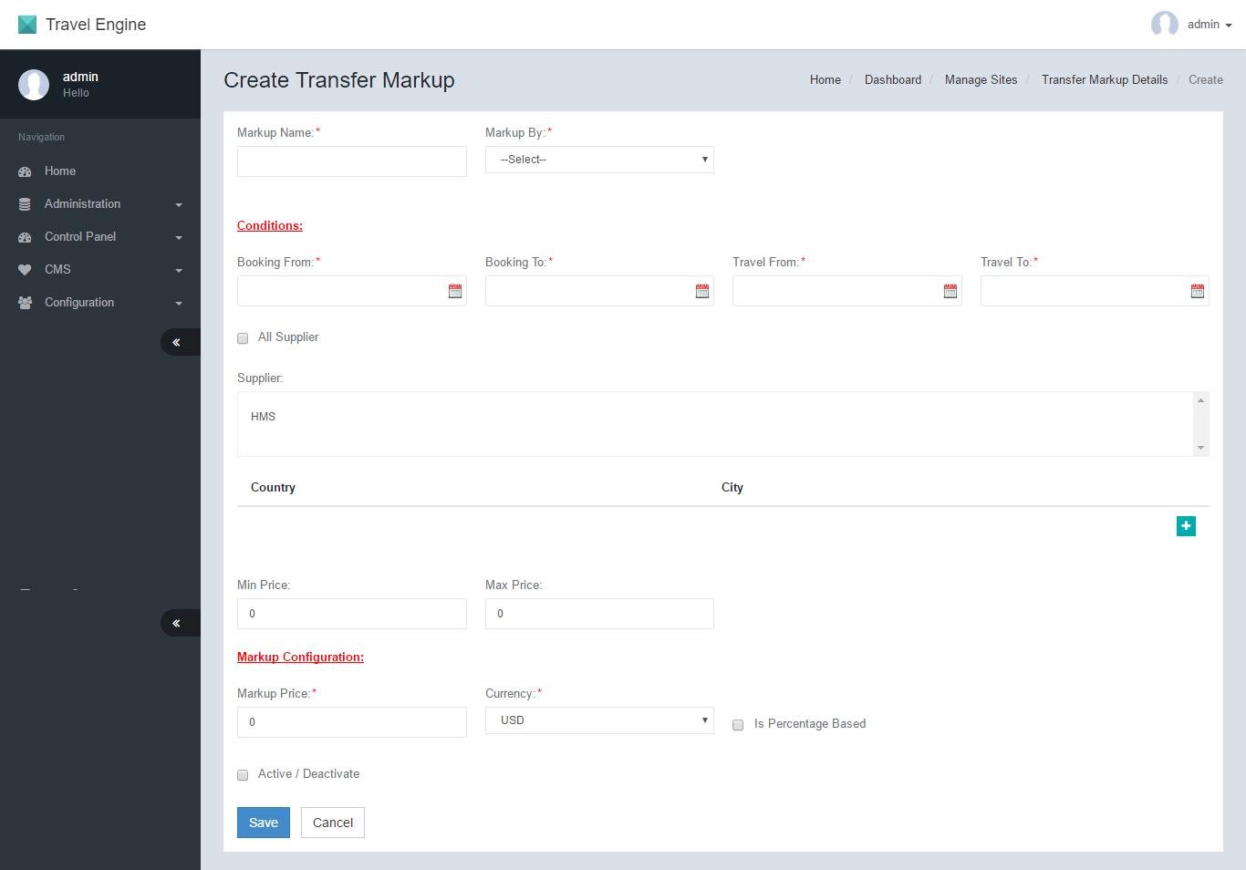

|  |  |  |
| --- | --- | --- |
| **Create Tour Markup** | | |
| No. | Function | Description |
| 1 | Markup Name | The name of the markup |
| 2 | Markup By | There are 2 methods of calculation for the markup  - Package – The markup will be applied to the transfer component of a package.  - DIY – The markup will be applied to the transfer only product.  [Citation needed] |
| 3 | Booking From | The booking date range start date. The markup will only be applied if the date the booking is made falls within the predefined date range |
| 4 | Booking To | The booking date range end date. |
| 5 | Travel From | The travel date range start date. The markup will only be applied if the dates that the passenger is travelling falls within the predefined date range. |
| 6 | Travel Date To | The travel date range end date. |
| 7 | Suppliers | The markup will only be applied to the list of suppliers that are entered. Key in the supplier codes. Leave blank to apply to all suppliers. |
| 8 | Country | Markups can be set for specific Countries. Select the country and click the + icon for more countries. The Markups will be applied only to the countries listed. |
| 9 | City | Markups can be set for specific Cities. Select the country and city. Click the + icon for more Cities. The Markups will be applied only to the Cities listed. |
| 10 | Min Price | The markup will be applied if the minimum total price of the tour matches the configuration |
| 11 | Max Price | The markup will be applied if the maximum total price of the tour matches the configuration |
| 12 | Markup Price | The value of the markup that will be added. |
| 13 | Currency | The currency value of the configured value. |
| 14 | Is Percentage Based | The value of the markup price may be setup as a percentage. If the checkbox is selected, then the markup calculations will be based on percentage of the total transfer price. |
| 15 | Active/Deactive | Select this checkbox to enable/activate this markup record. |

# Other Charge Markups

Other charge markups module is used for the purpose of adding markups to other ancillaries such as seats and baggage. It is also possible to add special markups where a combined package with ancillaries exist.

## Manage Other Charge Markups/Create Other Charge Markup

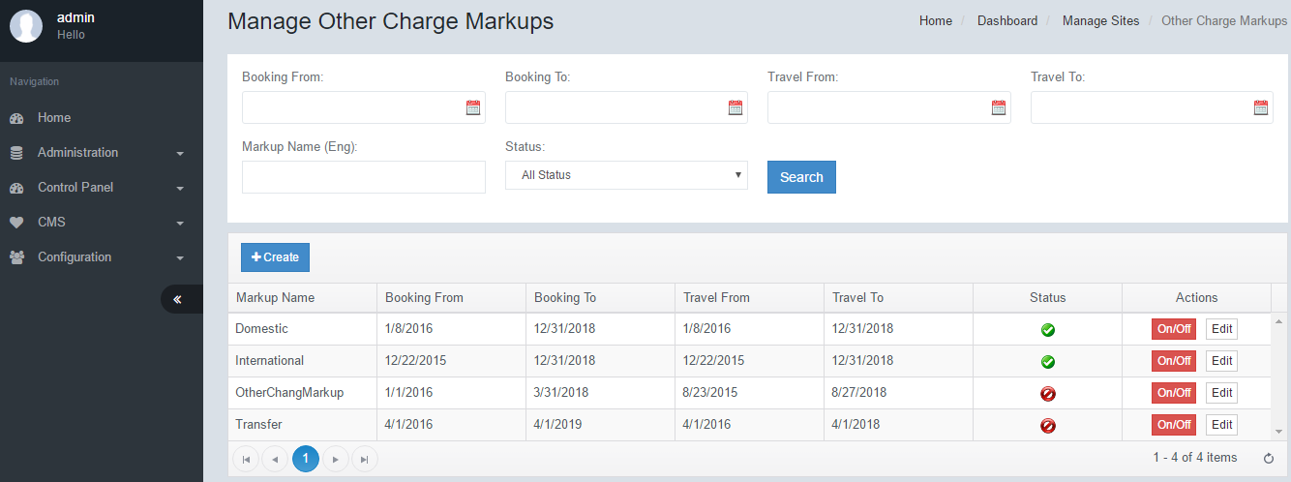

To create another Charge Markup, click Create. Enter all necessary fields, then click Save.

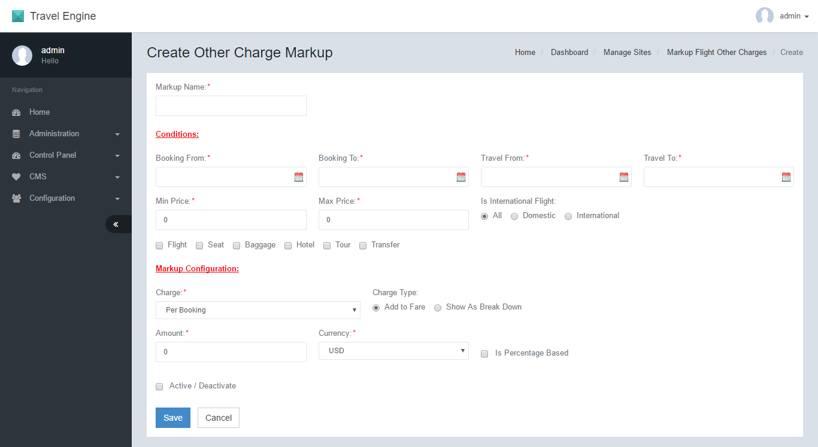

|  |  |  |
| --- | --- | --- |
| **Create Other Charge Markup** | | |
| No. | Function | Description |
| 1 | Markup Name | The name of the markup |
| 2 | Booking From | The booking date range start date. The markup will only be applied if the date the booking is made falls within the predefined date range |
| 3 | Booking To | The booking date range end date. |
| 4 | Travel From | The travel date range start date. The markup will only be applied if the dates that the passenger is travelling falls within the predefined date range. |
| 5 | Travel Date To | The travel date range end date. |
| 6 | Min Price | The markup will be applied if the minimum total price of the package matches the configuration |
| 7 | Max Price | The markup will be applied if the maximum total price of the package matches the configuration |
| 8 | Is International Flight | - All – Applies to both Domestic and International flights  - Domestic – Applies to only domestic flights  - International – Applies to only international flights |
| 9 | Flight | Select this if the other charge package includes flight |
| 10 | Seat | Select this if the other charge package includes Seat |
| 11 | Baggage | Select this if the other charge package includes Baggage |
| 12 | Hotel | Select this if the other charge package includes Hotel |
| 13 | Tour | Select this if the other charge package includes Tour |
| 14 | Transfer | Select this if the other charge package includes Transfer |
| 15 | Amount | The value of the markup that will be added. |
| 16 | Currency | The currency value of the configured value. |
| 17 | Is Percentage Based | The value of the markup price may be setup as a percentage. If the checkbox is selected, then the markup calculations will be based on percentage of the total price. |
| 18 | Active/Deactive | Select this checkbox to enable/activate this markup record. |